Agile planning and portfolio management with Azure Boards 1

Version Control with Git in Azure Repos 49

Configure agent pools and understanding pipeline styles 83

Enable Continuous Integration with Azure Pipelines 100

Implement GitHub Actions for CI/CD 106

Deploy Docker containers to Azure App Service web apps 118

Configure Pipelines as Code with YAML 123

Integrate Azure Key Vault with Azure DevOps 133

Control Deployments using Release Gates 133

Set up and run functional tests 133

Enable Dynamic Configuration and Feature Flags 133

Deployments using Azure Bicep templates 133

Package Management with Azure Artifacts 133

Monitor Application Performance with Azure Load Testing 133

Share team knowledge using Azure Project Wiki 133

# Agile planning and portfolio management with Azure Boards

## Lab requirements

In this **Cloudslice** lab these two Lab Requirements have already been completed for you.

* This lab requires **Microsoft Edge** or an [Azure DevOps supported browser.](https://docs.microsoft.com/azure/devops/server/compatibility?view=azure-devops#web-portal-supported-browsers)
* **Set up an Azure DevOps organization:** If you don't already have an Azure DevOps organization that you can use for this lab, create one by following the instructions available at [Create an organization or project collection](https://docs.microsoft.com/azure/devops/organizations/accounts/create-organization?view=azure-devops).

## Lab overview

In this lab, you'll learn about the agile planning and portfolio management tools and processes provided by Azure Boards and how they can help you quickly plan, manage, and track work across your entire team. You'll explore the product backlog, sprint backlog, and task boards that can track the flow of work during an iteration. We'll also look at the enhanced tools in this release to scale for larger teams and organizations.

## Objectives

After you complete this lab, you will be able to:

* Manage teams, areas, and iterations.
* Manage work items.
* Manage sprints and capacity.
* Customize Kanban boards.
* Define dashboards.
* Customize team process.

## Estimated timing: 60 minutes

## Instructions

### Exercise 0: (skip if done) Configure the lab prerequisites

In this **Cloudslice** lab, please skip **Exercise 0**

In this exercise, you will set up the prerequisites for the lab, which consist of a new Azure DevOps project with a repository based on the [eShopOnWeb](https://github.com/MicrosoftLearning/eShopOnWeb).

#### Task 1: (skip if done) Create and configure the team project

In this task, you will create an **eShopOnWeb** Azure DevOps project to be used by several labs.

1. On your lab computer, in a browser window open your Azure DevOps organization. Click on **New Project**. Give your project the name **eShopOnWeb**. Define **Private** as Visibility option.
2. Click **Advanced** and specify **Scrum** as **Work Item Process**. Click on **Create**.

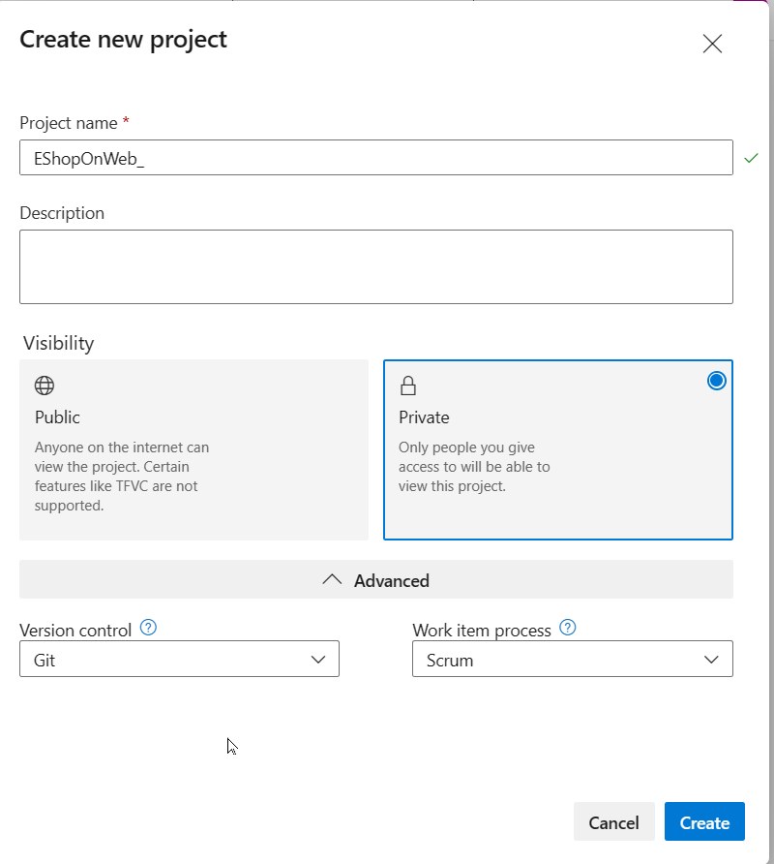

### Exercise 1: Manage Agile project

In this exercise, you will use Azure Boards to perform a number of common agile planning and portfolio management tasks, including management of teams, areas, iterations, work items, sprints and capacity, customizing Kanban boards, defining dashboards, and customizing team processes.

#### Task 1: Manage teams, areas, and iterations

In this task, you will create a new team and configure its area and iterations.

Each new project is configured with a default team, which name matches the project name. You have the option of creating additional teams. Each team can be granted access to a suite of Agile tools and team assets. The ability to create multiple teams gives you the flexibility to choose the proper balance between autonomy and collaboration across the enterprise.

1. On your lab computer, start a web browser and navigate to the Azure DevOps portal at [https:*//aex.dev.azure.com*](https://aex.dev.azure.com).

**Note**: If prompted, sign in using the Microsoft account associated with your Azure DevOps subscription.

1. Open the **eShopOnWeb** project under your Azure DevOps organization.

**Note**: Alternatively, you can access the project page directly by navigating to the <https://dev.azure.com/YOUR-AZURE-DEVOPS-ORGANIZATION/PROJECT-NAME> URL, where the YOUR-AZURE-DEVOPS-ORGANIZATION placeholder, represents your account name, and the PROJECT-NAME placeholder represents the name of the project.

1. Click the cogwheel icon labeled **Project settings** located in the lower left corner of the page to open the **Project settings** page.

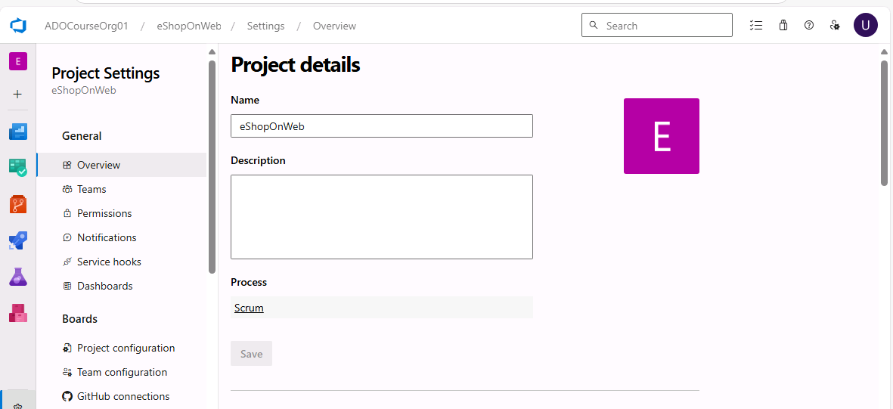

1. In the **General** section, select the **Teams** tab. There is already a default team in this project, **eShopOnWeb Team** but you'll create a new one for this lab. Click **New Team**.

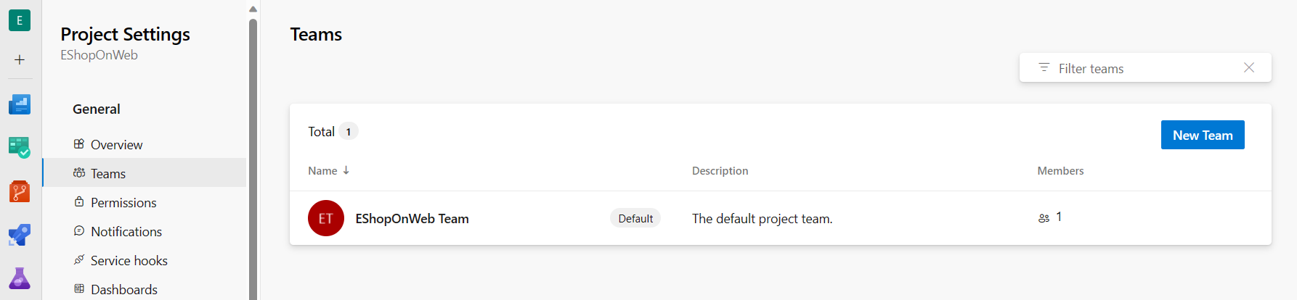

1. On the **Create a new team** pane, in the **Team name** textbox, type **EShop-Web**, leave other settings with their default values, and click **Create**.

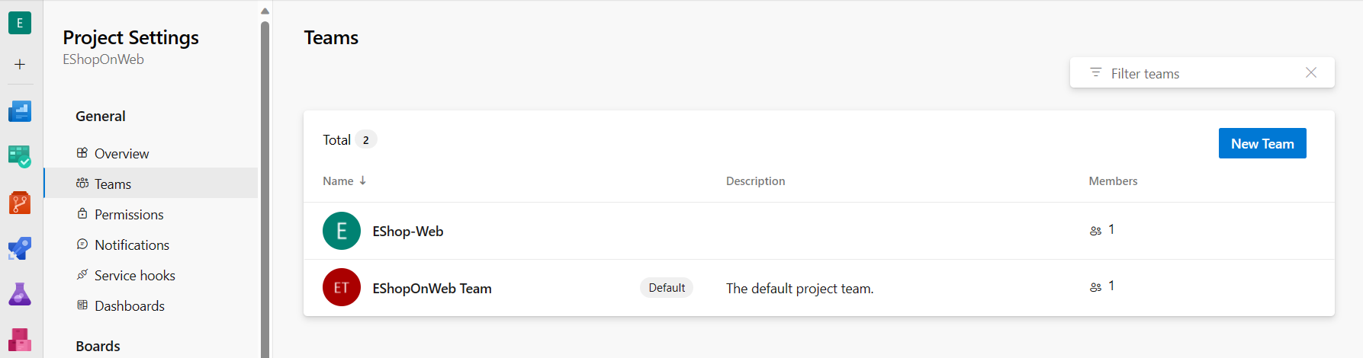

1. In the list of **Teams**, select the newly created team to view its details.

**Note**: By default, the new team has only you as its member. You can use this view to manage such functionality as team membership, notifications, and dashboards.

1. Click **Iterations and Area Paths** link at the top of the **EShop-Web** page to start defining the schedule and scope of the team.

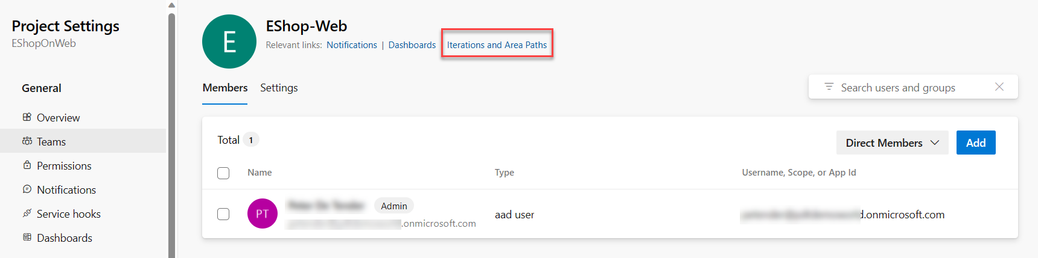

1. At the top of the **Boards** pane, select the **Iterations** tab and then click **+ Select iteration(s)**.

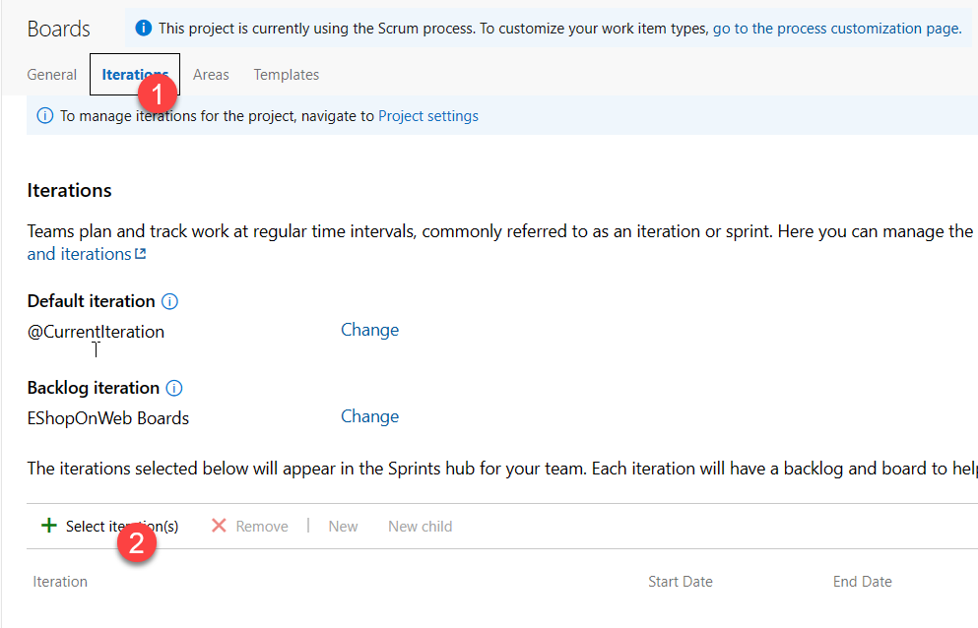

1. Select **eShopOnWeb\Sprint 1** and click **Save and close**. Note that this first sprint will show up in the list of iterations, but the Dates are not set yet.
2. Select **Sprint 1** and click the **ellipsis (…)**. From the context menu, select **Edit**.

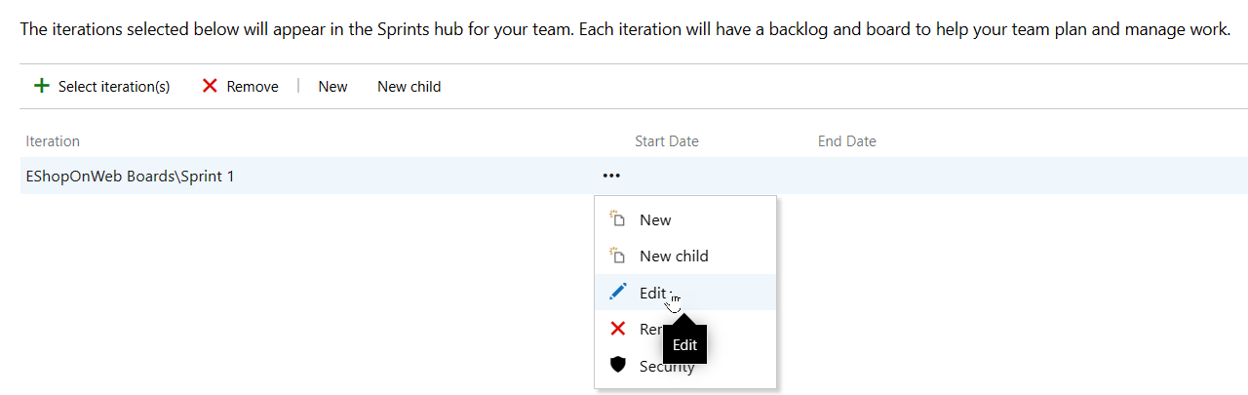

**Note**: Specify the Start Date as the first work day of last week, and count 3 full work weeks for each sprint. For example, if March 6 is the first work day of the sprint, it goes until March 24th. Sprint 2 starts on March 27, which is 3 weeks out from March 6.

1. Repeat the previous step to add **Sprint 2** and **Sprint 3**. You could say that we are currently in the 2nd week of the first sprint.

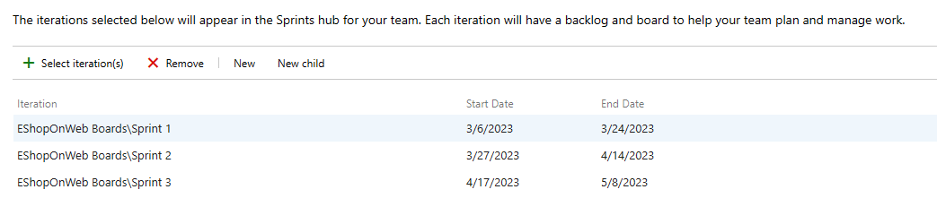

1. Still in the **Project Settings / Boards / Team Configuration** pane, at the top of the pane, select the **Areas** tab. You will find there an automatically generated area with the name matching the name of the team.

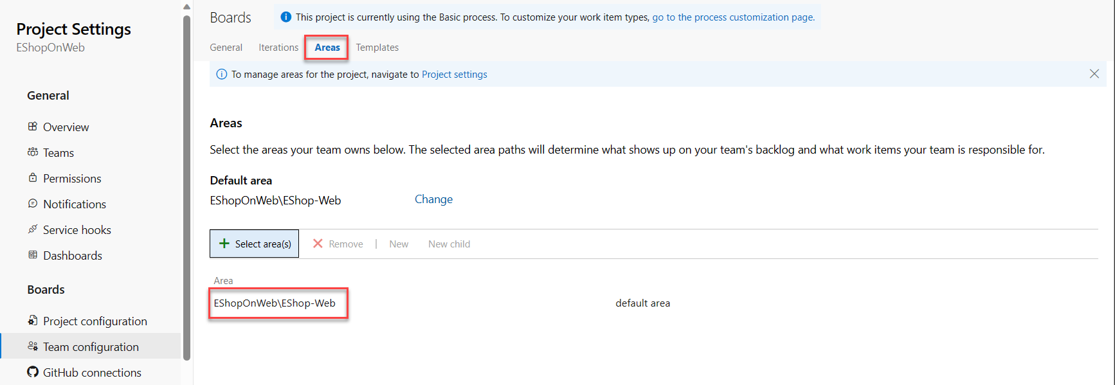

1. Click the ellipsis symbol (…) next to the **default area** entry and, in the dropdown list, select **Include sub areas**.

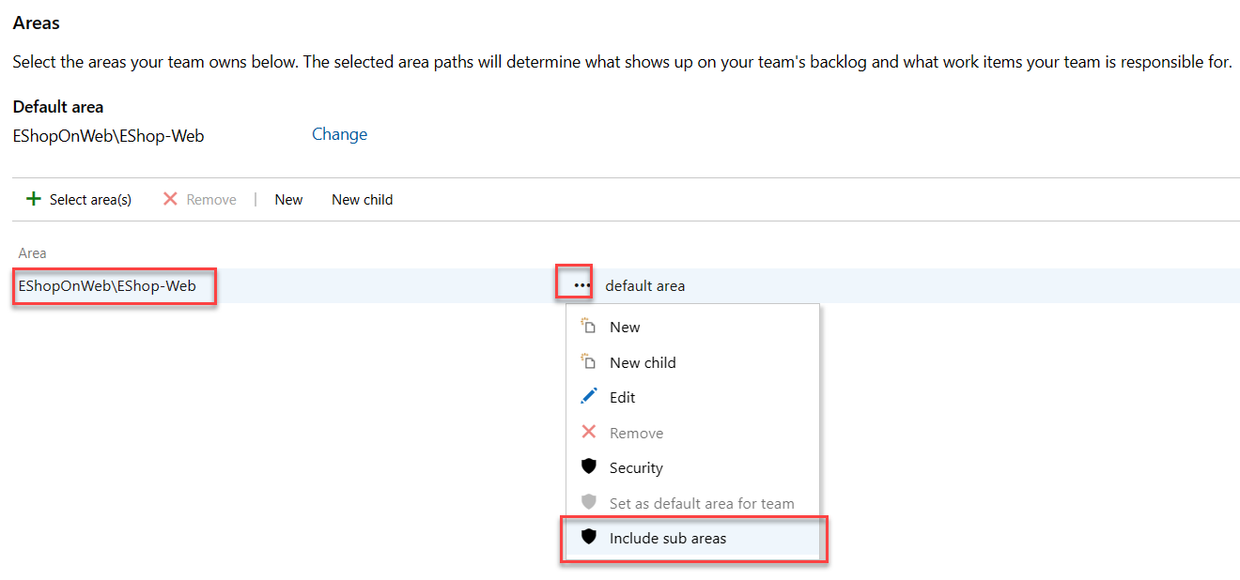

**Note**: The default setting for all teams is to exclude sub-area paths. We will change it to include sub-areas so that the team gets visibility into all of the work items from all teams. Optionally, the management team could also choose to not include sub-areas, which automatically removes work items from their view as soon as they are assigned to one of the teams.

#### Task 2: Manage work items

In this task, you will step through common work item management tasks.

Work items play a prominent role in Azure DevOps. Whether describing work to be done, impediments to release, test definitions, or other key items, work items are the workhorse of modern projects. In this task you'll focus on using various work items to set up the plan to extend the eShopOnWeb site with a product training section. While it can be daunting to build out such a substantial part of a company's offering, Azure DevOps and the Scrum process make it very manageable.

**Note**: This task is designed to illustrate a variety of ways you can create different kinds of work items, as well as to demonstrate the breadth of features available on the platform. As a result, these steps should not be viewed as prescriptive guidance for project management. The features are intended to be flexible enough to fit your process needs, so explore and experiment as you go.

1. Click on the project name in the upper left corner of the Azure DevOps portal to return to the project home page.
2. In the vertical navigational pane of the Azure DevOps portal, select the **Boards** icon and, select **Work Items**.

**Note**: There are many ways to create work items in Azure DevOps, and we'll explore a few of them. Sometimes it's as simple as firing one off from a dashboard.

1. On the **Work Items** window, click on **+ New Work Item > Epic**.

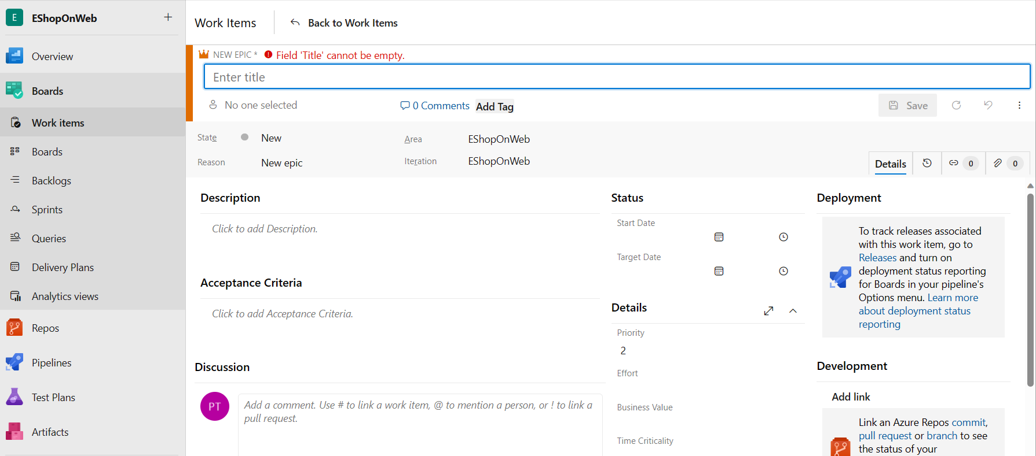

1. In the **Enter title** textbox, type **Product training**.
2. In the upper left corner, select the **No one selected** entry and, in the dropdown list, select your user account in order to assign the new work item to yourself. If your name doesn't appear to start with, begin typing your name and click **Search**.
3. Next to the **Area** entry, select the **eShopOnWeb** entry and, in the dropdown list, select **EShop-WEB**. This will set the **Area** to **eShopOnWeb\EShop-WEB**.
4. Next to the **Iteration** entry, select the **eShopOnWeb** entry and, in the dropdown list, select **Sprint 2**. This will set the **Iteration** to **eShopOnWeb\Sprint 2**.
5. Click **Save** to finalize your changes. **Do not close it**.

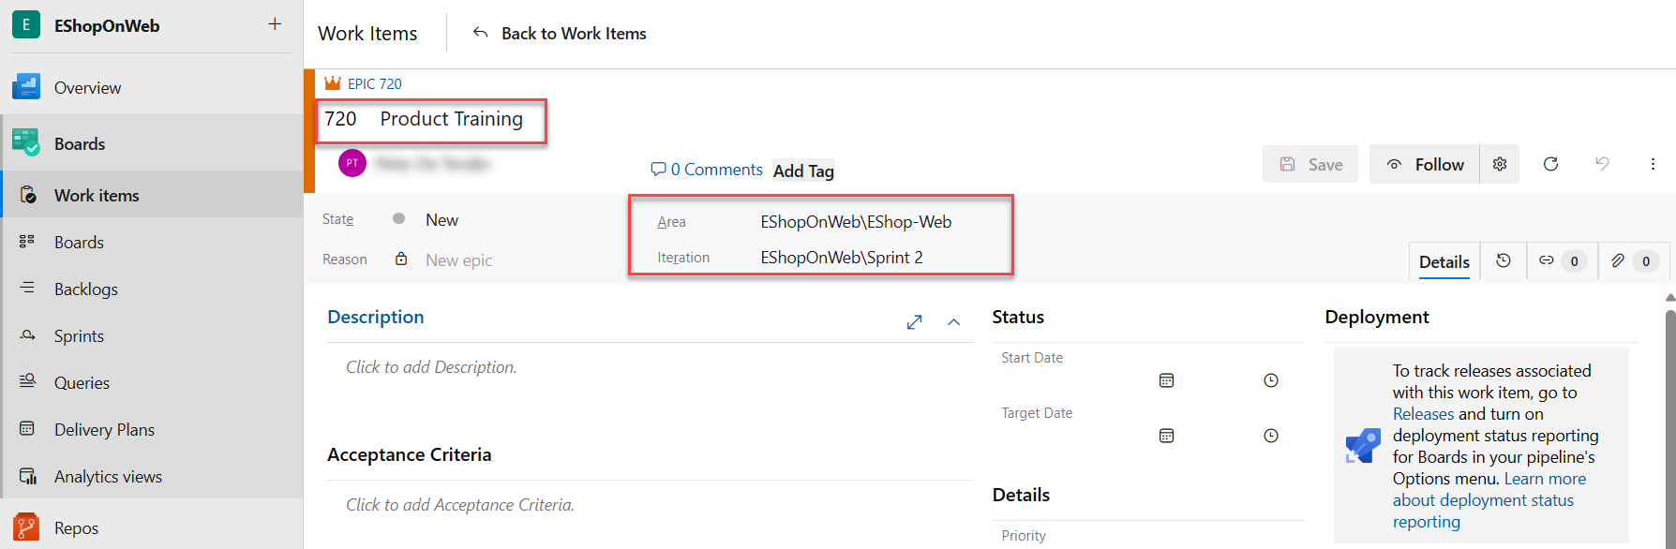

**Note**: Ordinarily you would want to fill out as much information as possible, but this is sufficient for the purposes of this lab.

**Note**: The work item form includes all of the relevant work item settings. This includes details about who it's assigned to, its status across many parameters, and all the associated information and history for how it has been handled since creation. One of the key areas to focus on is the **Related Work**. We will explore one of the ways to add a feature to this epic.

1. In the **Related work** section on the lower right-side, select the **Add link** entry and, in the dropdown list, select **New item**.
2. On the **Add link** panel, in the **Link Type** dropdown list, select **Child**. Next, in the **Work item type** dropdown list, select **Feature**, in the **Title** textbox, type **Training dashboard**.

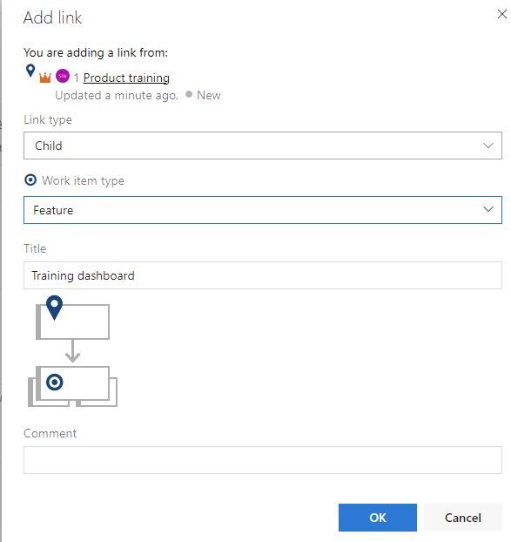

1. Click **Add link** to save the Child item

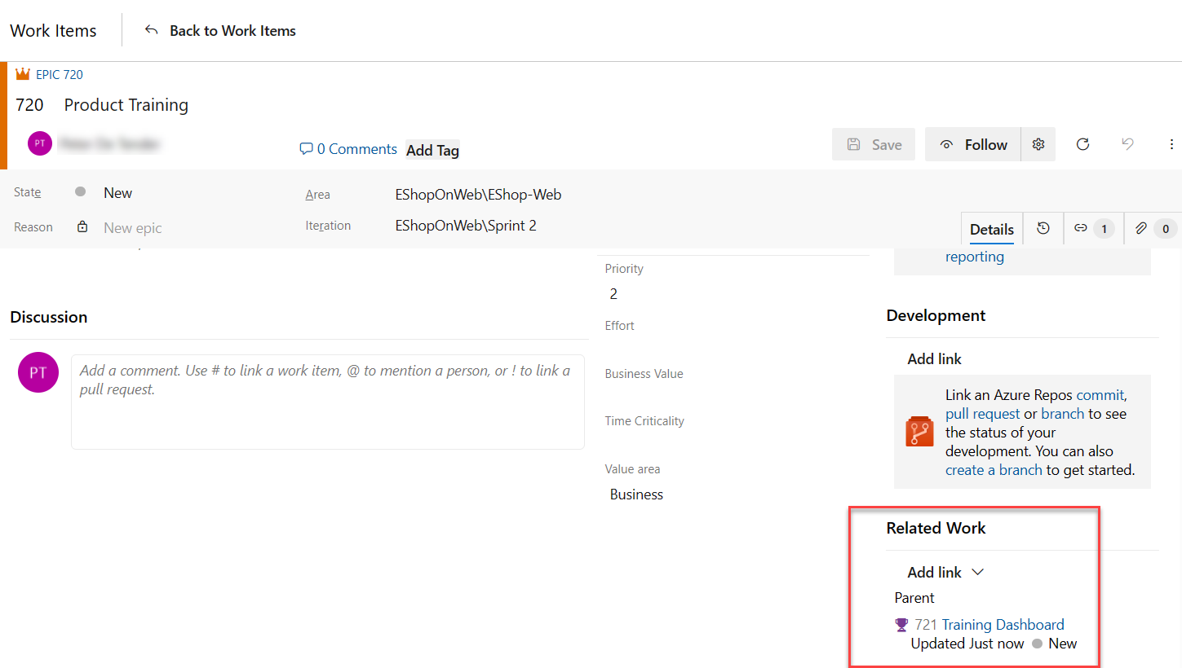

**Note**: On the **Training dashboard** panel, note that the assignment, **Area**, and **Iteration** are already set to the same values as the epic that the feature is based on. In addition, the feature is automatically linked to the parent item it was created from.

1. On the (New Feature) **Training dashboard** panel, click **Save and Close**.
2. In the vertical navigation pane of the Azure DevOps portal, in the list of the **Boards** items, select **Boards**.
3. On the **Boards** panel, select the **EShop-WEB boards** entry. This will open the board for that particular team.

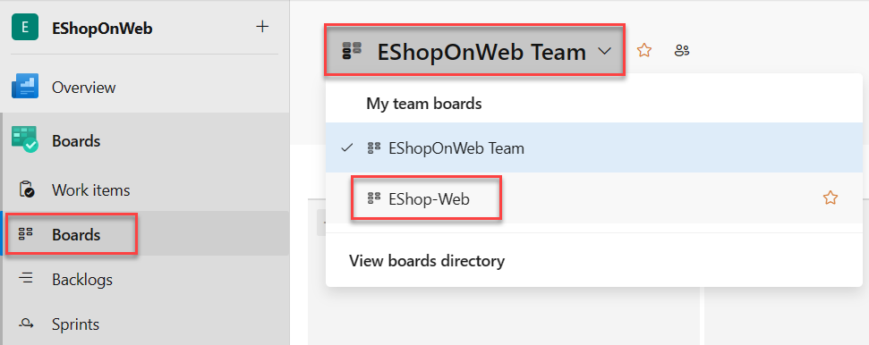

1. On the **Boards** panel, in the upper right corner, select the **Backlog items** entry and, in the dropdown list, select **Features**.

**Note**: This will make it easy to add tasks and other work items to the features.

1. Hover with the mouse pointer over the rectangle representing the **Training dashboard** feature. This will reveal the ellipsis symbol (…) in its upper right corner.
2. Click the ellipsis (…) icon and, in the dropdown list, select **Add Product Backlog Item**.

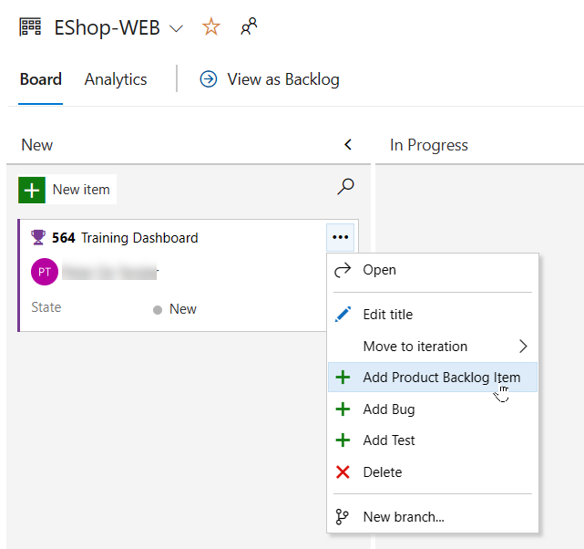

1. In the textbox of the new product backlog item, type **As a customer, I want to view new tutorials** and press the **Enter** key to save the entry.

**Note**: This creates a new product backlog item (PBI) work item that is a child of the feature and shares its area and iteration.

1. Repeat the previous step to add two more PBIs designed to enable the customer to see their recently viewed tutorials and to request new tutorials named, respectively, **As a customer, I want to see tutorials I recently viewed** and **As a customer, I want to request new tutorials**.

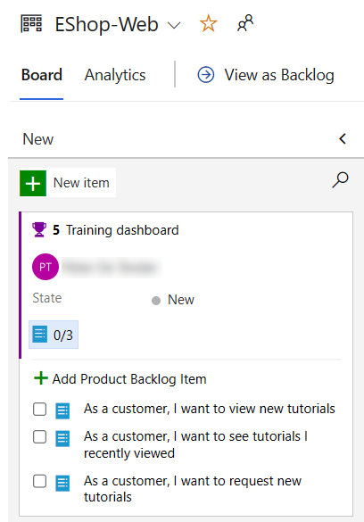

1. On the **Boards** panel, in the upper right corner, select the **Features** entry and, in the dropdown list, select **Backlog items**.

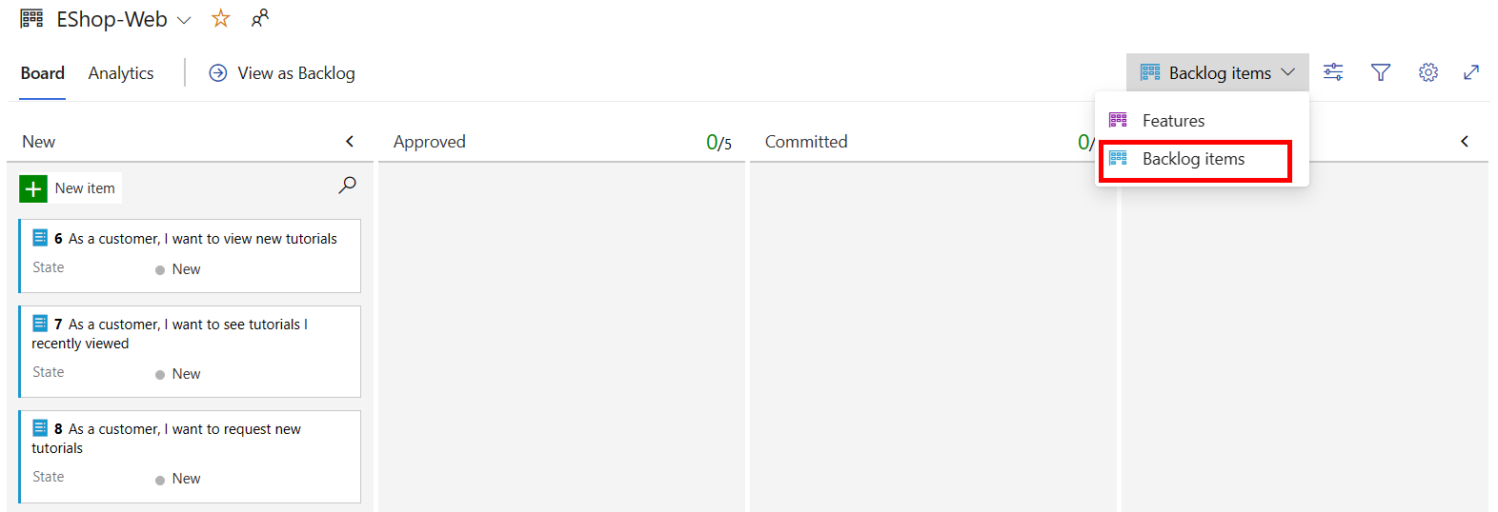

**Note**: Backlog items have a state that defines where they are relative to being completed. While you could open and edit the work item using the form, it's easier to just drag cards on the board.

1. On the **Board** tab of the **EShop-WEB** panel, drag the first work item named **As a customer, I want to view new tutorials** from the **New** to **Approved** stage.

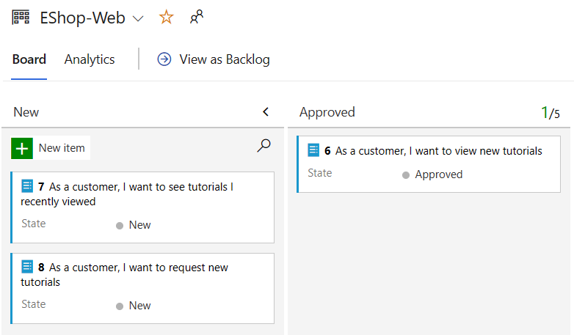

**Note**: You can also expand work item cards to get to conveniently editable details.

1. Hover with the mouse pointer over the rectangle representing the work item you moved to the **Approved** stage. This will reveal the down facing caret symbol.
2. Click the down facing caret symbol to expand the work item card, replace the **Unassigned** entry with your name, then select your account to assign the moved PBI to yourself.
3. On the **Board** tab of the **EShop-WEB** panel, drag the second work item named **As a customer, I want to see tutorials I recently viewed** from the **New** to the **Committed** stage.
4. On the **Board** tab of the **EShop-WEB** panel, drag the third work item named **As a customer, I want to request new tutorials** from the **New** to the **Done** stage.

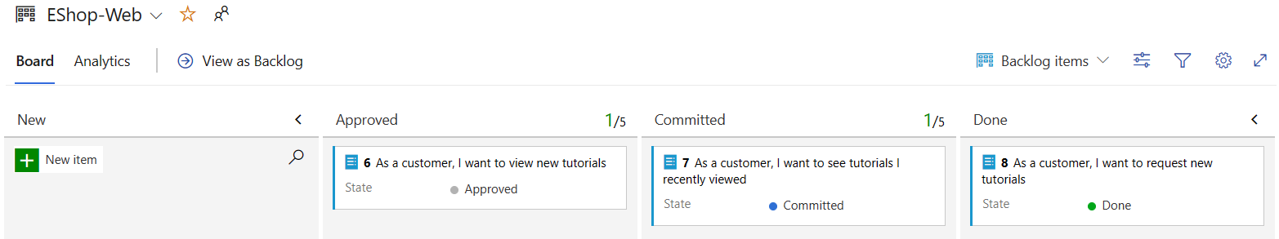

**Note**: The task board is one view into the backlog. You can also use the tabular view.

1. On the **Board** tab of the **EShop-WEB** pane, at the top of the pane, click **View as Backlog** to display the tabular form.

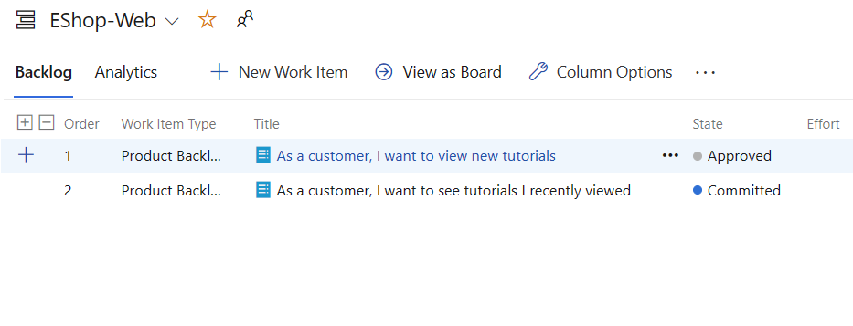

**Note**: You can use the plus sign directly under the **Backlog** tab label of the **EShop-WEB** panel to view nested tasks under these work items.

**Note**: You can use the second plus sign directly left to the first backlog item to add a new task to it.

1. On the **Backlog** tab of the **EShop-WEB** pane, in the upper left corner of the pane, click the plus sign next to the first work item. This will display the **NEW TASK** panel.

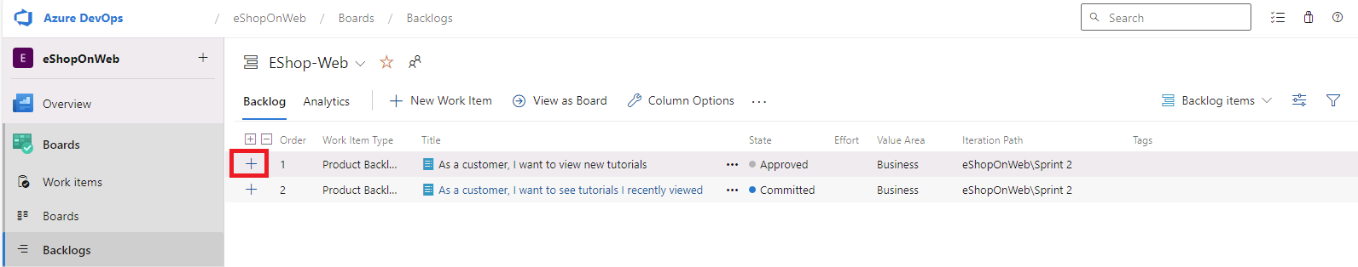

1. At the top of the **NEW TASK** panel, in the **Enter title** textbox, type **Add page for most recent tutorials**.
2. On the **NEW TASK** panel, in the **Remaining Work** textbox, type **5**.
3. On the **NEW TASK** panel, in the **Activity** dropdown list, select **Development**.
4. On the **NEW TASK** panel, click **Save and Close**.

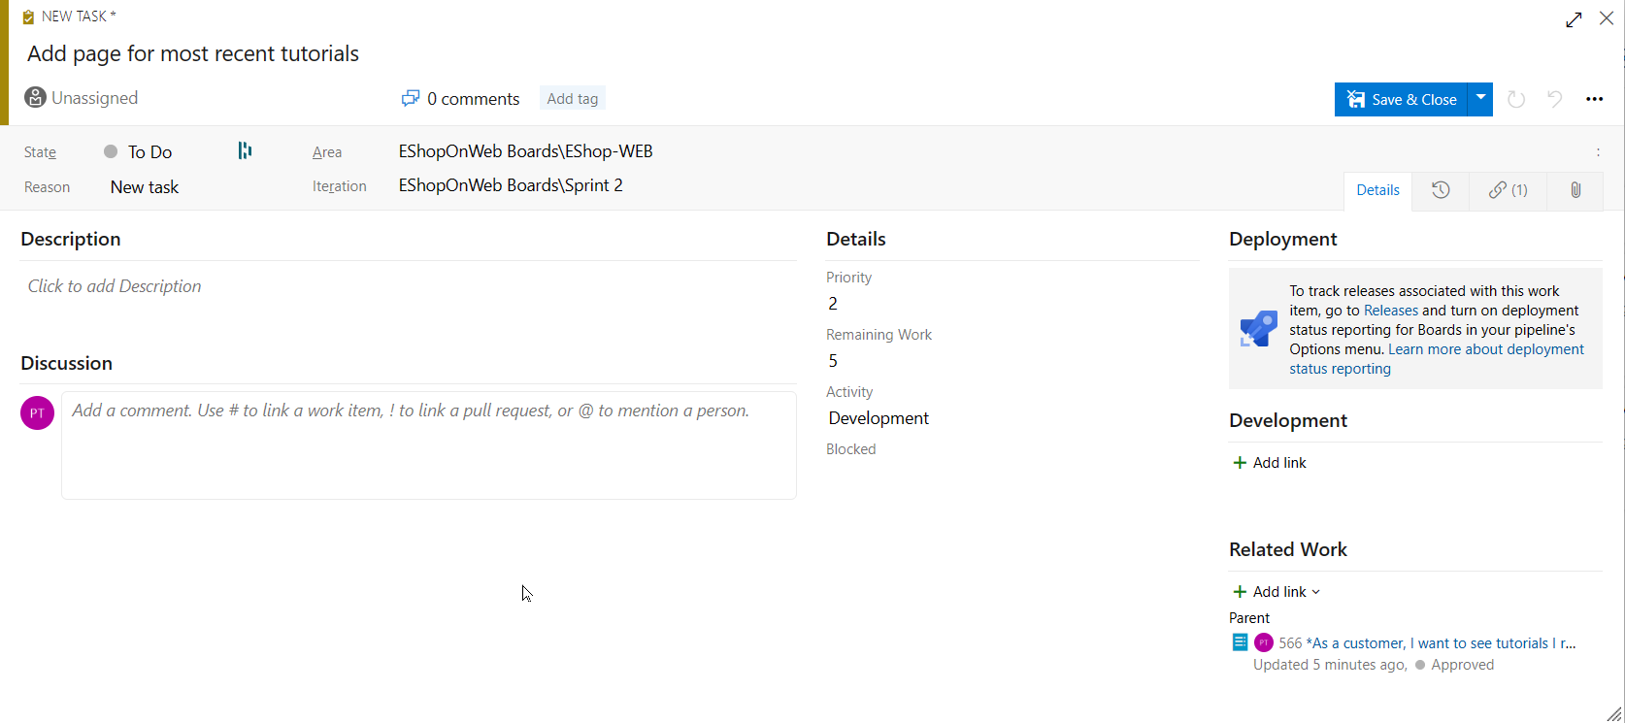

1. Repeat the last five steps to add another task named **Optimize data query for most recent tutorials**. Set its **Remaining Work** to **3** and its **Activity** to **Design**. Click **Save and Close** once completed.

#### Task 3: Manage sprints and capacity

In this task, you will step through common sprint and capacity management tasks.

Teams build the sprint backlog during the sprint planning meeting, typically held on the first day of the sprint. Each sprint corresponds to a time-boxed interval which supports the team's ability to work using Agile processes and tools. During the planning meeting, the product owner works with the team to identify those stories or backlog items to complete in the sprint.

Planning meetings typically consist of two parts. In the first part, the team and product owner identify the backlog items that the team feels it can commit to completing in the sprint, based on experience with previous sprints. These items get added to the sprint backlog. In the second part, the team determines how it will develop and test each item. They then define and estimate the tasks required to complete each item. Finally, the team commits to implementing some or all the items based on these estimates.

The sprint backlog should contain all the information the team needs to successfully plan and complete work within the time allotted without having to rush at the end. Before planning the sprint, you'd want to have created, prioritized, and estimated the backlog and defined the sprints.

1. In the vertical navigational pane of the Azure DevOps portal, select the **Boards** icon and, in the list of the **Boards** items, select **Sprints**.
2. On the **Taskboard** tab of the **Sprints** view, in the toolbar, on the right hand side, select the **View options** symbol (directly to the left of the funnel icon) and, in the **View options** dropdown list, select the **Work details** entry. Select **Sprint 2** as filter.

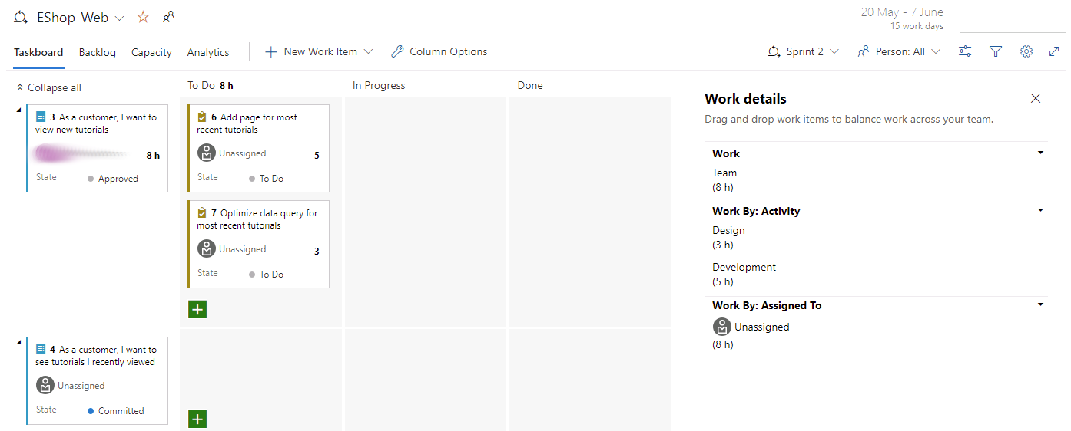

**Note**: The current sprint has a pretty limited scope. There are two tasks in the **To do** stage. At this point, neither task has been assigned. Both show a numeric value to the right of **Unassigned** entry representing the remaining work estimate.

1. Within the **ToDo** Column, notice the Task Item **Add page for most recent tutorials**, click the **Unassigned** entry and, in the list of user accounts, select your account to assign the task to yourself.
2. Select the **Capacity** tab of the **Sprints** view.

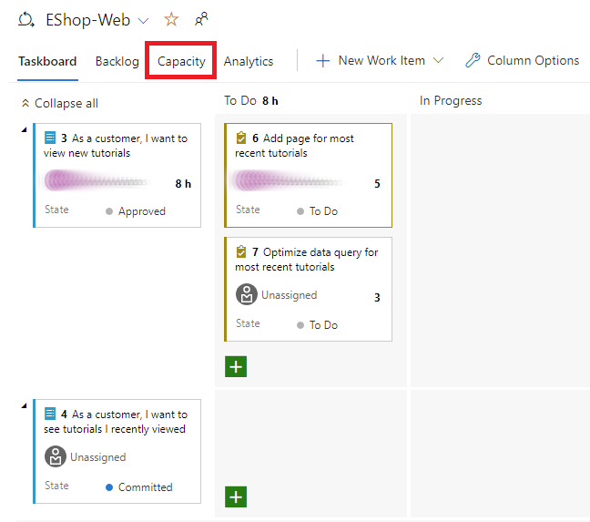

**Note**: This view enables you to define what activities a user can take on and at what level of capacity.

1. On the **Capacity** tab of the **Sprints** view, for your user account, set the **Activity** field to **Development** and, in the **Capacity per day** textbox, type **1**. Then click **Save**.

**Note**: This represents 1 hour of development work per day. Note that you can add additional activities per user in the case they do more than just development.

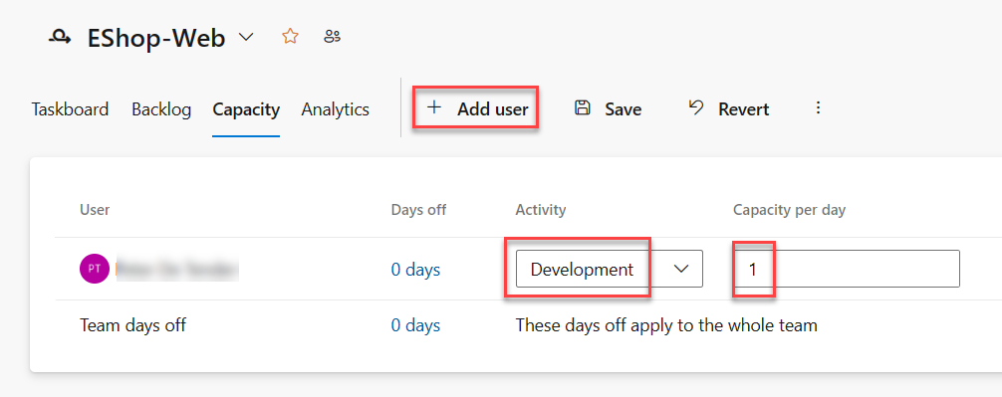

**Note**: Let's assume you're also going to take some vacation. Which should be added to the capacity view too.

1. On the **Capacity** tab of the **Sprints** view, directly next to the entry representing your user account, in the **Days off** column, click the **0 days** entry. This will display a panel where you can set your days off.
2. In the displayed panel, use the calendar view to set your vacation to span five work days during the current sprint (within the next three weeks) and, once completed, click **OK**.

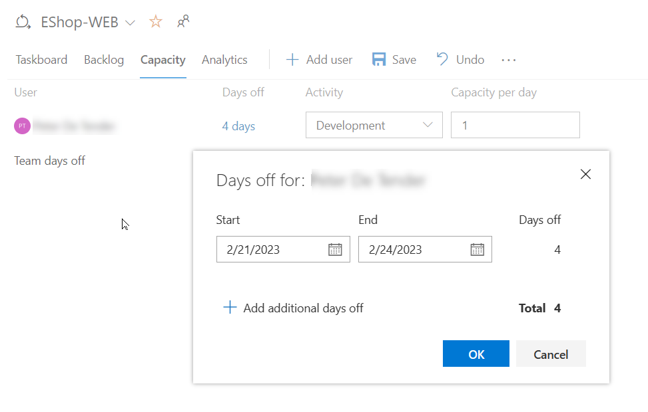

1. Back on the **Capacity** tab of the **Sprints** view, click **Save**.
2. Select the **Taskboard** tab of the **Sprints** view.

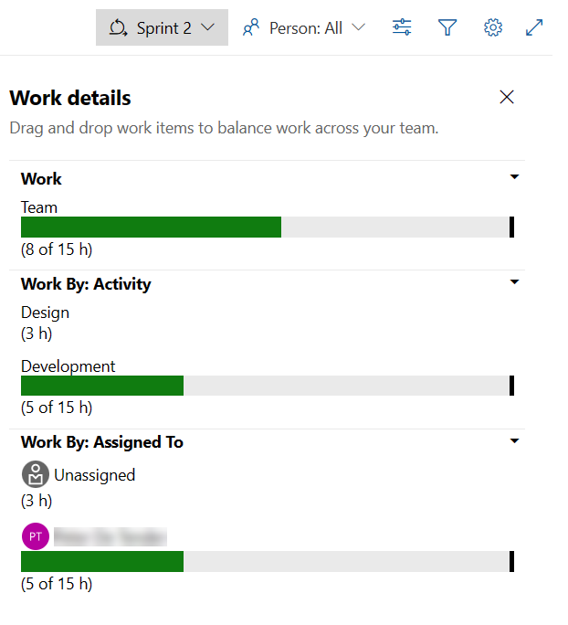

**Note**: Note that the **Work details** panel has been updated to reflect your available bandwidth. The actual number displayed in the **Work details** panel might vary, but your total sprint capacity will be equal to the number of working days remaining till the end of the sprint, since you allocated 1 hour per day. Take a note of this value since you will use it in the upcoming steps.

**Note**: One convenient feature of the boards is that you can easily update key data in-line. It's a good practice to regularly update the **Remaining Work** estimate to reflect the amount of time expected for each task. Let's say you've reviewed the work for the **Add page for most recent tutorials** task and found that it will actually take longer than originally expected.

1. On the **Taskboard** tab of the **Sprints** view, in the square box representing the **Add page for most recent tutorials**, set the estimated number of hours to **14**, to match your total capacity for this sprint, which you identified in the previous step.

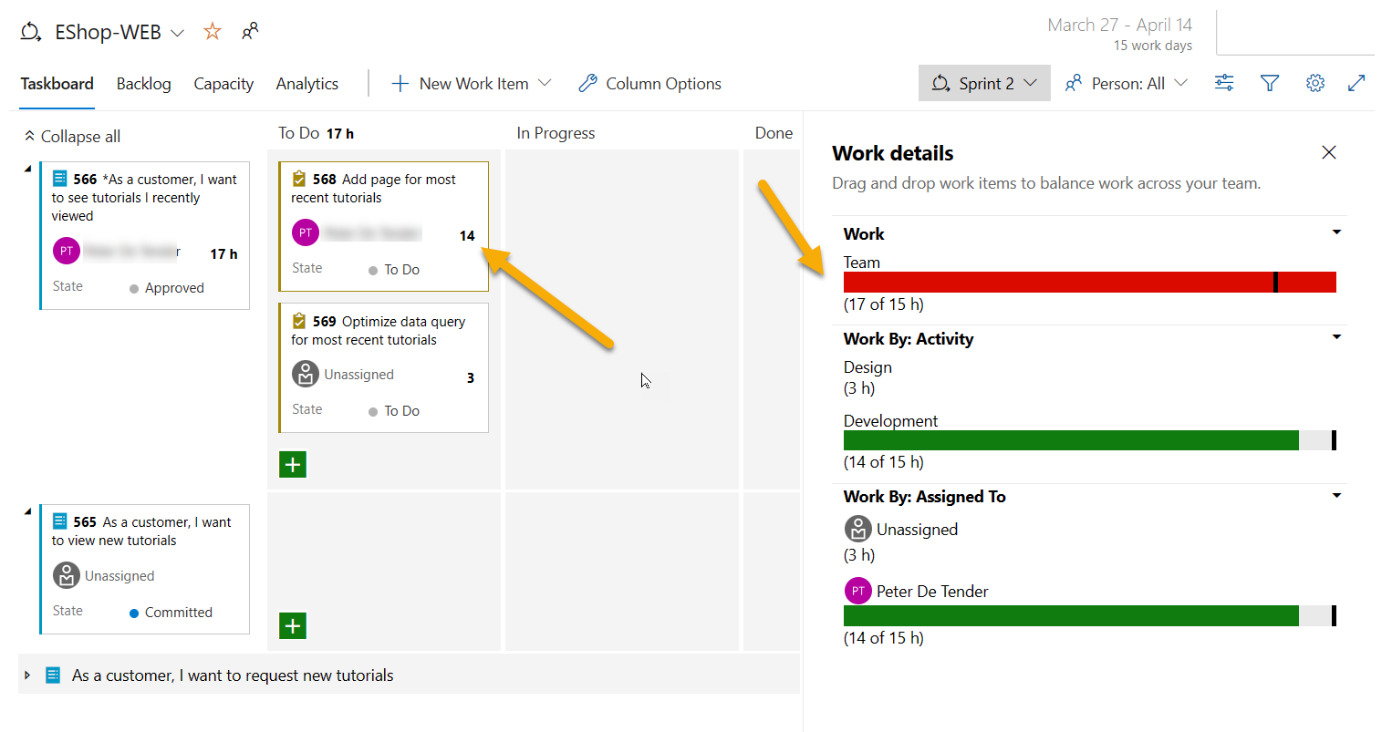

**Note**: This automatically expands the **Development** and your personal capacities to their maximum. Since they're large enough to cover the assigned tasks, they stay green. However, the overall **Team** capacity is exceeded due to the additional 3 hours required by the **Optimize data query for most recent tutorials** task.

**Note**: One way to resolve this capacity issue would be to move the task to a future iteration. There are a few ways this could be done. You could, for example, open the task here and edit it within the panel providing access to the task details. Another approach would be to use the **Backlog** view, which provides an in-line menu option to move it. At this point though, don't move the task yet.

1. On the **Taskboard** tab of the **Sprints** view, in the toolbar, on the right hand side, select the **View options** symbol (directly to the left of the funnel icon) and, in the **View options** dropdown list, select the **Assigned To** entry.

**Note**: This adjusts your view such that you can review the progress of tasks by person instead of by backlog item.

**Note**: There is also a lot of customization available.

1. Click the **Configure team settings** cogwheel icon (directly to the right of the funnel icon).
2. On the **Settings** panel, select the **Styles** tab, click **+ Add styling rule**, under the **Rule name** label, in the **Name** textbox, type **Development**, and, in the **Color** dropdown list, select the green rectangle.

**Note**: This will color all cards green if they meet the rule criteria set directly below the rule name.

1. In the section under the rule name, in the **Field** dropdown list, select **Activity**, in the **Operator** dropdown list, select **=**, and, in the **Value** dropdown list, select **Development**.

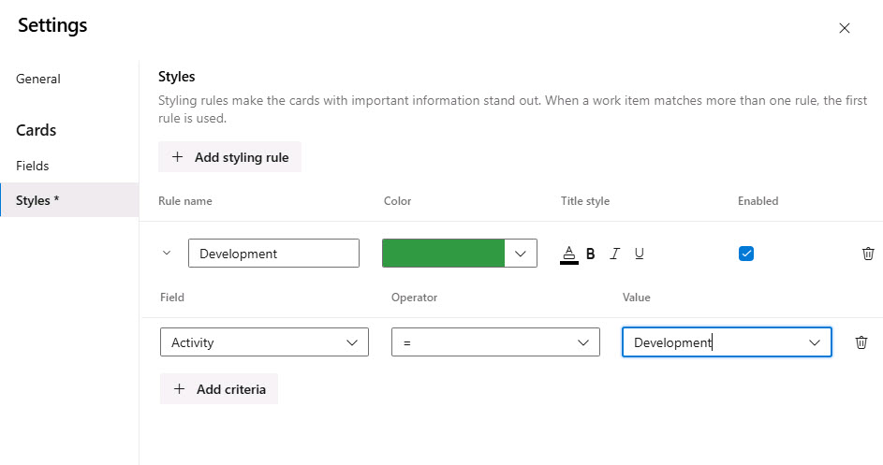

1. Click **Save** to save and close the settings.

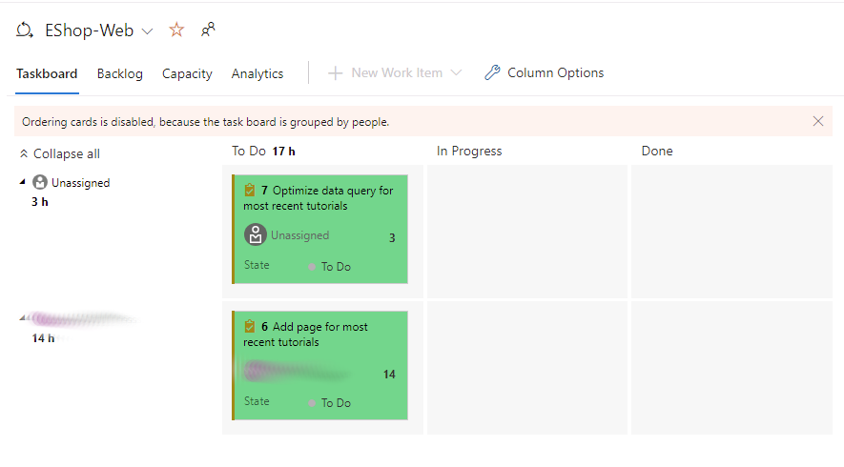

**Note**: This will set all cards assigned to **Development** activities green.

1. Go back to the **Settings** panel, select the **General** tab, and under the **Backlogs** section, view and configure the navigation levels.

**Note**: Epics are not included by default, but you could change that.

1. In the **Settings** panel, select the **General** tab, and under the **Working days** section specify the working days the team follows.

**Note**: This applies to capacity and burndown calculations.

1. In the **Settings** panel, select the **General** tab, and under the **Working with bugs** section you can specify how you manage bugs in backlogs and boards.

**Note**: Entries on this tab allow you to specify how bugs are presented on the board.

1. On the **Settings** panel, click **Save** to save and close the styling rule.

**Note**: The task associated with **Development** is now green and very easy to identify.

#### Task 4: Customize Kanban boards

In this task, you will step through the process of customizing Kanban boards.

To maximize a team's ability to consistently deliver high quality software, Kanban emphasizes two main practices. The first, visualizing the flow of work, requires that you map your team's workflow stages and configure a Kanban board to match. The second, constraining the amount of work in progress, requires that you set work-in-progress (WIP) limits. You're then ready to track progress on your Kanban board and monitor key metrics to reduce lead or cycle time. Your Kanban board turns your backlog into an interactive signboard, providing a visual flow of work. As work progresses from idea to completion, you update the items on the board. Each column represents a work stage, and each card represents a user story (blue cards) or a bug (red cards) at that stage of work. However, every team develops its own process over time, so the ability to customize the Kanban board to match the way your team works is critical for the successful delivery.

1. In the vertical navigational pane of the Azure DevOps portal, in the list of the **Boards** items, select **Boards**.
2. On the **Boards** panel, click the **Configure board settings** cogwheel icon (directly to the right of the funnel icon).

**Note**: The team is emphasizing work done with data, so there is special attention paid to any task associated with accessing or storing data.

1. On the **Settings** panel, select the **Tag colors** tab, click **+ Add tag color**, in the **Tag** textbox, type **data** and select the yellow rectangle.

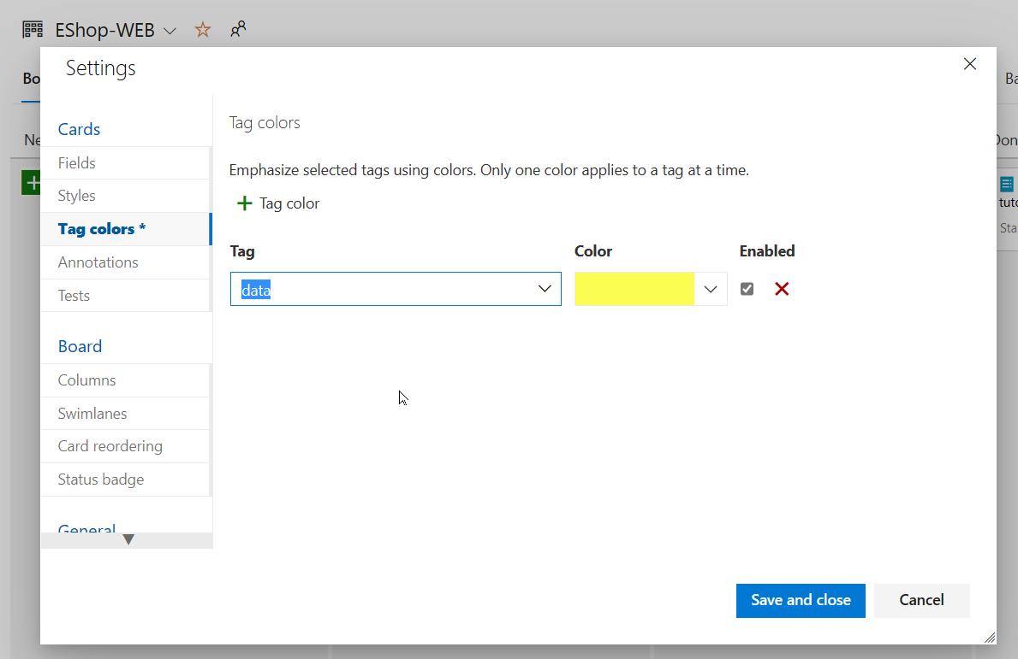

**Note**: Whenever a backlog item or bug is tagged with **data**, that tag will be highlighted.

1. Select the **Annotations** tab.

**Note**: You can specify which **Annotations** you would like included on cards to make them easier to read and navigate. When an annotation is enabled, the child work items of that type are easily accessible by clicking the visualization on each card.

1. Select the **Tests** tab.

**Note**: The **Tests** tab enables you to configure how tests appear and behave on the cards.

1. Click **Save** to save and close the settings.
2. From the **Board** tab of the **EShop-WEB** panel, open the Work Item representing the **As a customer, I want to view new tutorials** backlog item.
3. From the detailed item view, at the top of the panel, to the right of the **0 comments** entry, click **Add tag**.
4. In the resulting textbox, type **data** and press the **Enter** key.
5. Repeat the previous step to add the **ux** tag.
6. Save these edits by clicking **Save and Close**.

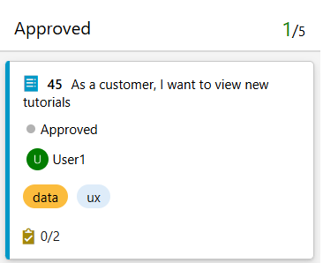

**Note**: The two tags are now visible on the card, with the **data** tag highlighted in yellow as configured.

1. On the **Boards** panel, click the **Configure board settings** cogwheel icon (directly to the right of the funnel icon).
2. On the **Settings** panel, select the **Columns** tab.

**Note**: This section allows you to add new stages to the workflow.

1. Click **+ Add column**, under the **Column name** label, in the **Name** textbox, type **QA Approved** and, in the **WIP limit** textbox, type **1**

**Note**: The Work in progress limit of 1 indicates that only one work item should be in this stage at a time. You would ordinarily set this higher, but there are only two work items to demonstrate the feature.

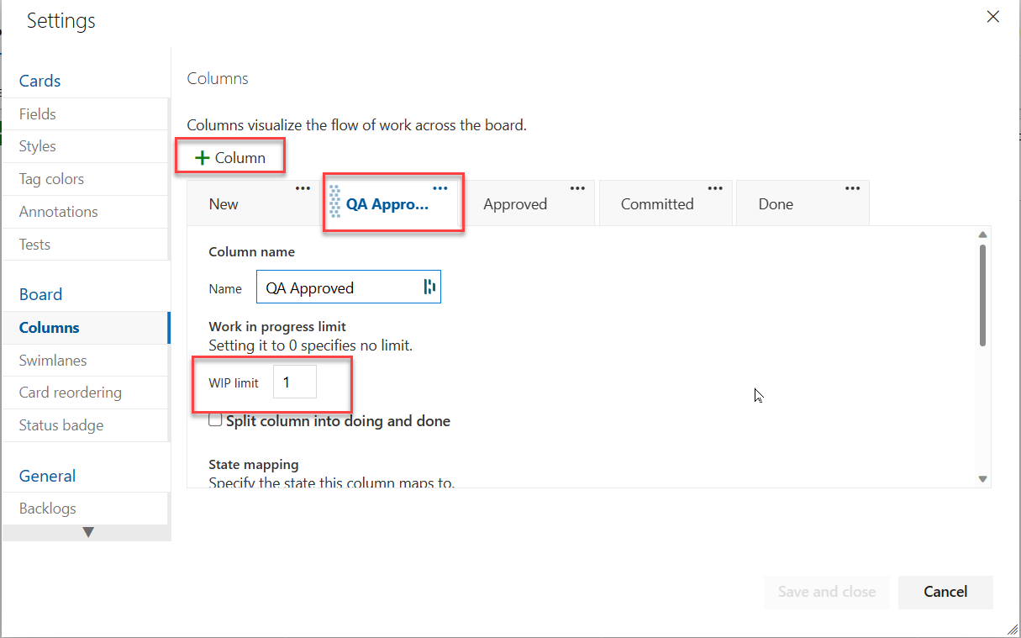

1. Notice the ellipsis next to the **QA Approved** column you created. Select **Move right** twice, so that the QA Approved column gets positioned in-between **Committed** and **Done**.
2. Click **Save** to save and close the settings.
3. On the **Boards portal**, the **QA Approved** column is now visible in the Kanban board view.
4. Drag the **As a customer, I want to see tutorials I recently viewed** work item from the **Committed** stage into the **QA Approved** stage.
5. Drag the **As a customer, I want to view new tutorials** work item from the **Approved** stage into the **QA Approved** stage.

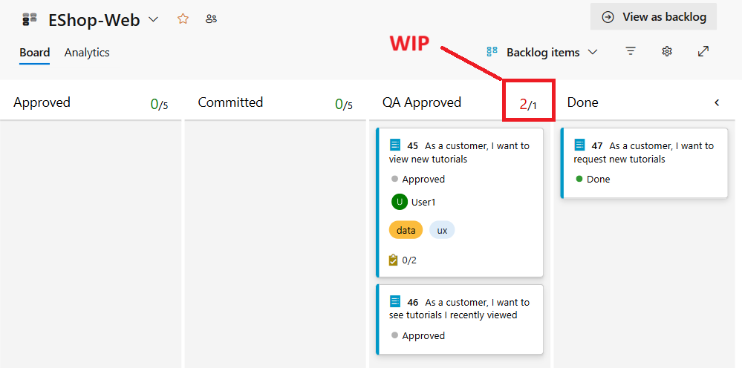

**Note**: The stage now exceeds its **WIP** limit and is colored red as a warning.

1. Move the **As a customer, I want to see tutorials I recently viewed** backlog item back to **Committed**.
2. On the **Boards** panel, click the **Configure board settings** cogwheel icon (directly to the right of the funnel icon).
3. On the **Settings** panel, return to the **Columns** tab and select the **QA Approved** tab.

**Note**: A lag often exists between when work gets moved into a column and when work starts. To counter that lag and reveal the actual state of work in progress, you can turn on split columns. When split, each column contains two sub-columns: **Doing** and **Done**. Split columns let your team implement a pull model. Without split columns, teams push work forward, to signal that they've completed their stage of work. However, pushing it to the next stage doesn't necessarily mean that a team member immediately starts work on that item.

1. On the **QA Approved** tab, enable the **Split column into doing and done** checkbox to create two separate columns.

**Note**: As your team updates the status of work as it progresses from one stage to the next, it helps that they agree on what **done** means. By specifying the **Definition of done** criteria for each Kanban column, you help share the essential tasks to complete before moving an item into a downstream stage.

1. On the **QA Approved** tab, at the bottom of the panel, in the **Definition of done** textbox, type **Passes **all** tests**.
2. Click **Save** to save and close the settings.

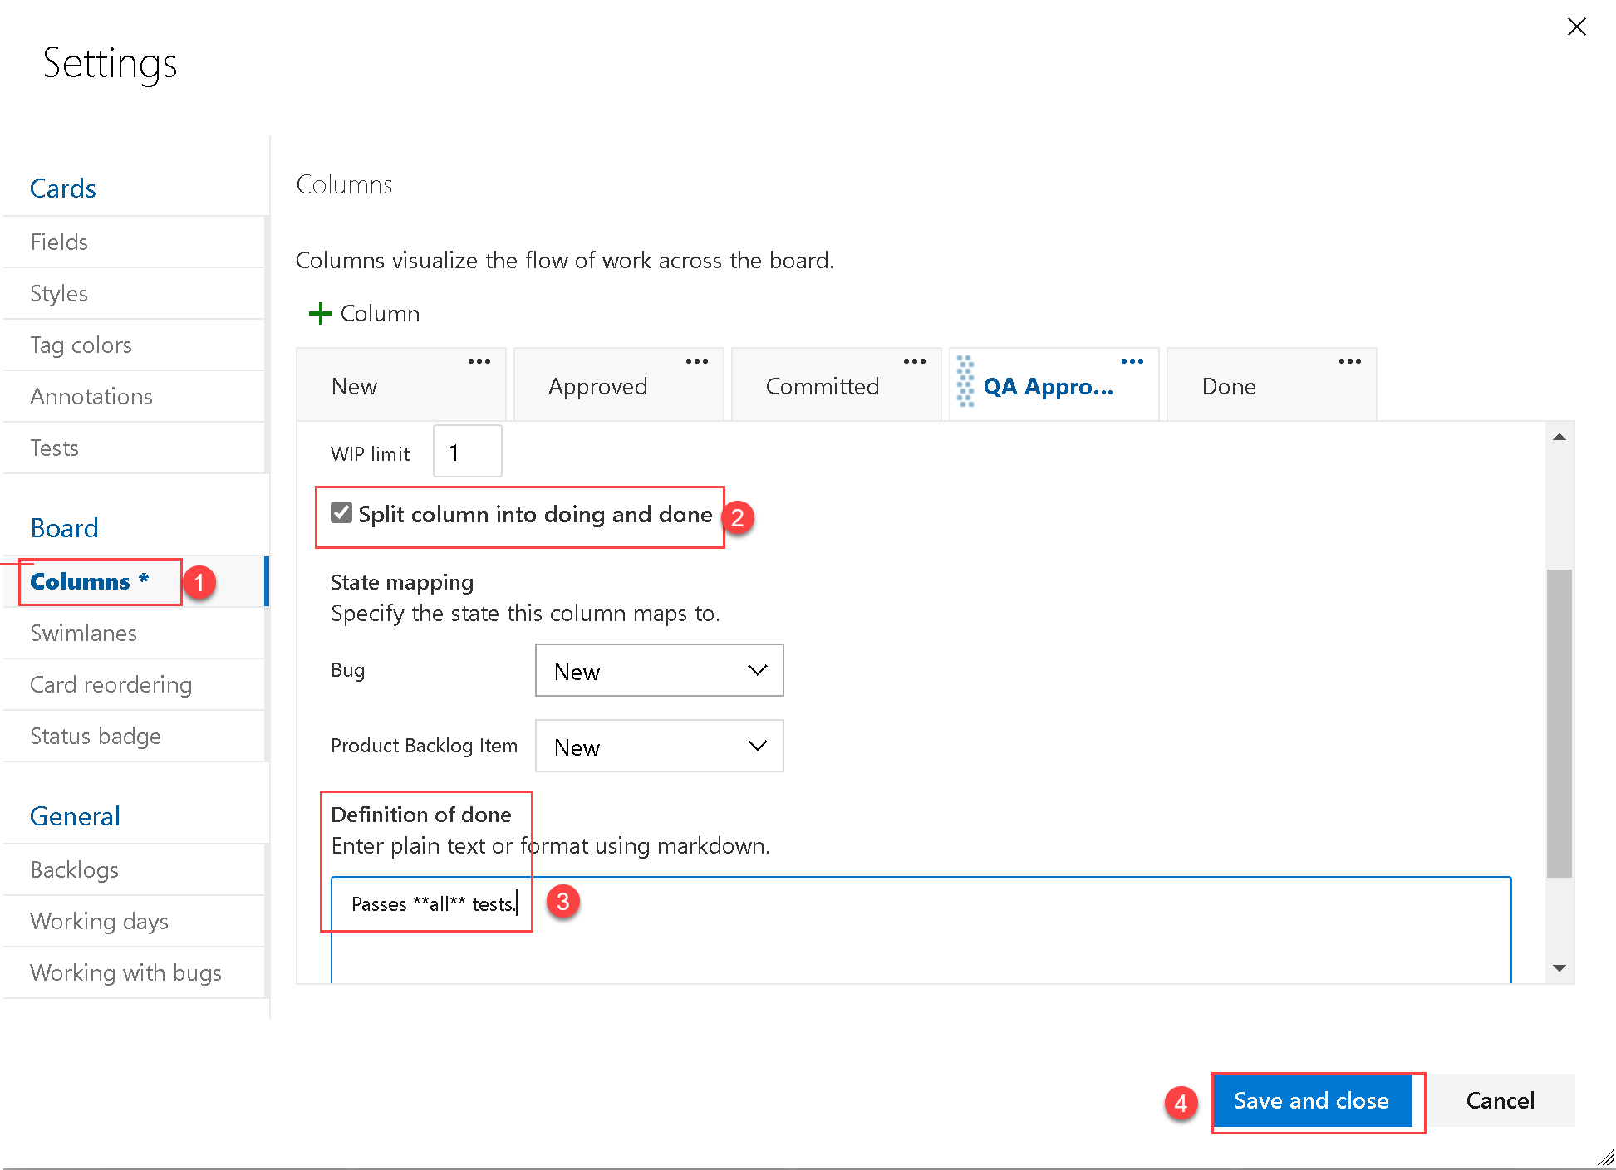

**Note**: The **QA Approved** stage now has **Doing** and **Done** columns. You can also click the informational symbol (with letter **i** in a circle) next to the column header to read the **Definition of done**. You may need to refresh the browser to see changes.

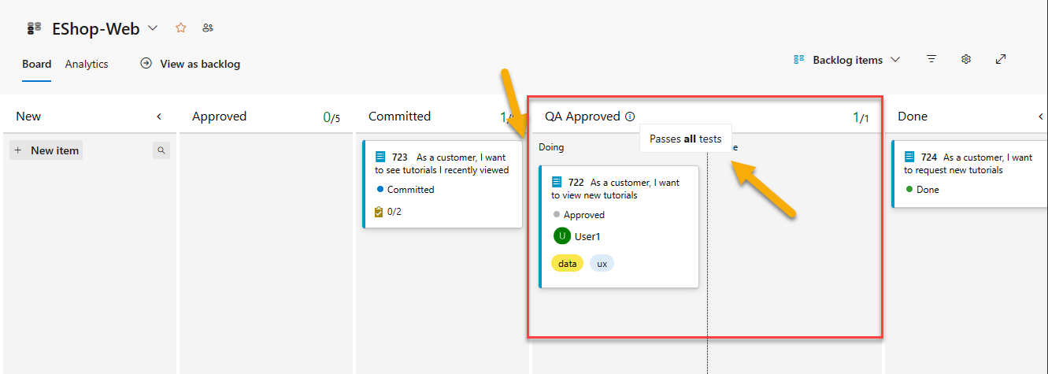

1. On the **Boards** panel, click the **Configure boards settings** cogwheel icon (directly to the right of the funnel icon).

**Note**: Your Kanban board supports your ability to visualize the flow of work as it moves from new to done. When you add **swimlanes**, you can also visualize the status of work that supports different service-level classes. You can create a swimlane to represent any other dimension that supports your tracking needs.

1. On the **Settings** panel, select the **Swimlanes** tab.
2. On the **Swimlanes** tab, click **+ Add swimlane**, directly under the **Swimlane name** label, in the **Name** textbox, type **Expedite**.
3. In the **Color** dropdown list, select the **Green** rectangle.
4. Click **Save** to save and close the settings.

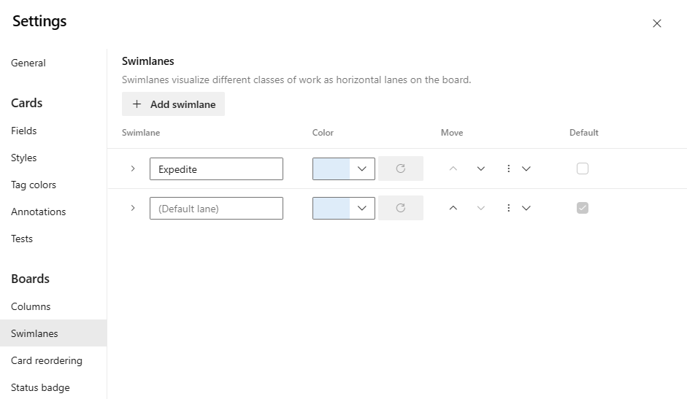

1. Back on the **Board** tab of the **Boards** panel, drag and drop the **Committed** work item onto the **QA Approved | Doing** stage of the **Expedite** swimlane so that it gets recognized as having priority when QA bandwidth becomes available.

**Note**: You may need to refresh the browser to make the swimlane visible.

In this exercise you learned how to use the Kanban board to visualize the flow of work in a way that is easy to understand and to track progress. You also learned how to configure the board to support your team's process and how to set the work in progress (WIP) limit to ensure that the team doesn't get overwhelmed with work.

### Exercise 2: Define dashboards

#### Task 1: Create and customize dashboards

In this task, you will step through the process of creating dashboards and their core components.

Dashboards allow teams to visualize status and monitor progress across the project. At a glance, you can make informed decisions without having to drill down into other parts of your team project site. The Overview page provides access to a default team dashboard which you can customize by adding, removing, or rearranging the tiles. Each tile corresponds to a widget that provides access to one or more features or functions.

1. In the vertical navigational pane of the Azure DevOps portal, select the **Overview** icon and, in the list of the **Overview** items, select **Dashboards**.
2. Select the **Overview** for the **eShopOnWeb Team** and review the existing dashboard.

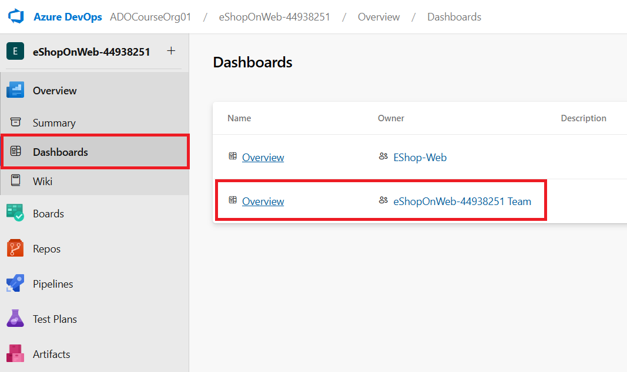

1. On the **Dashboards** pane, in the upper-right corner, select **+ New Dashboard**.
2. On the **Create a dashboard** pane, in the **Name** textbox, type **Product training**, in the **Team** dropdown list, select the **EShop-WEB** team, and click **Create**.

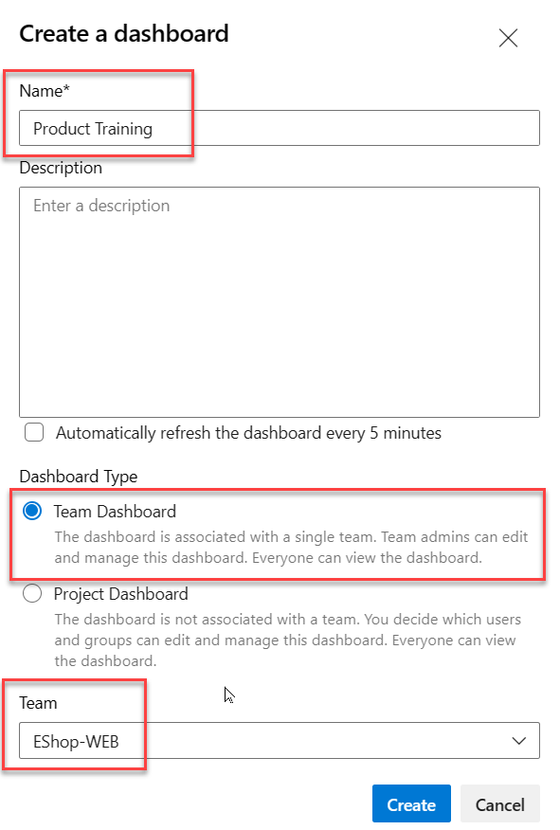

1. On the new dashboard pane, click **Add a widget**.
2. On the **Add Widget** panel, in the **Search widgets** textbox, type **sprint** to find existing widgets that focus on sprints. In the list of results, select **Sprint Overview** and click **Add**.
3. In the rectangle representing the newly added widget, click the **Settings** cogwheel icon and review the **Configuration** pane.

**Note**: The customization level will vary by widget.

1. On the **Configuration** pane, click **Close** without making any changes.
2. Back on the **Add Widget** pane, in the **Search** textbox, type **sprint** again to find existing widgets that focus on sprints. In the list of results, select **Sprint Capacity** and click **Add**.

**Note**: If the widget shows "Set capacity to use the sprint capacity widget", you can select the **Set capacity** link to set the capacity. Set the Activity to Development and the Capacity to 1. Click **Save** and back to the dashboard.

1. In the **Dashboard** view, at the top of the pane, click **Done Editing**.

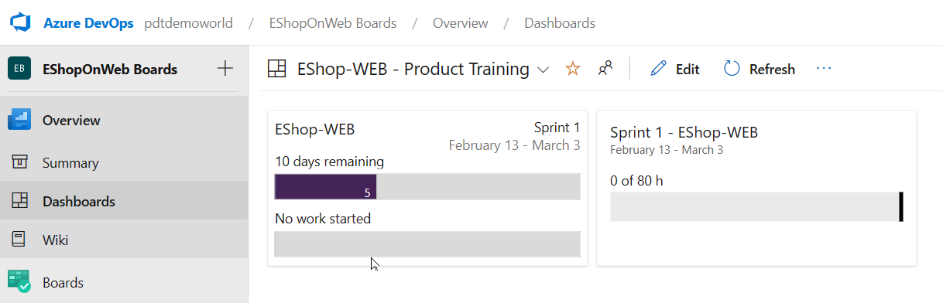

**Note**: You can now review two important aspects of your current sprint on your custom dashboard.

**Note**: Another way of customizing dashboards is to generate charts based on work item queries, which you can share to a dashboard.

1. In the vertical navigational pane of the Azure DevOps portal, select the **Boards** icon and, in the list of the **Boards** items, select **Queries**.
2. On the **Queries** pane, click **+ New query**.
3. On the **Editor** tab of **Queries > My Queries** pane, in the **Value** dropdown list of the **Work Item Type** row, select **Task**.
4. Click on **Add new clause**, and in the **Field** column, select **Area Path** and, in the corresponding **Value** dropdown list, select **eShopOnWeb\EShop-WEB**.
5. Click **Save**.

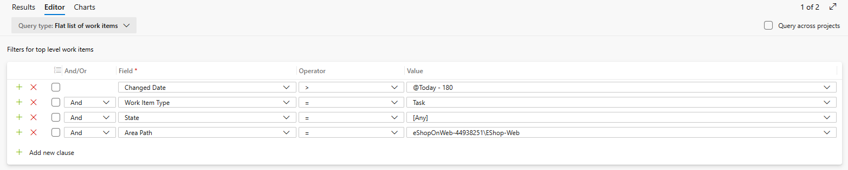

1. In the **Enter name** textbox, type **Web tasks**, in the **Folder** dropdown list, select **Shared Queries**, and click **OK**.
2. On the **Queries > Shared Queries** pane, click **Web tasks** to open the query.
3. Select the **Charts** tab and click **New chart**.
4. On the **Configure Chart** panel, in the **Name** textbox, type **Web tasks - By assignment**, in the **Group by** dropdown list, select **Assigned To**, and click **Save chart** to save the changes.

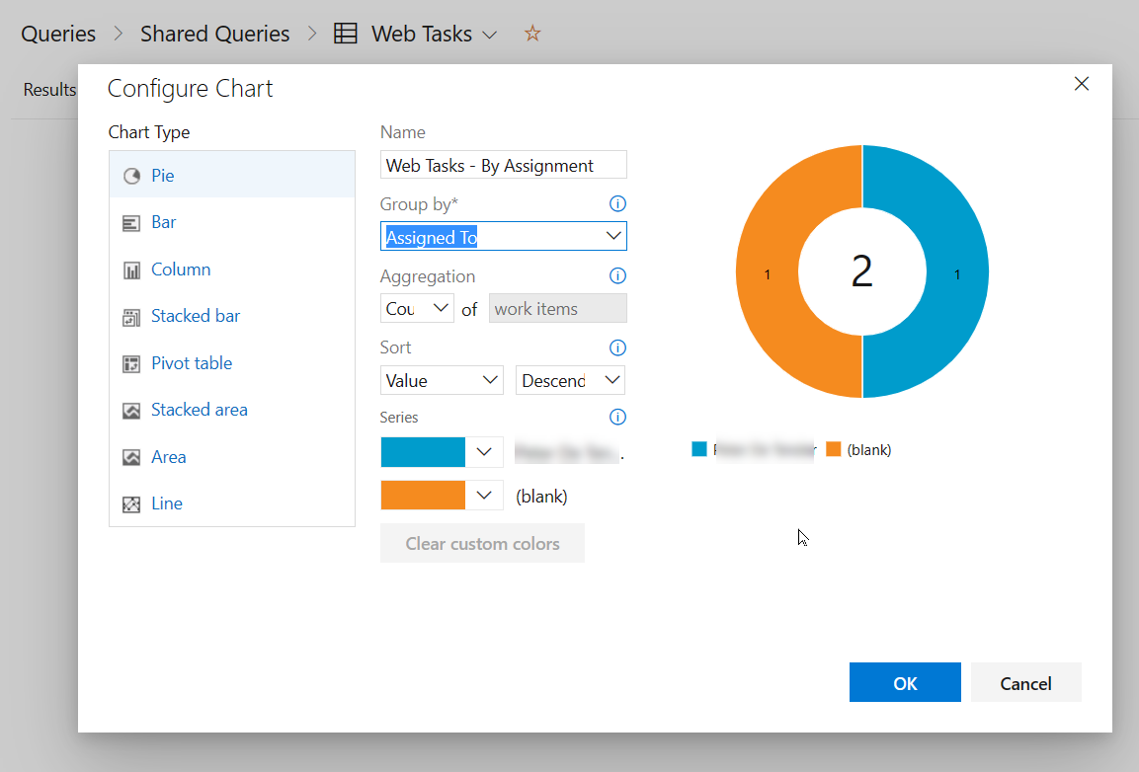

**Note**: You can now add this chart to a dashboard.

1. Return to the **Dashboards** section in the **Overview** Menu. From the **EShop-Web** section, select the **Product Training** dashboard you used earlier, to open it.
2. Click **Edit** from the top menu. From the **Add Widget** list, search for **Chart** , and select **Chart for Work Items**. Click **Add** to add this widget to the EShop-Web dashboard.
3. Click the **configure** (cogwheel) within the **Chart for Work Items** to open the widget settings.
4. Accept the title as is. Under **Query**, select **Shared Queries / Web Tasks**. Keep **Pie** for Chart Type. Under **Group By**, select **Assigned To**. Keep the Aggregation (Count) and Sort (Value / Ascending) defaults.
5. Confirm the configuration by clicking **Save**.
6. Notice the query results pie chart is shown on the dashboard. **Save** the changes by pressing the **Done Editing** button on top.

## Review

In this lab you used Azure Boards to perform a number of common agile planning and portfolio management tasks, including management of teams, areas, iterations, work items, sprints and capacity, customizing Kanban boards, and defining dashboards.

### Congratulations

You have successfully completed this lab. Click **End** to mark the lab as **Complete**.

1 Hr 58 Min Remaining

# Version Control with Git in Azure Repos

## Lab requirements

In this **Cloudslice** lab these Lab Requirements listed immediately below have already been completed for you.

* This lab requires **Microsoft Edge** or an [Azure DevOps supported browser.](https://docs.microsoft.com/azure/devops/server/compatibility)
* **Set up an Azure DevOps organization:** If you don't already have an Azure DevOps organization that you can use for this lab, create one by following the instructions available at [Create an organization or project collection](https://docs.microsoft.com/azure/devops/organizations/accounts/create-organization).
* If you don't have Git 2.47.0 or later installed yet, start a web browser, navigate to the [Git for Windows download page](https://gitforwindows.org/) download it, and install it.
* If you don't have Visual Studio Code installed yet, from the web browser window, navigate to the [Visual Studio Code download page](https://code.visualstudio.com/), download it, and install it.
* If you don't have Visual Studio C# extension installed yet, in the web browser window, navigate to the [C# extension installation page](https://marketplace.visualstudio.com/items?itemName=ms-dotnettools.csharp) and install it.

## Lab overview

Azure DevOps supports two types of version control, Git and Team Foundation Version Control (TFVC). Here's a quick overview of the two version control systems:

* **Team Foundation Version Control (TFVC)**: TFVC is a centralized version control system. Typically, team members have only one version of each file on their dev machines. Historical data is maintained only on the server. Branches are path-based and created on the server.
* **Git**: Git is a distributed version control system. Git repositories can live locally (on a developer's machine). Each developer has a copy of the source repository on their dev machine. Developers can commit each set of changes on their dev machine and perform version control operations such as history and compare without a network connection.

Git is the default version control provider for new projects. You should use Git for version control in your projects unless you need centralized version control features in TFVC.

In this lab, you'll learn to establish a local Git repository, which can easily be synchronized with a centralized Git repository in Azure DevOps. In addition, you'll learn about Git branching and merging support. You'll use Visual Studio Code, but the same processes apply to using any Git-compatible client.

## Objectives

After you complete this lab, you will be able to:

* Clone an existing repository.
* Save work with commits.
* Review history of changes.
* Work with branches by using Visual Studio Code.

## Estimated timing: 45 minutes

## Instructions

### Exercise 0: (skip if done) Configure the lab prerequisites

In this **Cloudslice** lab, please skip **Task 2**

In this exercise, you will set up the prerequisites for the lab, which consist of a new Azure DevOps project with a repository based on the [eShopOnWeb](https://github.com/MicrosoftLearning/eShopOnWeb).

#### Task 1: Configure Git and Visual Studio Code

In this task, you will install and configure Git and Visual Studio Code, including configuring the Git credential helper to securely store the Git credentials used to communicate with Azure DevOps. If you have already implemented these prerequisites, you can proceed directly to the next task.

1. On the lab computer, open **Visual Studio Code**.
2. In the Visual Studio Code interface, from the main menu, select **Terminal | New Terminal** to open the **TERMINAL** pane.
3. Make sure that the current Terminal is running **PowerShell** by checking if the drop-down list at the top right corner of the **TERMINAL** pane shows **1: powershell**

**Note**: To change the current Terminal shell to **PowerShell** click the drop-down list at the top right corner of the **TERMINAL** pane and click **Select Default Shell**. At the top of the Visual Studio Code window select your preferred terminal shell **Windows PowerShell** and click the plus sign on the right-hand side of the drop-down list to open a new terminal with the selected default shell.

1. In the **TERMINAL** pane, run the following command below to configure the credential helper.

gitTypeCopy

git config --global credential.helper wincred

1. In the **TERMINAL** pane, run the following commands to configure a user name and email for Git commits (replace the placeholders in braces with your preferred user name and email eliminating the < and > symbols):

gitTypeCopy

git config --global user.name "<John Doe>"  
git config --global user.email [<johndoe@example.com](mailto:<johndoe@example.com)>

#### Task 2: (skip if done) Create and configure the team project

In this task, you will create an **eShopOnWeb** Azure DevOps project to be used by several labs.

1. On your lab computer, in a browser window open your Azure DevOps organization. Click on **New Project**. Give your project the name **eShopOnWeb** and choose **Scrum** on the **Work Item process** dropdown. Click on **Create**.



#### Task 3: (skip if done) Import eShopOnWeb Git Repository

In this task you will import the eShopOnWeb Git repository that will be used by several labs.

1. On your lab computer, in a browser window open your Azure DevOps organization and the previously created **eShopOnWeb** project. Click on **Repos>Files** , **Import**. On the **Import a Git Repository** window, paste the following URL [https:*//github.com/MicrosoftLearning/eShopOnWeb.git*](https://github.com/MicrosoftLearning/eShopOnWeb.git) and click on **Import**:

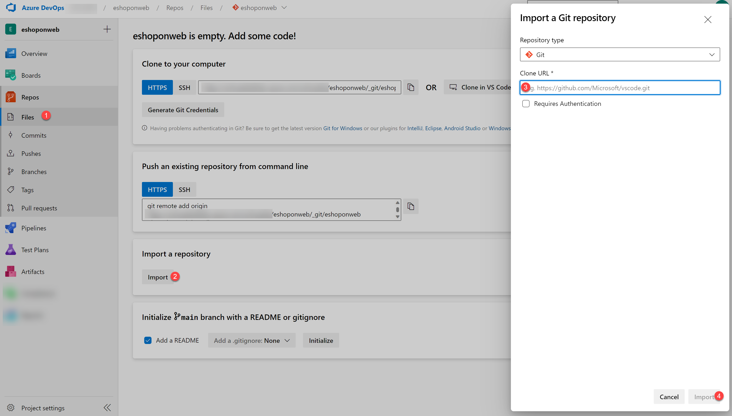

1. The repository is organized the following way:
   1. **.ado** folder contains Azure DevOps YAML pipelines
   2. **.devcontainer** folder container setup to develop using containers (either locally in VS Code or GitHub Codespaces)
   3. **infra** folder contains Bicep&ARM infrastructure as code templates used in some lab scenarios.
   4. **.github** folder container YAML GitHub workflow definitions.
   5. **src** folder contains the .NET 8 website used on the lab scenarios.

#### Task 4: (skip if done) Set main branch as default branch

1. Go to **Repos>Branches**.
2. Hover on the **main** branch then click the ellipsis on the right of the column.
3. Click on **Set as default branch**.

### Exercise 1: Clone an existing repository

In this exercise, you will use Visual Studio Code to commit changes to the **main** branch of the **eShopOnWeb** repository.

**Note**: The **main** branch is the default branch in the **eShopOnWeb** repository and is the branch that you will use for the rest of the lab.

#### Task 1: Clone an existing repository

In this task, you will step through the process of cloning a Git repository by using Visual Studio Code.

1. Switch to the the web browser displaying your Azure DevOps organization with the **eShopOnWeb** project you generated in the previous exercise.
2. In the vertical navigational pane of the Azure DevOps portal, select the **Repos** icon.
3. In the upper right corner of the **eShopOnWeb** repository pane, click **Clone**.

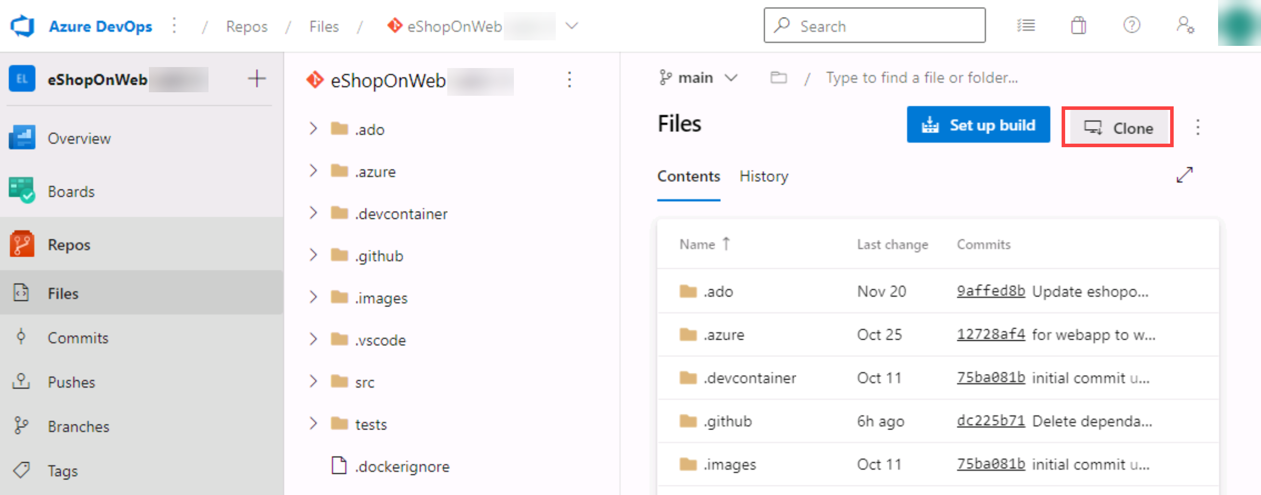

**Note**: Getting a local copy of a Git repo is called *cloning*. Every mainstream development tool supports this and will be able to connect to Azure Repos to pull down the latest source to work with.

1. On the **Clone Repository** panel, with the **HTTPS** Command line option selected, click the **Copy to clipboard** button next to the repo clone URL.

**Note**: You can use this URL with any Git-compatible tool to get a copy of the codebase.

1. Close the **Clone Repository** panel.
2. Switch to **Visual Studio Code** running on your lab computer.
3. Click the **View** menu header and, in the drop-down menu, click **Command Palette**.

**Note**: The Command Palette provides an easy and convenient way to access a wide variety of tasks, including those implemented as 3rd party extensions. You can use the keyboard shortcut **Ctrl+Shift+P** or **F1** to open it.

1. At the Command Palette prompt, run the **Git: Clone** command.

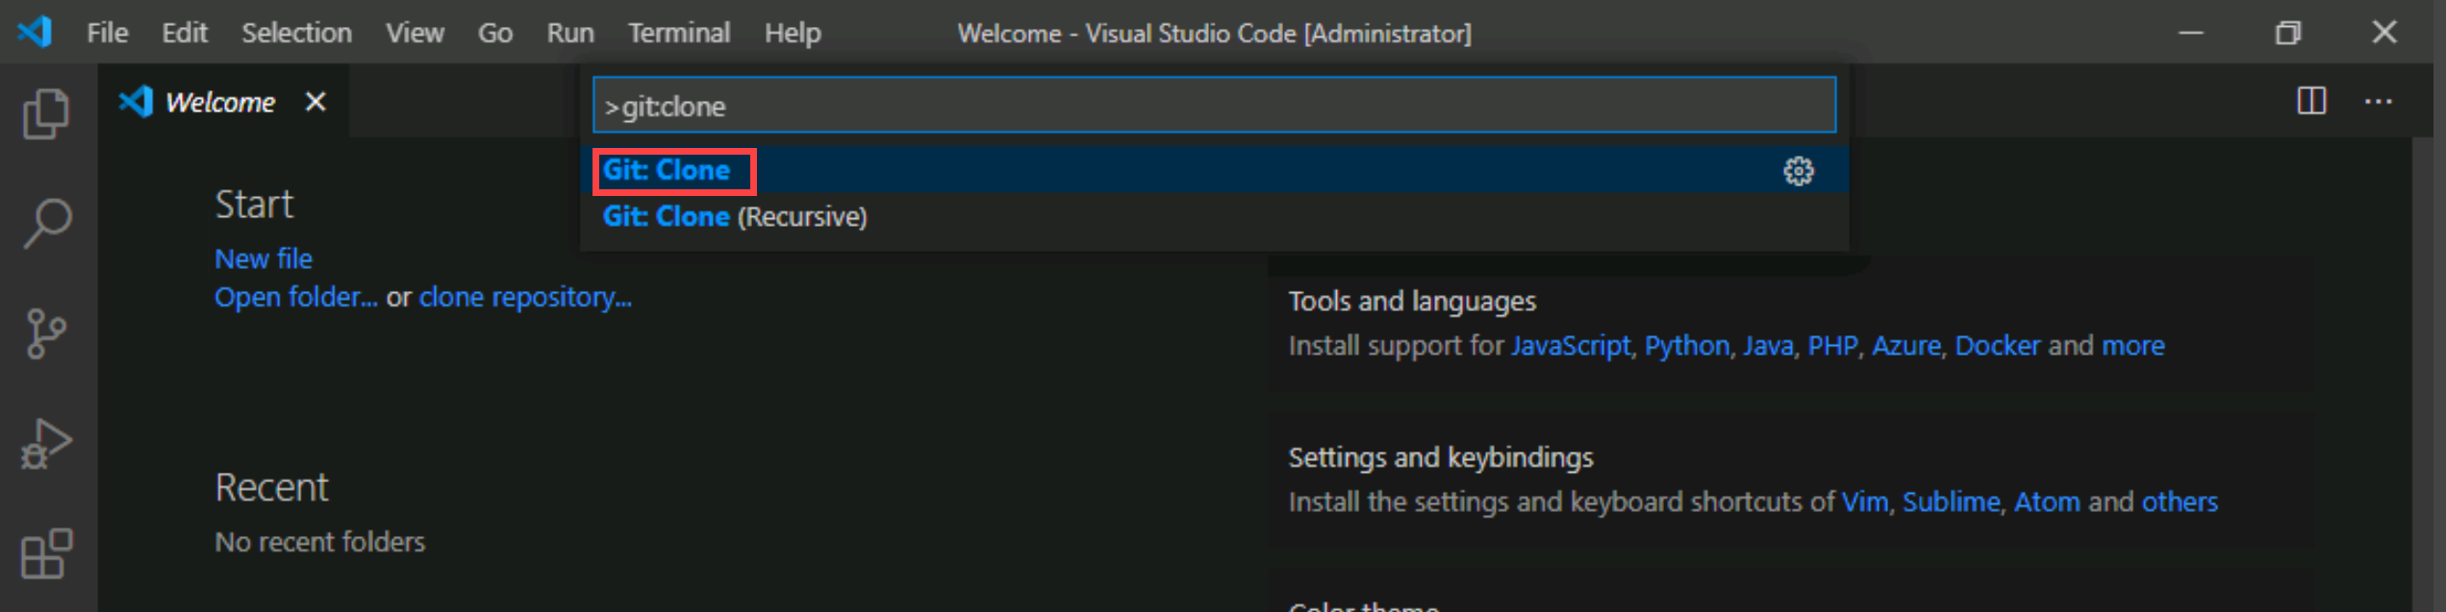

**Note**: To see all relevant commands, you can start by typing **Git**.

1. In the **Provide repository URL or pick a repository source** text box, paste the repo clone URL you copied earlier in this task and press the **Enter** key.
2. Within the **Select Folder** dialog box, navigate to the C: drive, create a new folder named **Git**, select it, and then click **Select as Repository Destination**.
3. When prompted, log in to your Azure DevOps account.
4. After the cloning process completes, once prompted, in the Visual Studio Code, click **Open** to open the cloned repository.

**Note**: You can ignore warnings you might receive regarding problems with loading of the project. The solution may not be in the state suitable for a build, but we're going to focus on working with Git, so building the project is not required.

### Exercise 2: Save work with commits

In this exercise, you will step through several scenarios that involve the use of Visual Studio Code to stage and commit changes.

When you make changes to your files, Git will record the changes in the local repository. You can select the changes that you want to commit by staging them. Commits are always made against your local Git repository, so you don't have to worry about the commit being perfect or ready to share with others. You can make more commits as you continue to work and push the changes to others when they are ready to be shared.

Git commits consists of the following:

* The file(s) changed in the commit. Git keeps the contents of all file changes in your repo in the commits. This keeps it fast and allows intelligent merging.
* A reference to the parent commit(s). Git manages your code history using these references.
* A message describing a commit. You give this message to Git when you create the commit. It's a good idea to keep this message descriptive, but to the point.

#### Task 1: Commit changes

In this task, you will use Visual Studio Code to commit changes.

1. In the Visual Studio Code window, at the top of the vertical toolbar, select the **EXPLORER** tab, navigate to the **/eShopOnWeb/src/Web/Program.cs** file and select it. This will automatically display its content in the details pane.
2. On the first line add the following comment:

csharpTypeCopy

*// My first change*

**Note**: It doesn't really matter what the comment is since the goal is just to make a change.

1. Press **Ctrl+S** to save the change.
2. In the Visual Studio Code window, select the **SOURCE CONTROL** tab to verify that Git recognized the latest change to the file residing in the local clone of the Git repository.
3. With the **SOURCE CONTROL** tab selected, at the top of the pane, in the textbox, type **My commit** as the commit message and press **Ctrl+Enter** to commit it locally.

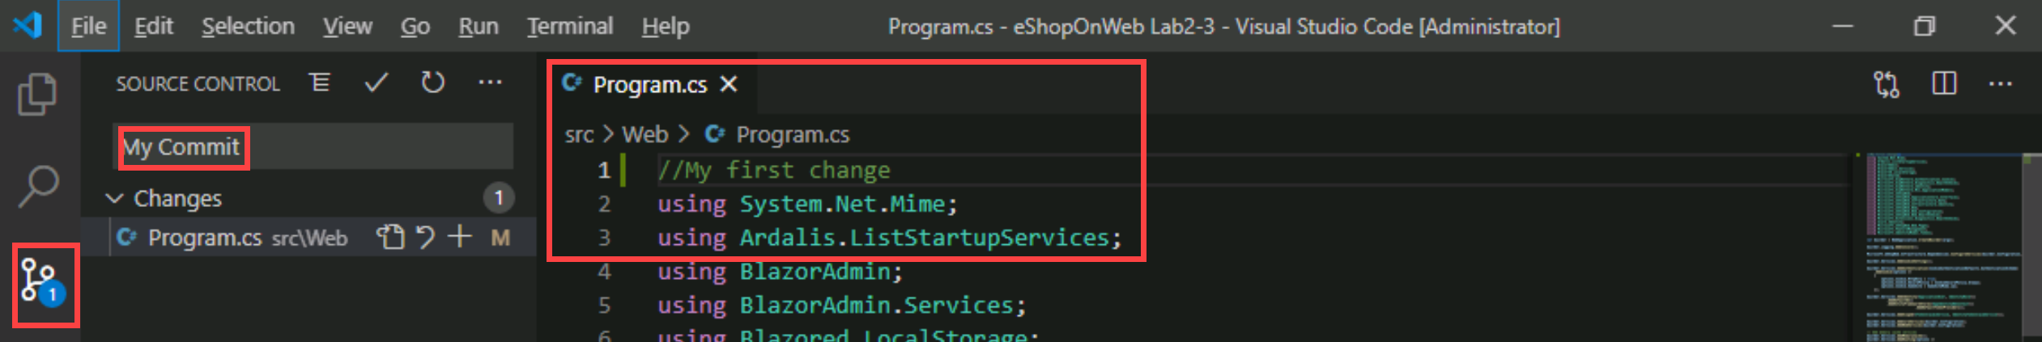

1. If prompted whether you would like to automatically stage your changes and commit them directly, click **Always**.

**Note**: We will discuss **staging** later in the lab.

1. In the lower left corner of the Visual Studio Code window, to the right of the **main** label, note the **Synchronize Changes** icon of a circle with two vertical arrows pointing in the opposite directions and the number **1** next to the arrow pointing up. Click the icon and, if prompted, whether to proceed, click **OK** to push and pull commits to and from **origin/main**.

#### Task 2: Review commits

In this task, you will use the Azure DevOps portal to review commits.

1. Switch to the web browser window displaying the Azure DevOps interface.
2. In the vertical navigational pane of the Azure DevOps portal, in the **Repos** section, select **Commits**.
3. Verify that your commit appears at the top of list.

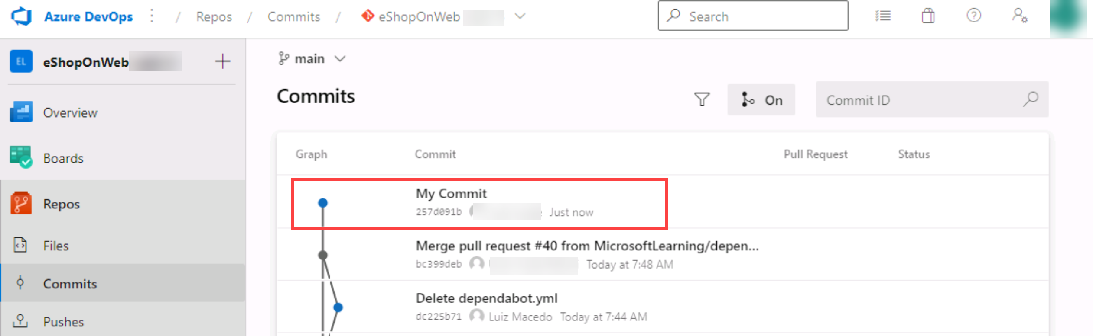

#### Task 3: Stage changes

In this task, you will explore the use of staging changes by using Visual Studio Code. Staging changes allows you to selectively add certain files to a commit while passing over the changes made in other files.

1. Switch back to the **Visual Studio Code** window.
2. Update the open **Program.cs** class by changing the first comment with the following, and saving the file.

csharpTypeCopy

*//My second change*

1. In the Visual Studio Code window, switch back the **EXPLORER** tab, navigate to the **/eShopOnWeb/src/Web/Constants.cs** file and select it. This will automatically display its content in the details pane.
2. Add to the **Constants.cs** file a comment on the first line and save the file.

csharpTypeCopy

*// My third change*

1. In the Visual Studio Code window, switch to the **SOURCE CONTROL** tab, hover the mouse pointer over the **Program.cs** entry, and click the plus sign on the right side of that entry.

**Note**: This stages the change to the **Program.cs** file only, preparing it for commit without **Constants.cs**.

1. With the **SOURCE CONTROL** tab selected, at the top of the pane, in the textbox, type **Added comments** as the commit message.

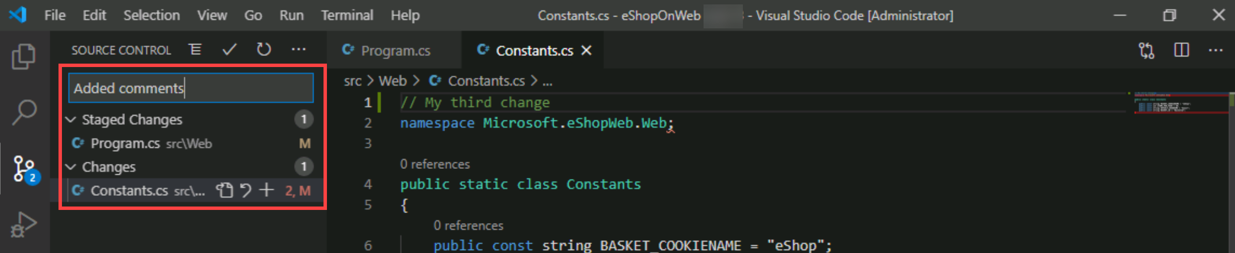

1. At the top of the **SOURCE CONTROL** tab, click the ellipsis symbol, in the drop-down menu, select **Commit** and, in the cascading menu, select **Commit Staged**.
2. In the lower left corner of the Visual Studio Code window, click the **Synchronize Changes** button to synchronize the committed changes with the server and, if prompted, whether to proceed, click **OK** to push and pull commits to and from **origin/main**.

**Note**: Note that since only the staged change was committed, the other change is still pending to be synchronized.

### Exercise 3: Review history

In this exercise, you will use the Azure DevOps portal to review history of commits.

Git uses the parent reference information stored in each commit to manage a full history of your development. You can easily review this commit history to find out when file changes were made and determine differences between versions of your code using the terminal or from one of the many available Visual Studio Code extensions. You can also review changes by using the Azure DevOps portal.

Git's use of the **Branches and Merges** feature works through pull requests, so the commit history of your development doesn't necessarily form a straight, chronological line. When you use history to compare versions, think in terms of file changes between two commits instead of file changes between two points in time. A recent change to a file in the main branch may have come from a commit created two weeks ago in a feature branch that was merged yesterday.

#### Task 1: Compare files

In this task, you will step through commit history by using the Azure DevOps portal.

1. With the **SOURCE CONTROL** tab of the Visual Studio Code window open, select **Constants.cs** representing the non-staged version of the file.

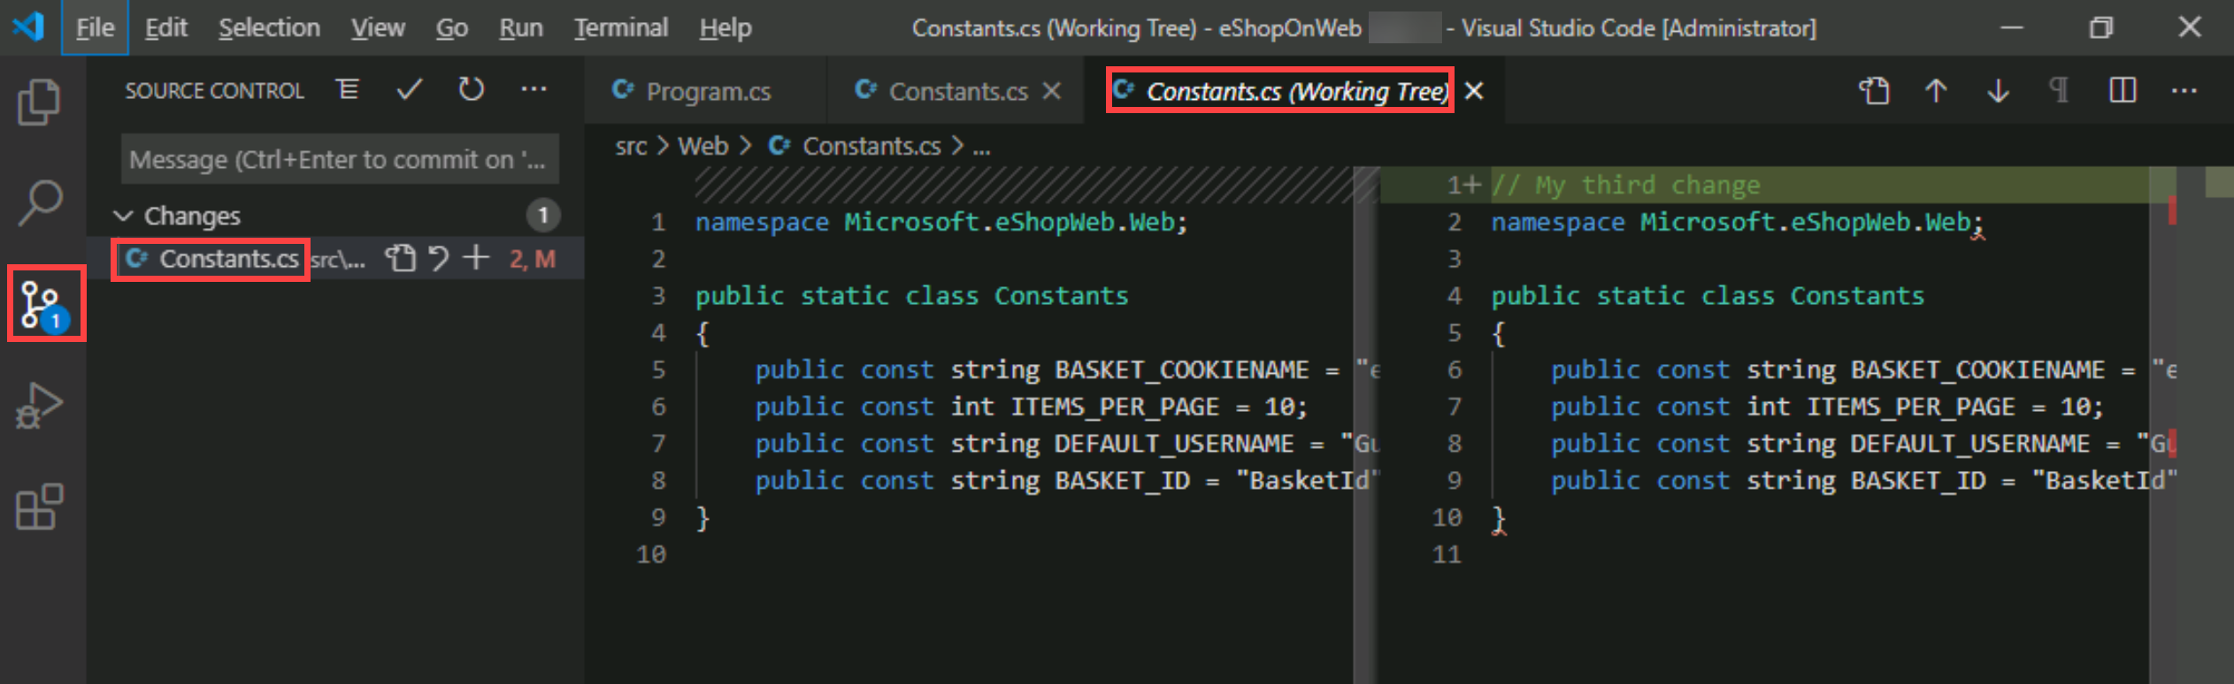

**Note**: A comparison view is opened to enable you to easily locate the changes you've made. In this case, it's just the one comment.

1. Switch to the web browser window displaying the **Commits** pane of the **Azure DevOps** portal to review the source branches and merges. These provide a convenient way to visualize when and how changes were made to the source.
2. Scroll down to the **My commit** entry (pushed before) and hover the mouse pointer over it to reveal the ellipsis symbol on the right side.
3. Click the ellipsis, in the dropdown menu, select **Browse Files**, and review the results.

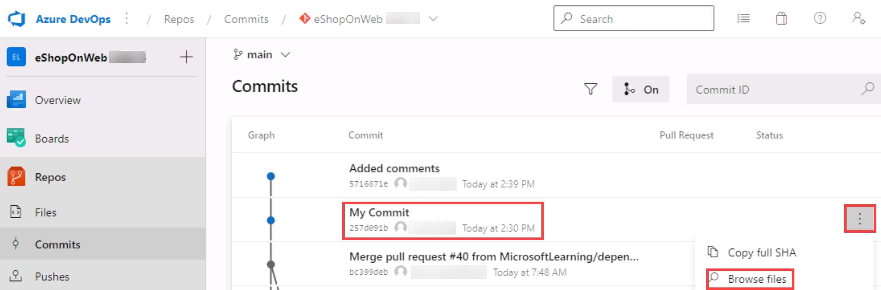

**Note**: This view represents the state of the source corresponding to the commit, allowing you to review and download each of source files.

### Exercise 4: Work with branches

In this exercise, you will step through scenarios that involve branch management by using Visual Studio Code and the Azure DevOps portal.

You can manage in your Azure DevOps Git repo from the **Branches** view of **Azure Repos** in the Azure DevOps portal. You can also customize the view to track the branches you care most about so you can stay on top of changes made by your team.

Committing changes to a branch will not affect other branches and you can share branches with others without having to merge the changes into the main project. You can also create new branches to isolate changes for a feature or a bug fix from your main branch and other work. Since the branches are lightweight, switching between branches is quick and easy. Git does not create multiple copies of your source when working with branches, but rather uses the history information stored in commits to recreate the files on a branch when you start working on it. Your Git workflow should create and use branches for managing features and bugfixes. The rest of the Git workflow, such as sharing code and reviewing code with pull requests, all work through branches. Isolating work in branches makes it very simple to change what you are working on by simply changing your current branch.

#### Task 1: Create a new branch in your local repository

In this task, you will create a branch by using Visual Studio Code.

1. Switch to **Visual Studio Code** running on your lab computer.
2. With the **SOURCE CONTROL** tab selected, in the lower left corner of the Visual Studio Code window, click **main**.
3. In the pop-up window, select **+ Create new branch from…**.

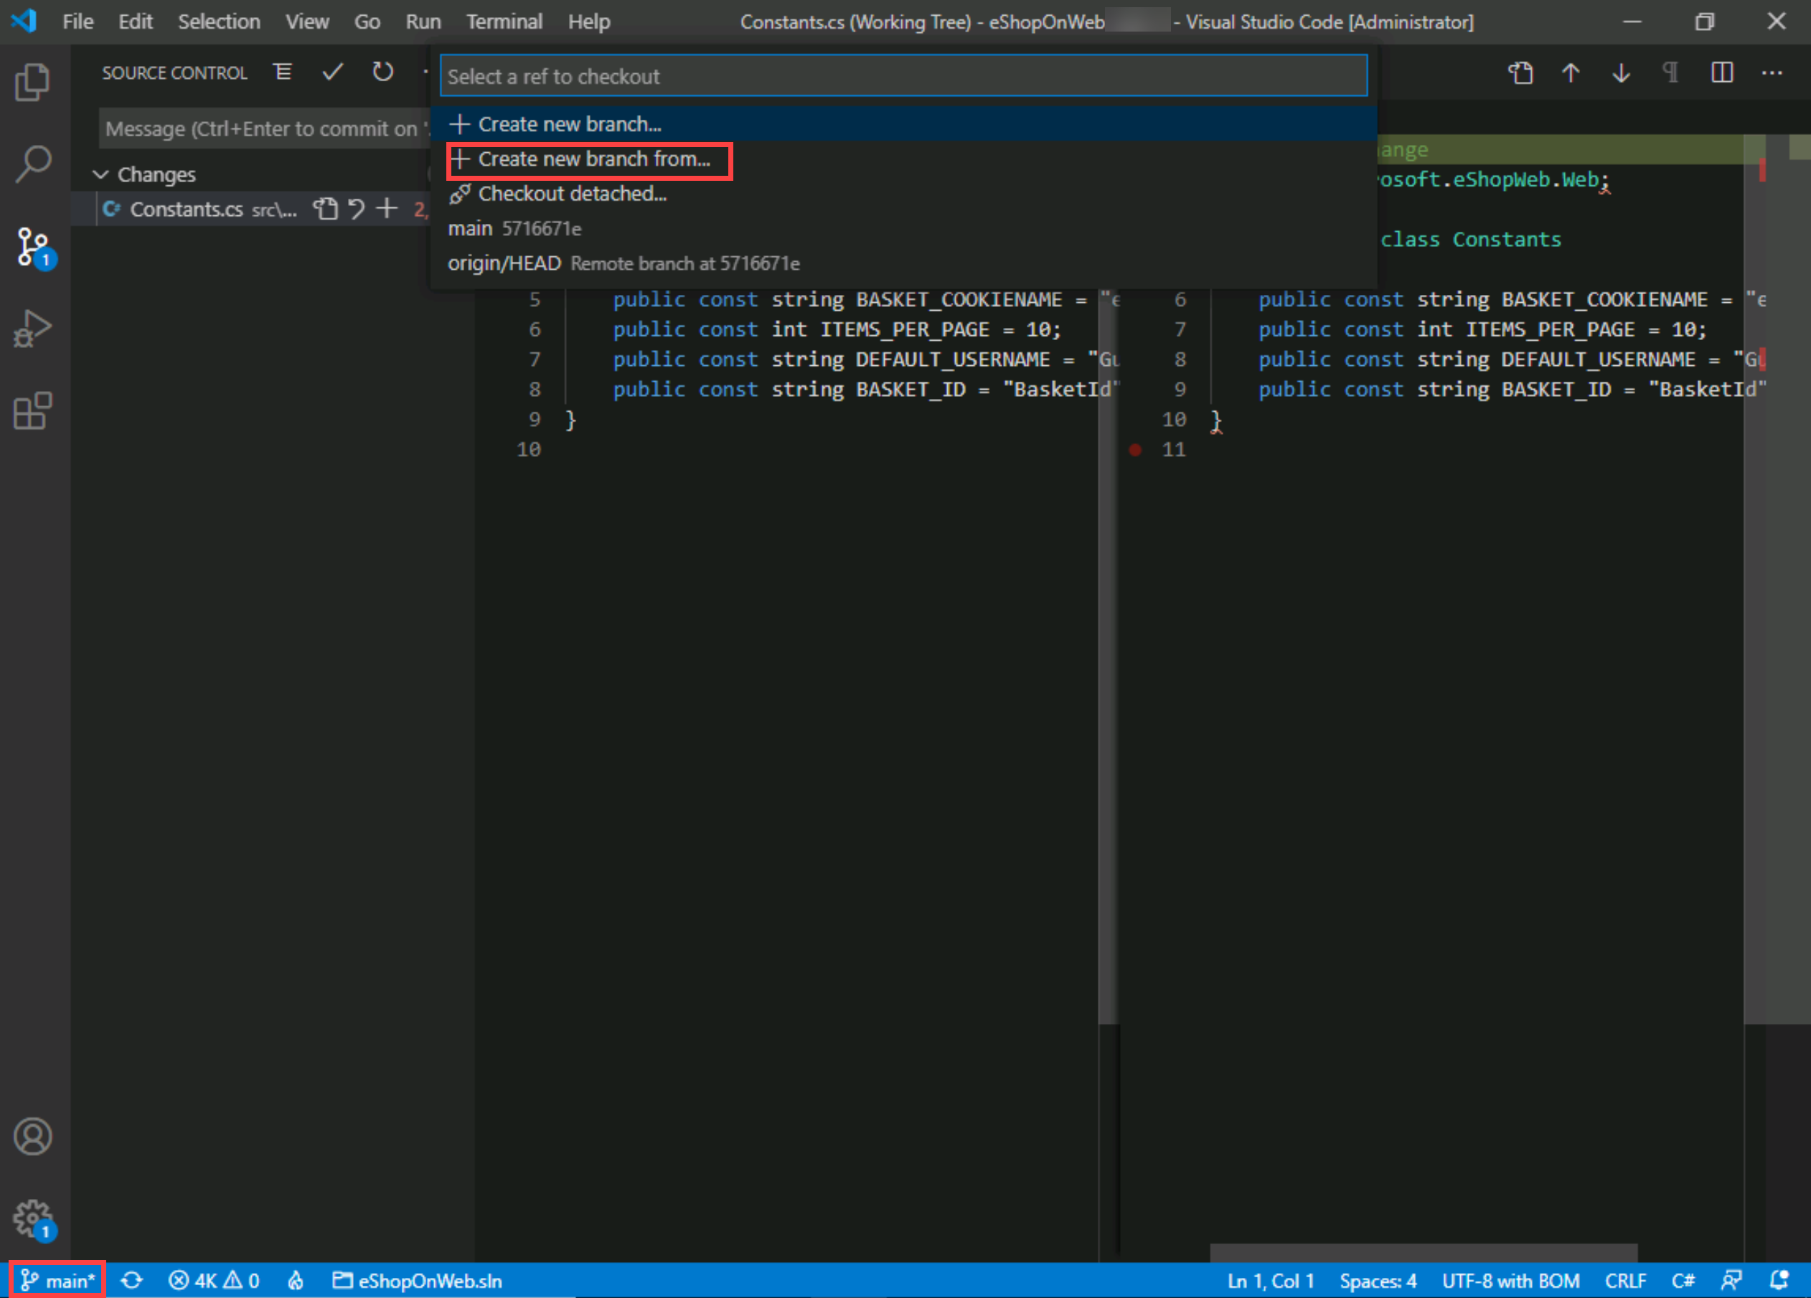

1. In the **Select a ref to create the branch from** textbox, select **main** as the reference branch.
2. In the **Branch name** textbox, type **dev** to specify the new branch and press **Enter**.

**Note**: At this point, you are automatically switched to the **dev** branch.

#### Task 2: Delete a branch

In this task, you will use the Visual Studio Code to work with a branch created in the previous task.

Git keeps track of which branch you are working on and makes sure that, when you check out a branch, your files match the most recent commit on that branch. Branches let you work with multiple versions of the source code in the same local Git repository at the same time. You can use Visual Studio Code to publish, check out and delete branches.

1. In the **Visual Studio Code** window, with the **SOURCE CONTROL** tab selected, in the lower left corner of the Visual Studio Code window, click the **Publish changes** icon (directly to the right of the **dev** label representing your newly created branch).
2. Switch to the web browser window displaying the **Commits** pane of the **Azure DevOps** portal and select **Branches**.
3. On the **Mine** tab of the **Branches** pane, verify that the list of branches includes **dev**.
4. Hover the mouse pointer over the **dev** branch entry to reveal the ellipsis symbol on the right side.
5. Click the ellipsis, in the pop-up menu, select **Delete branch**, and, when prompted for confirmation, click **Delete**.

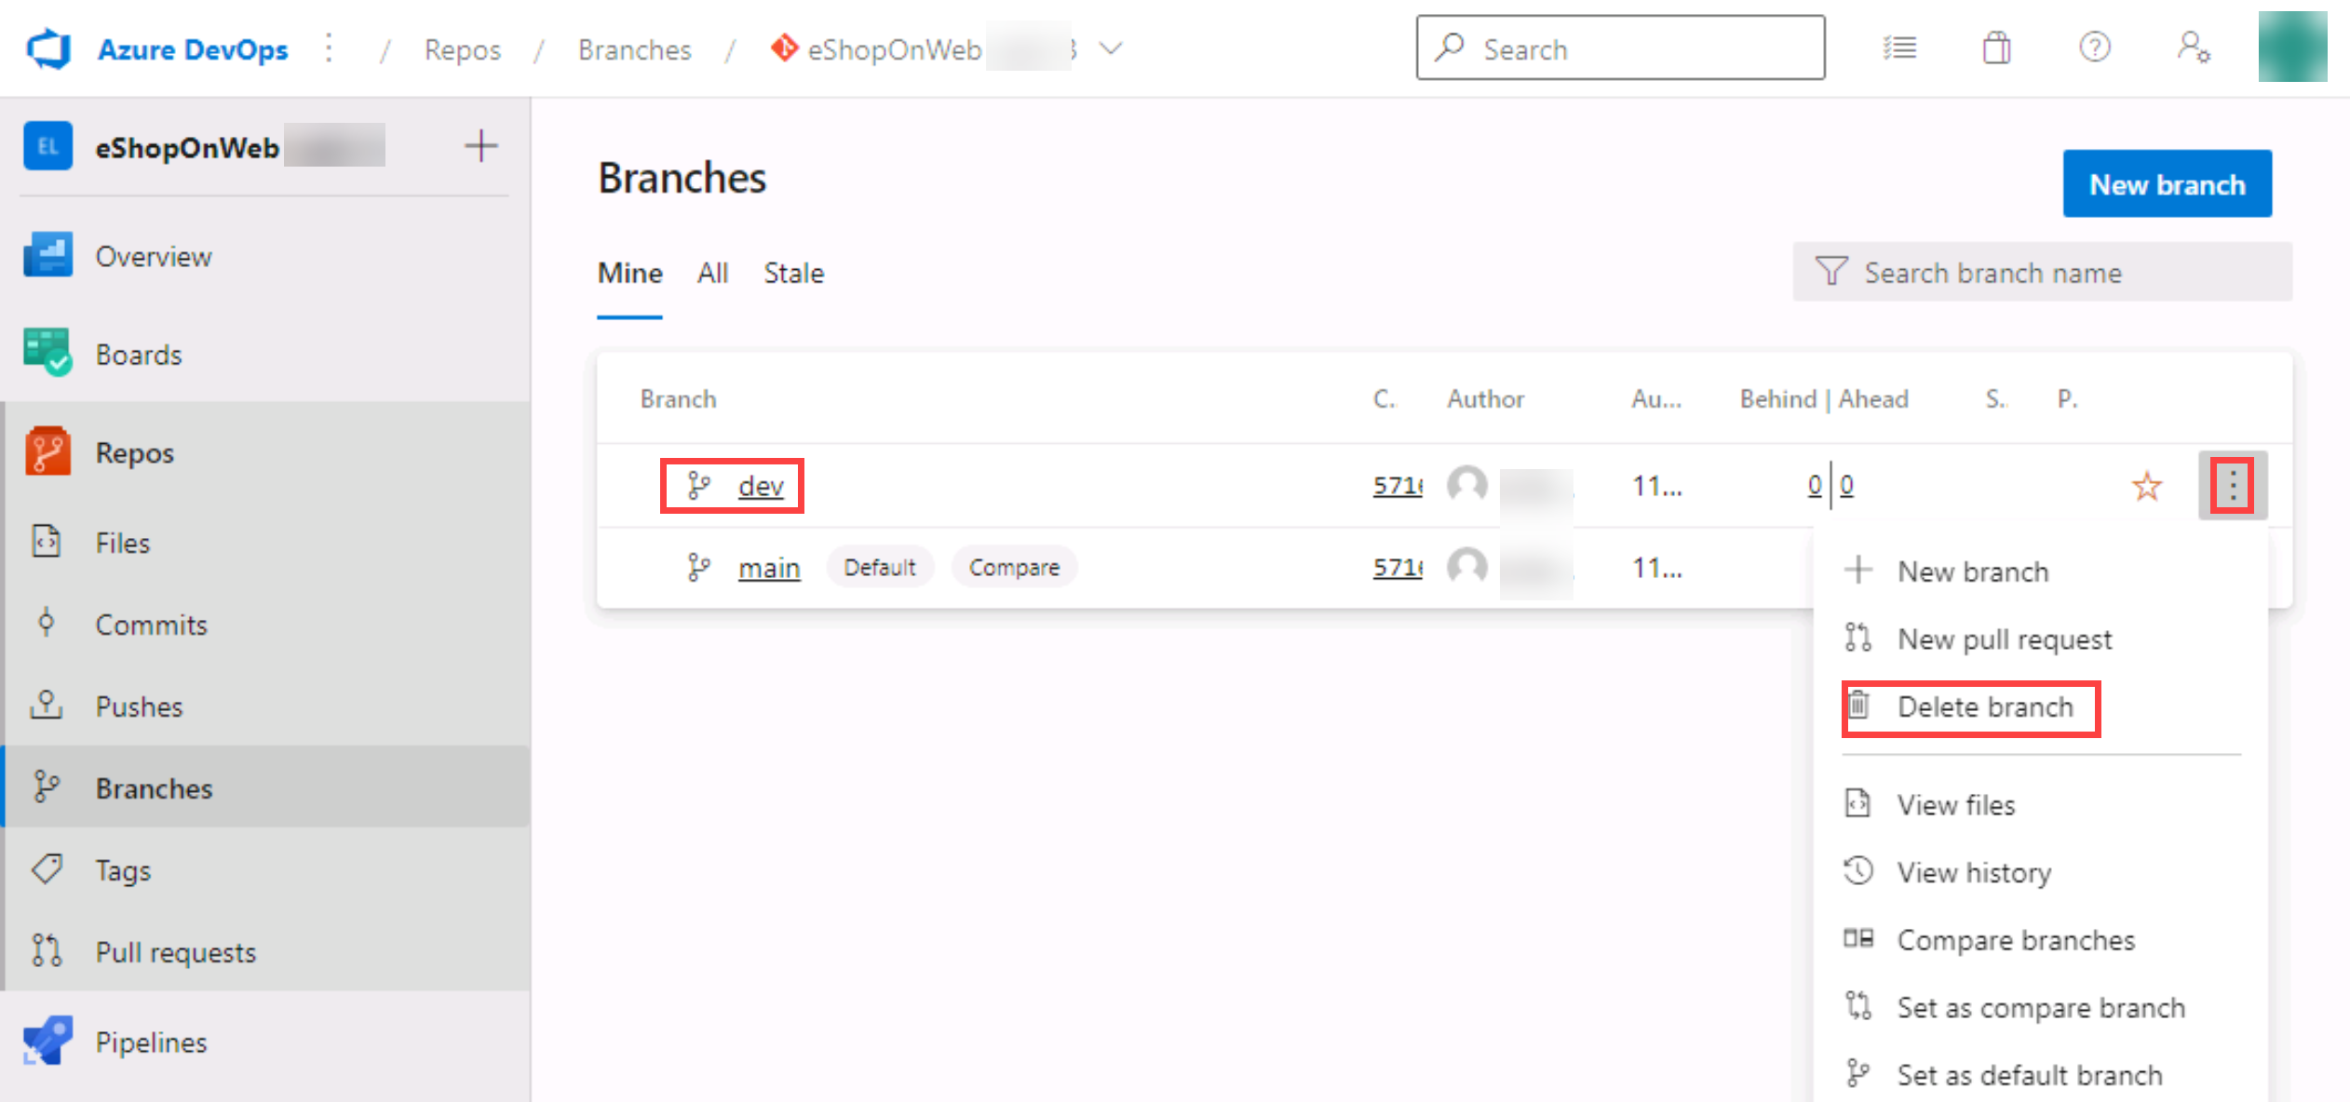

1. Switch back to the **Visual Studio Code** window and, with the **SOURCE CONTROL** tab selected, in the lower left corner of the Visual Studio Code window, click the **dev** entry. This will display the existing branches in the upper portion of the Visual Studio Code window.
2. Verify that now there are two **dev** branches listed.
3. Go to the web browser displaying the **Mine** tab of the **Branches**
4. On the **Mine** tab of the **Branches** pane, select the **All** tab.
5. On the **All** tab of the **Branches** pane, in the **Search branch name** text box, type **dev**.
6. Review the **Deleted branches** section containing the entry representing the newly deleted branch.
7. In the **Deleted branches** section, hover the mouse pointer over the **dev** branch entry to reveal the ellipsis symbol on the right side.
8. Click the ellipsis, in the pop-up menu and select **Restore branch**.

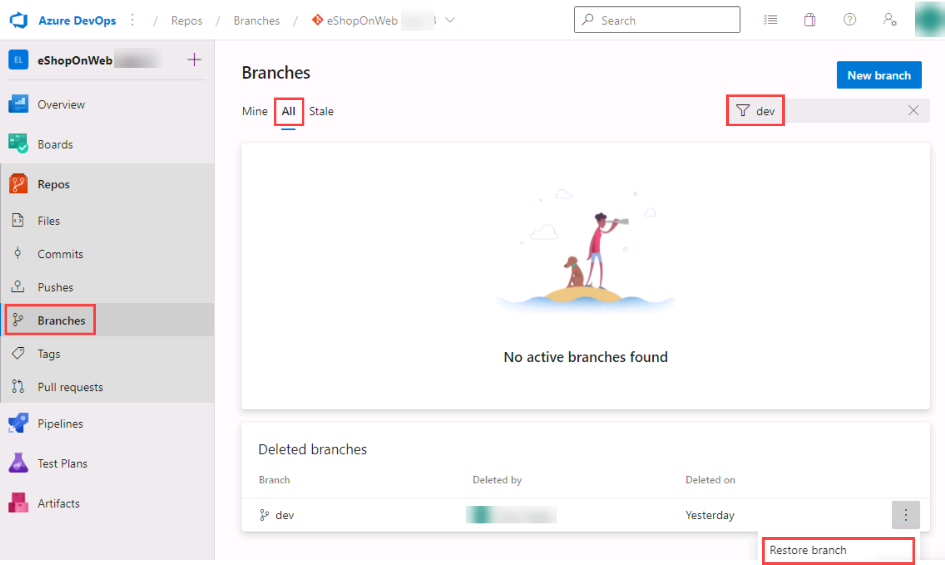

**Note**: You can use this functionality to restore a deleted branch as long as you know its exact name.

#### Task 3: Branch Policies

In this task, you will use the Azure DevOps portal to add policies to the main branch and only allow changes using Pull Requests that comply with the defined policies. You want to ensure that changes in a branch are reviewed before they are merged.

For simplicity we will work directly on the web browser repo editor (working directly in origin), instead of using the local clone in VS code (recommended for real scenarios).

1. Switch to the web browser displaying the **Mine** tab of the **Branches** pane in the Azure DevOps portal.
2. On the **Mine** tab of the **Branches** pane, hover the mouse pointer over the **main** branch entry to reveal the ellipsis symbol on the right side.
3. Click the ellipsis and, in the pop-up menu, select **Branch Policies**.

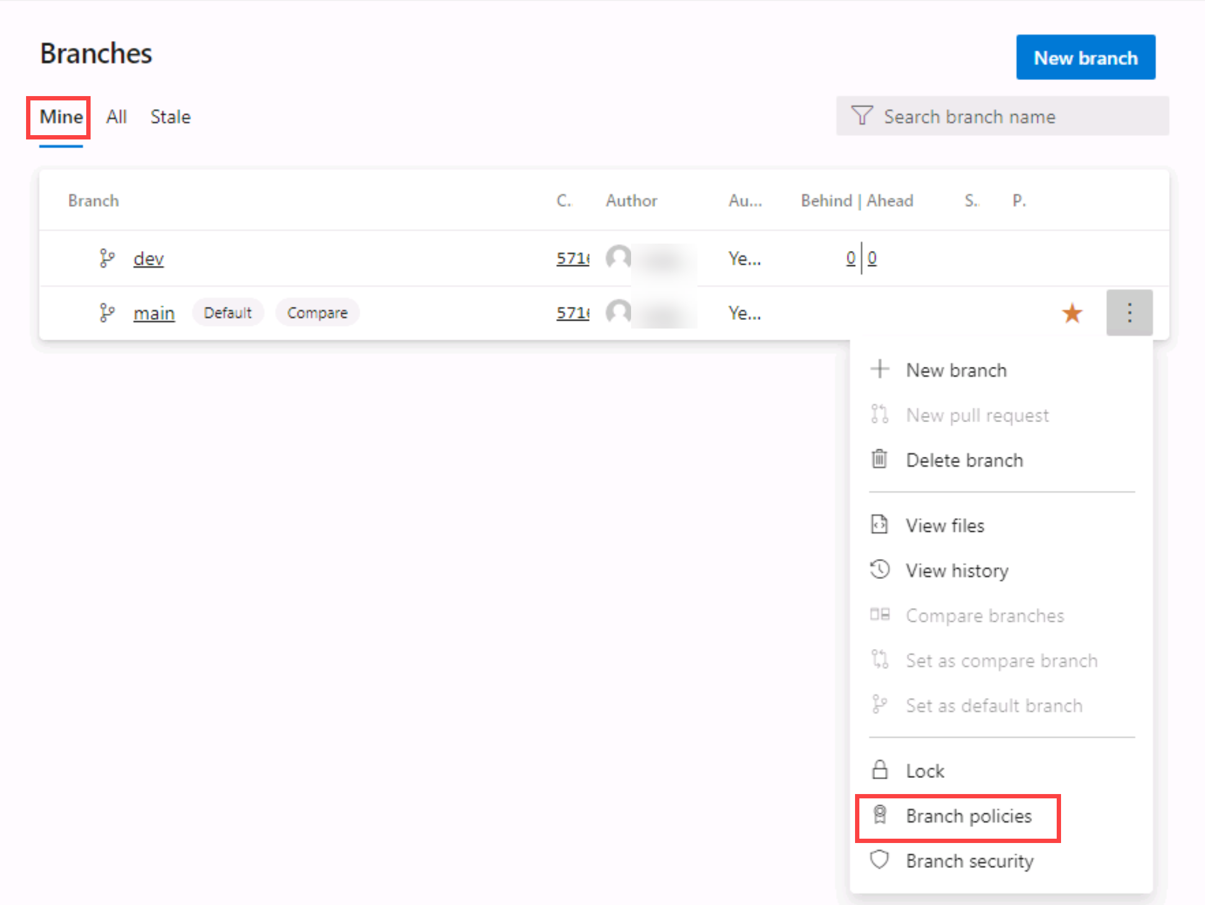

1. On the **main** tab of the repository settings, enable the option for **Require minimum number of reviewers**. Add **1** reviewer and check the box **Allow requestors to approve their own changes**(as you are the only user in your project for the lab)
2. On the **main** tab of the repository settings, enable the option for **Check for linked work items** and leave it with **Required** option.

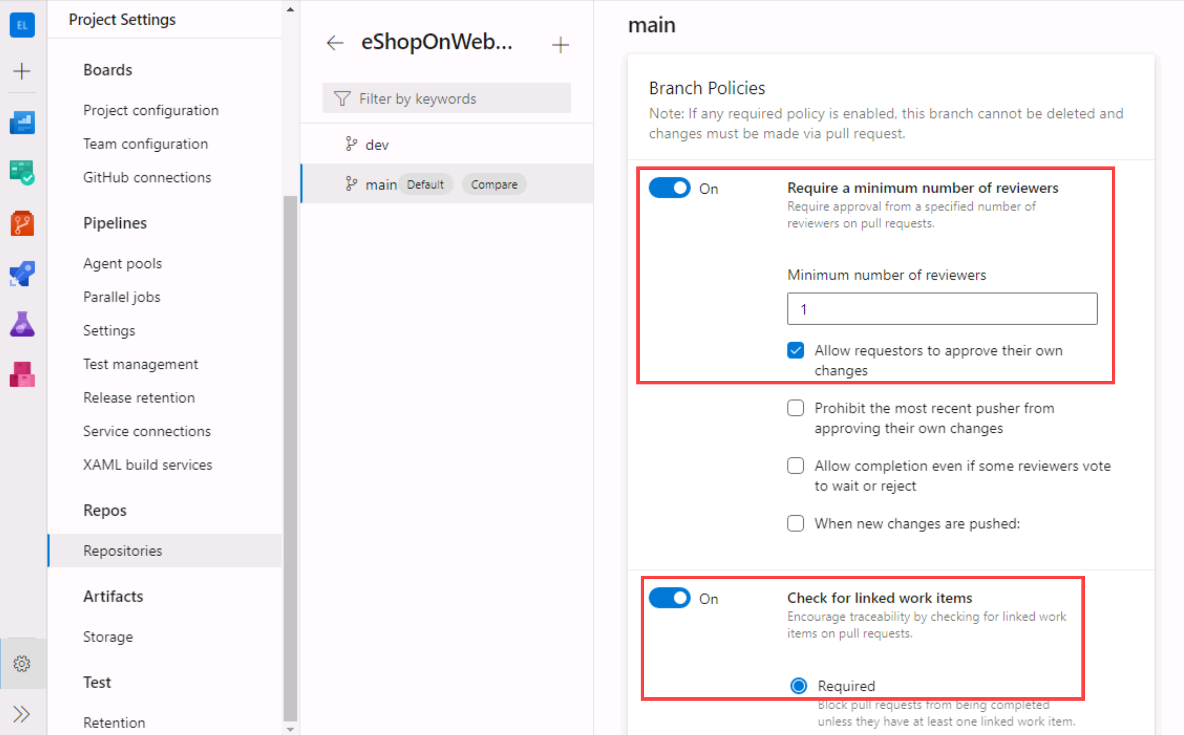

#### Task 4: Testing branch policy

In this task, you will use the Azure DevOps portal to test the policy and create your first Pull Request.

1. In the vertical navigational pane of the of the Azure DevOps portal, in the **Repos>Files**, make sure the **main** branch is selected (dropdown above shown content).
2. To make sure policies are working, try making a change and committing it on the **main** branch, navigate to the **/eShopOnWeb/src/Web/Program.cs** file and select it. This will automatically display its content in the details pane.
3. On the first line add the following comment:

csharpTypeCopy

*// Testing main branch policy*

1. Click on **Commit > Commit**. You will see a warning: changes to the main branch can only be done using a Pull Request.

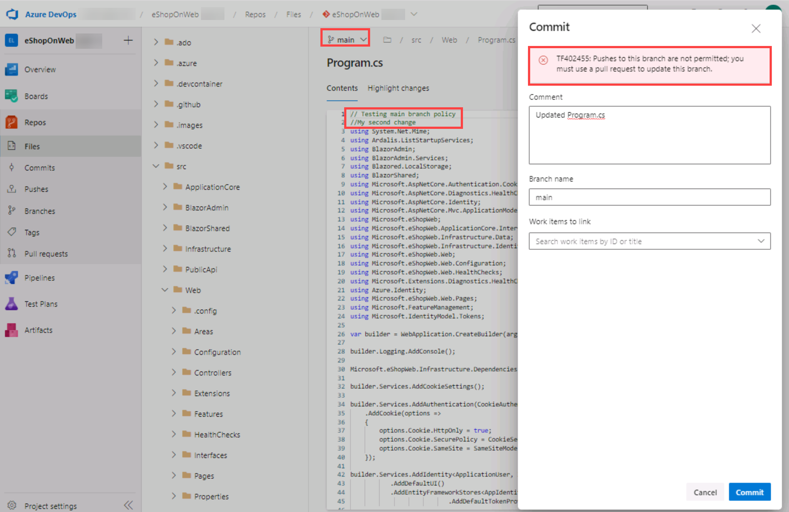

1. Click on **Cancel** to skip the commit.

#### Task 5: Working with Pull Requests

In this task, you will use the Azure DevOps portal to create a Pull Request, using the **dev** branch to merge a change into the protected **main** branch. An Azure DevOps work item will be linked to the changes to be able to trace pending work with code activity.

1. In the vertical navigational pane of the of the Azure DevOps portal, in the **Boards** section, select **Work Items**.
2. Click on **+ New Work Item > Product Backlog Item**. In title field, write **Testing my first PR** and click on **Save**.
3. Now go back to the vertical navigational pane of the of the Azure DevOps portal, in the **Repos>Files**, make sure the **dev** branch is selected.
4. Navigate to the **/eShopOnWeb/src/Web/Program.cs** file and make the following change on the first line:

csharpTypeCopy

*// Testing my first PR*

1. Click on **Commit > Commit** (leave default commit message). This time the commit works, **dev** branch has no policies.
2. A message will pop-up, proposing to create a Pull Request (as you **dev** branch is now ahead in changes, compared to **main**). Click on **Create a Pull Request**.

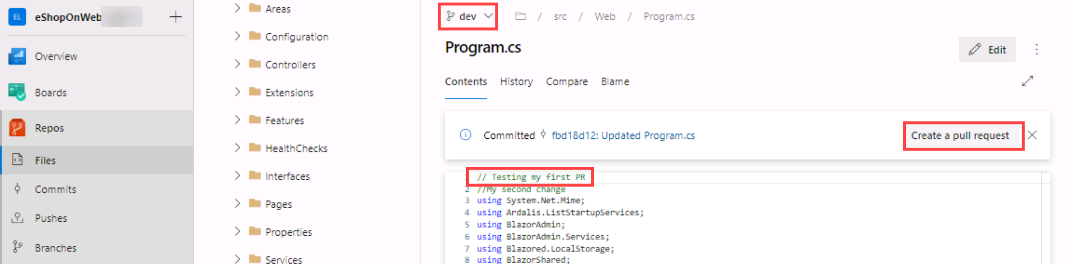

1. In the **New pull request** tab, leave defaults and click on **Create**.
2. The Pull Request will show some failed/pending requirements, based on the policies applied to our target **main** branch.
   1. Proposed changes should have a work item linked
   2. At least 1 user should review and approve the changes.
3. On the right side options, click on the **+** button next to **Work Items**. Link the previously created work item to the Pull Request by clicking on it. You will see one of the requirements changes status.

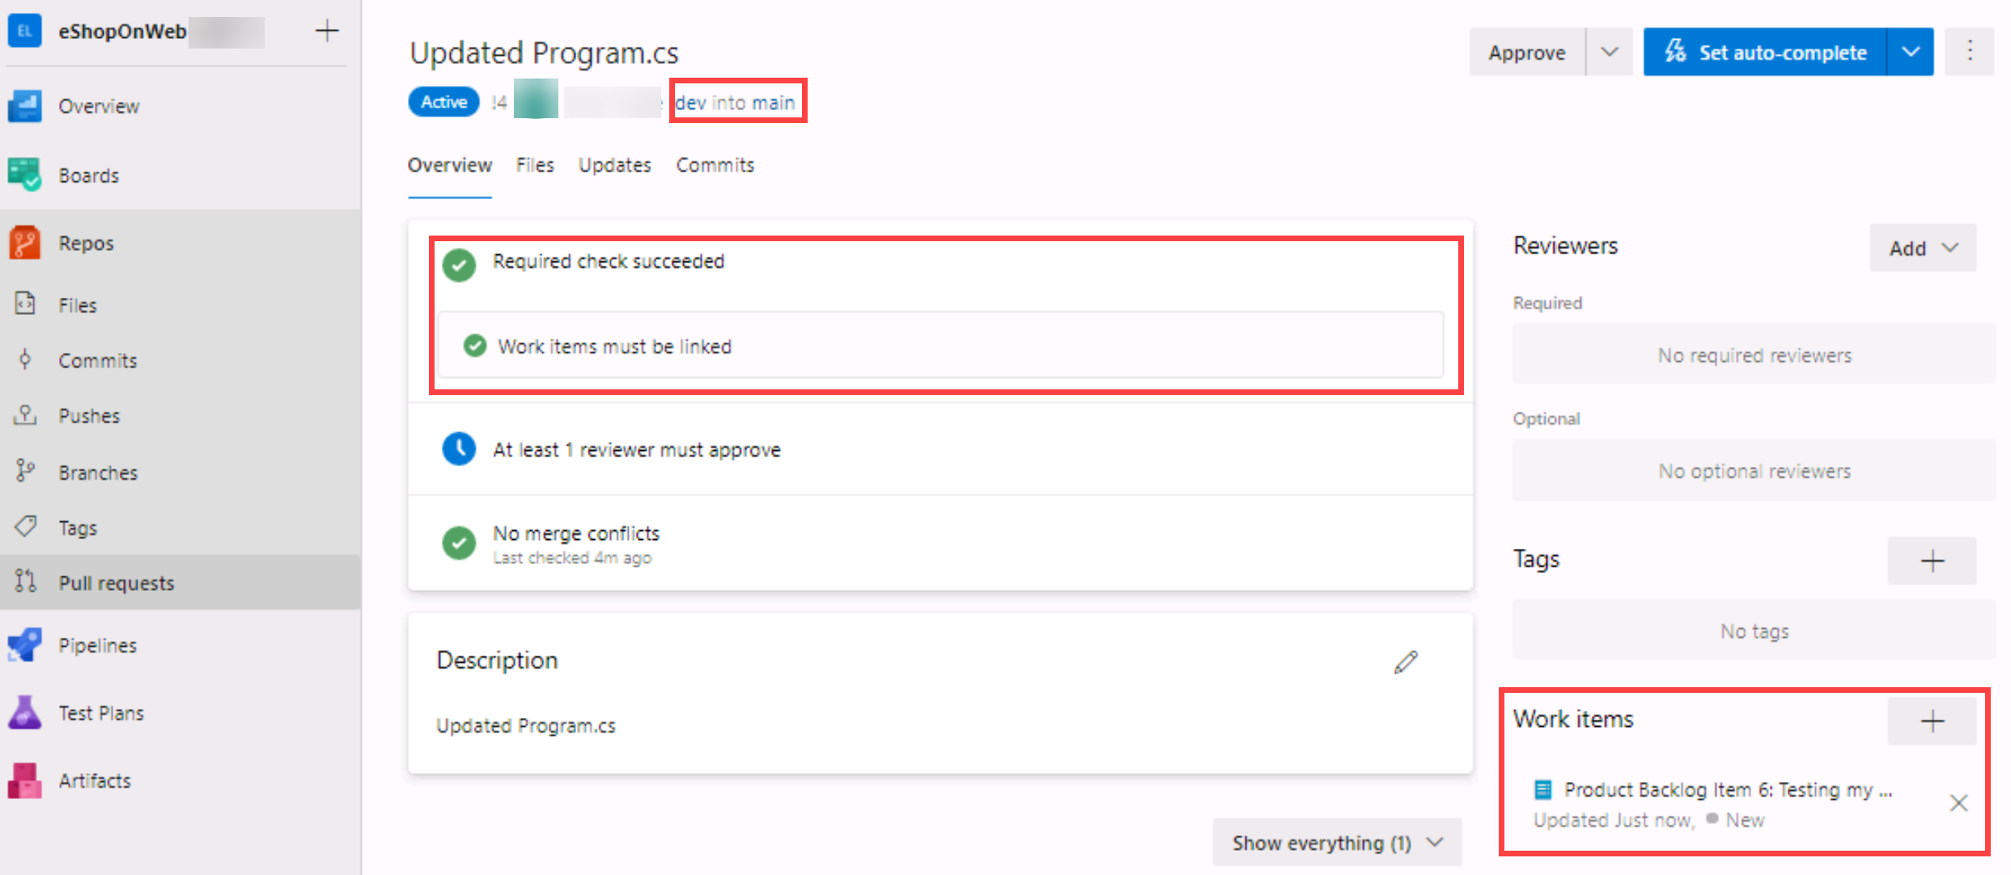

1. Next, open the **Files** tab to review the proposed changes. In a more complete Pull Request, you would be able to review files one by one (marked as reviewed) and open comments for lines that may not be clear (hovering the mouse over the line number gives you an option to post a comment).
2. Go back to the **Overview** tab, and on the top-right click on **Approve**. All the requirements will change to green. Now you can click on **Complete**.
3. On the **Complete Pull Request** tab, multiple options will be given before completing the merge:
   1. **Merge Type**: 4 merge types are offered, you can review them [here](https://learn.microsoft.com/azure/devops/repos/git/complete-pull-requests?view=azure-devops&tabs=browser#complete-a-pull-request) or observing the given animations. Choose **Merge (no fast forward)**.
   2. **Post-complete options**:
      1. Check **Complete associated work item…**. It will move associated PBI to **Done** state.
4. Click on **Complete Merge**

#### Task 6: Applying tags

The product team has decided that the current version of the site should be released as v1.1.0-beta.

1. In the vertical navigational pane of the of the Azure DevOps portal, in the **Repos** section, select **Tags**.
2. In the **Tags** pane, click **New tag**.
3. In the **Create a tag** panel, in the **Name** text box, type **v1.1.0-beta**, in the **Based on** drop-down list leave the **main** entry selected, in the **Description** text box, type **Beta release v1.1.0** and click **Create**.

**Note**: You have now tagged the repository at this release (the latest commit gets linked to the tag). You could tag commits for a variety of reasons and Azure DevOps offers the flexibility to edit and delete them, as well as manage their permissions.

### Exercise 5: Remove Branch Policies

When going through the different course labs in the order they are presented, the branch policy configured during this lab will block exercises in future labs. Therefore, we want you to remove the configured branch policies.

1. From the Azure DevOps **eShopOnWeb** Project view, navigate to **Repos** and select **Branches**. Select the **Mine** tab of the **Branches** pane.
2. On the **Mine** tab of the **Branches** pane, hover the mouse pointer over the **main** branch entry to reveal the ellipsis symbol (the …) on the right side.
3. Click the ellipsis and, in the pop-up menu, select **Branch Policies**.



1. On the **main** tab of the repository settings, disable the option for **Require minimum number of reviewers**.
2. On the **main** tab of the repository settings, disable the option for **Check for linked work items**.



1. You have now disabled/removed the branch policies for the main branch.

## Review

In this lab, you have learned how to use Git for version control in Azure Repos.

### Congratulations

You have successfully completed this lab. Click **End** to mark the lab as **Complete**.

2 Hours Remaining

# Configure agent pools and understanding pipeline styles

## Lab requirements

In this **Cloudslice** lab these Lab Requirements listed immediately below have already been completed for you.

* This lab requires **Microsoft Edge** or an [Azure DevOps supported browser.](https://docs.microsoft.com/azure/devops/server/compatibility)
* **Set up an Azure DevOps organization:** If you don't already have an Azure DevOps organization that you can use for this lab, create one by following the instructions available at [Create an organization or project collection](https://docs.microsoft.com/azure/devops/organizations/accounts/create-organization).
* [Git for Windows download page](https://gitforwindows.org/). This will be installed as part of prerequisites for this lab.
* [Visual Studio Code](https://code.visualstudio.com/). This will be installed as part of prerequisites for this lab.

## Lab overview

YAML-based pipelines allow you to fully implement CI/CD as code, in which pipeline definitions reside in the same repository as the code that is part of your Azure DevOps project. YAML-based pipelines support a wide range of features that are part of the classic pipelines, such as pull requests, code reviews, history, branching, and templates.

Regardless of the choice of the pipeline style, to build your code or deploy your solution by using Azure Pipelines, you need an agent. An agent hosts compute resources that run one job at a time. Jobs can be run directly on the host machine of the agent or in a container. You have an option to run your jobs using Microsoft-hosted agents, which are managed for you, or implementing a self-hosted agent that you set up and manage on your own.

In this lab, you will learn how to implement and use self-hosted agents with YAML pipelines.

## Objectives

After you complete this lab, you will be able to:

* Implement YAML-based pipelines.
* Implement self-hosted agents.

## Estimated timing: 30 minutes

## Instructions

### Exercise 0: (skip if done) Configure the lab prerequisites

In this **Cloudslice** lab, please skip **Exercise 0**

In this exercise, you will set up the prerequisites for the lab, which consist of a new Azure DevOps project with a repository based on the [eShopOnWeb](https://github.com/MicrosoftLearning/eShopOnWeb).

#### Task 1: (skip if done) Create and configure the team project

In this task, you will create an **eShopOnWeb** Azure DevOps project to be used by several labs.

1. On your lab computer, in a browser window open your Azure DevOps organization. Click on **New Project**. Give your project the name **eShopOnWeb** and leave the other fields with defaults. Click on **Create**.

#### Task 2: (skip if done) Import eShopOnWeb Git Repository

In this task you will import the eShopOnWeb Git repository that will be used by several labs.

1. On your lab computer, in a browser window open your Azure DevOps organization and the previously created **eShopOnWeb** project. Click on **Repos > Files** , **Import a Repository**. Select **Import**. On the **Import a Git Repository** window, paste the following URL <https://github.com/MicrosoftLearning/eShopOnWeb.git> and click **Import**:
2. The repository is organized the following way:
   1. **.ado** folder contains Azure DevOps YAML pipelines.
   2. **.devcontainer** folder container setup to develop using containers (either locally in VS Code or GitHub Codespaces).
   3. **infra** folder contains Bicep & ARM infrastructure as code templates used in some lab scenarios.
   4. **.github** folder contains YAML GitHub workflow definitions.
   5. **src** folder contains the .NET 8 website used in the lab scenarios.

#### Task 3: (skip if done) Set main branch as default branch

1. Go to **Repos > Branches**.
2. Hover on the **main** branch then click the ellipsis on the right of the column.
3. Click on **Set as default branch**.

### Exercise 1: Create agents and configure agent pools

In this exercise, you will create an Azure virtual machine (VM) and use it to create an agent and configure agent pools.

#### Task 1: Create and connect to an Azure VM

1. In your browser, open the Azure Portal at [https:*//portal.azure.com*](https://portal.azure.com). If prompted, sign in by using an account with the Owner role in your Azure subscription.
2. In the **Search resources, services and docs (G+/)** box, type **Virtual Machines** and select it from the dropdown list.
3. Select the **Create** button.
4. Select the **Presets**.

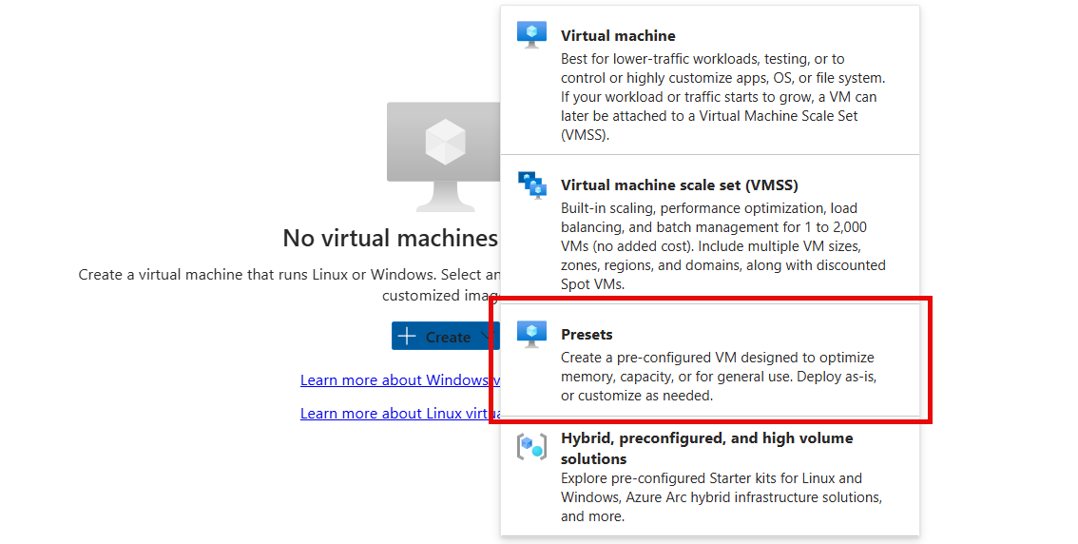

1. Select the **Dev/Test** as the workload environment and the **General purpose** as the workload type.
2. Select the **Continue to create a VM** button, on the **Basics** tab perform the following actions and then select **Management**:

|  |  |
| --- | --- |
| **Setting** | **Action** |
| **Subscription** drop-down list | Select your Azure subscription. |
| **Resource group** section | **rg-eshoponweb-agentpool**. |
| **Virtual machine name** text box | Enter name of your preference, for example, **eshoponweb-vm**. |
| **Region** drop-down list | **eastus2** |
| **Availability options** drop-down list | Select **No infrastructure redundancy required**. |
| **Security type** drop-down list | Select with the **Trusted launch virtual machines** option. |
| **Image** drop-down list | Select the **Windows Server 2022 Datacenter: Azure Edition - x64 Gen2** image. |
| **Size** drop-down list | Select **Standard** size **D2s_v3** for testing purposes. |
| **Username** text box | Enter the username of your preference |
| **Password** text box | Enter the password of your preference |
| **Public inbound ports** section | Select **Allow selected ports**. |
| **Select inbound ports** drop-down list | Select **RDP (3389)**. |

1. On the **Management** tab, in the **Identity** section, select the **Enable system assigned managed identity** checkbox and then select **Review + create**:
2. On the **Review + create** tab, select **Create**.

**Note**: Wait for the provisioning process to complete. This should take about 2 minutes.

1. In the Azure portal, navigate to the page displaying configuration of the newly created Azure VM.
2. On the Azure VM page, select **Connect**, in the drop-down menu, select **Connect**, then select **Download RDP file**.
3. Use the downloaded RDP file to establish a Remote Desktop session to the operating system running in the Azure VM.

#### Task 2: Create an agent pool

1. In the Remote Desktop session to the Azure VM, start Microsoft Edge web browser.
2. In the web browser, navigate to the Azure DevOps portal at [https:*//aex.dev.azure.com*](https://aex.dev.azure.com) and sign in to access your organization.

**Note**: If it is your first time accessing the Azure DevOps portal, you may need to create your profile.

1. Open the **eShopOnWeb** project, and select **Project settings** from the left-side bottom menu.
2. From **Pipelines > Agent Pools**, select the **Add pool** button.
3. Choose the **Self-hosted** pool type.
4. Provide a name for the agent pool, such as **eShopOnWebSelfPool56853955**, and add an optional description.
5. Leave the **Grant access permission to all pipelines** option unchecked.

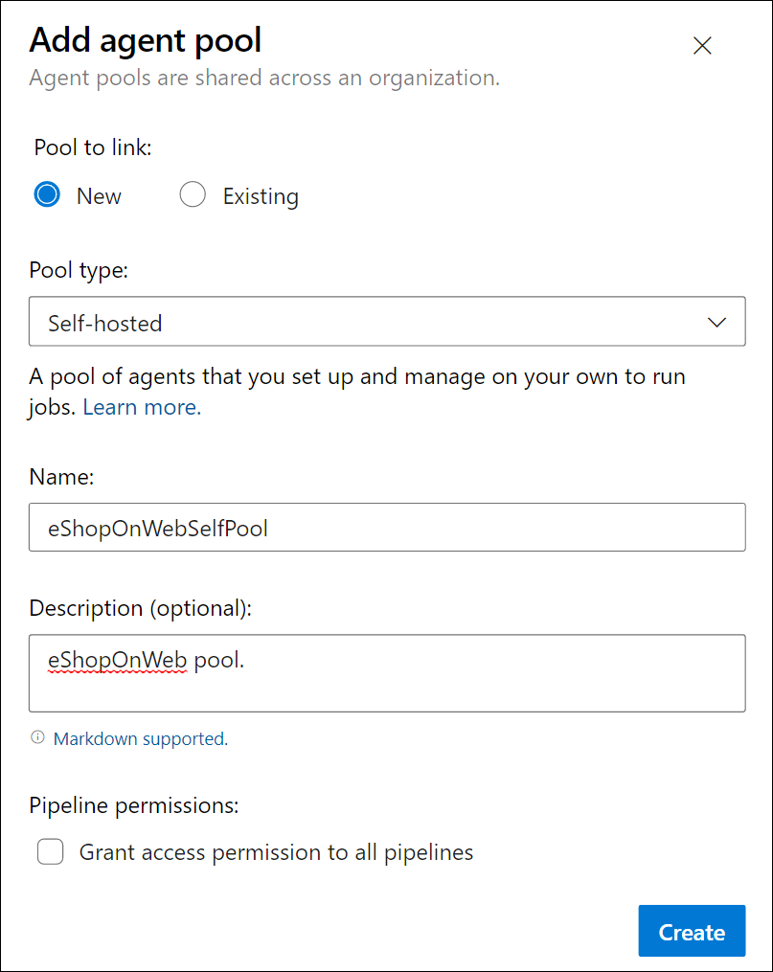

**Note**: Granting access permission to all pipelines is not recommended for production environments. It is only used in this lab to simplify the configuration of the pipeline.

1. Select **Create** button to create the agent pool.

#### Task 3: Download and extract the agent installation files

1. In the Azure DevOps portal, select the newly created agent pool and then select the **Agents** tab.
2. Select the **New agent** button and then **Download** button from the **Download agent** in the new pop-up window.

**Note**: Follow the installation instructions to install the agent.

**Note**: The name of the zip file you downloaded with the **Download** button should be similar to the following vsts-agent-win-x64-X.YYY.Z.zip (at the time of writing this lab the file name is vsts-agent-win-x64-4.255.0.zip). The file name will be used later in one of the agent installation commands.

1. Start a PowerShell session and run the following commands to create a folder named **agent**.

powershellTypeCopy

mkdir agent ; cd agent

**Note**: Make sure you are in the folder where you want to install the agent, for example, C:\agent.

1. Run the following command to extract the content of the downloaded agent installer files:

powershellTypeCopy

Add-Type -AssemblyName System.IO.Compression.FileSystem ; [System.IO.Compression.ZipFile]::ExtractToDirectory("$HOME\Downloads\vsts-agent-win-x64-4.255.0.zip", "$PWD")

**Note**: If you downloaded the agent to a different location (or the downloaded version differs), adjust the above command accordingly.

**Note**: Make sure that the zip file name specified inside the ExtractToDirectory command is the same as the zip file name you previously downloaded.

#### Task 4: Create a PAT token

**Note**: Before configuring the agent, you need to create a PAT token (unless you have an existing one). To create a PAT token, follow the steps below:

1. Within the Remote Desktop session to the Azure VM, open another browser window, navigate to the Azure DevOps portal at [https:*//aex.dev.azure.com*](https://aex.dev.azure.com), and access your organization and project.
2. Select **User settings** from the right-side top menu (directly to the left of your user's avatar icon).
3. Select the **Personal access tokens** menu item.

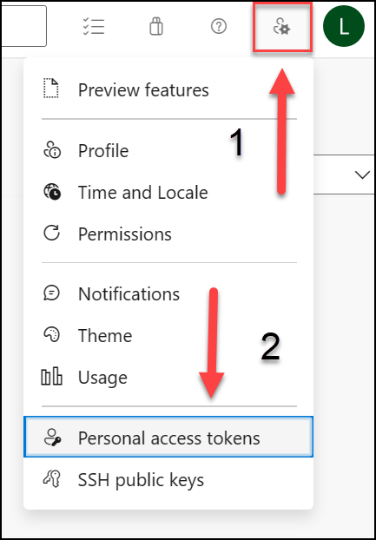

1. Select the **New Token** button.
2. Provide a name for the token, such as **eShopOnWebToken**.
3. Select the Azure DevOps organization for you want to use the token.
4. Set the expiration date for the token (only used to configure the agent).
5. Select the custom defined scope.
6. Select to show all scopes.
7. Select the **Agent Pools (Read & Manage)** scope.
8. Select the **Create** button to create the token.
9. Copy the token value and save it in a safe place (you will not be able to see it again. You can only regenerate the token).

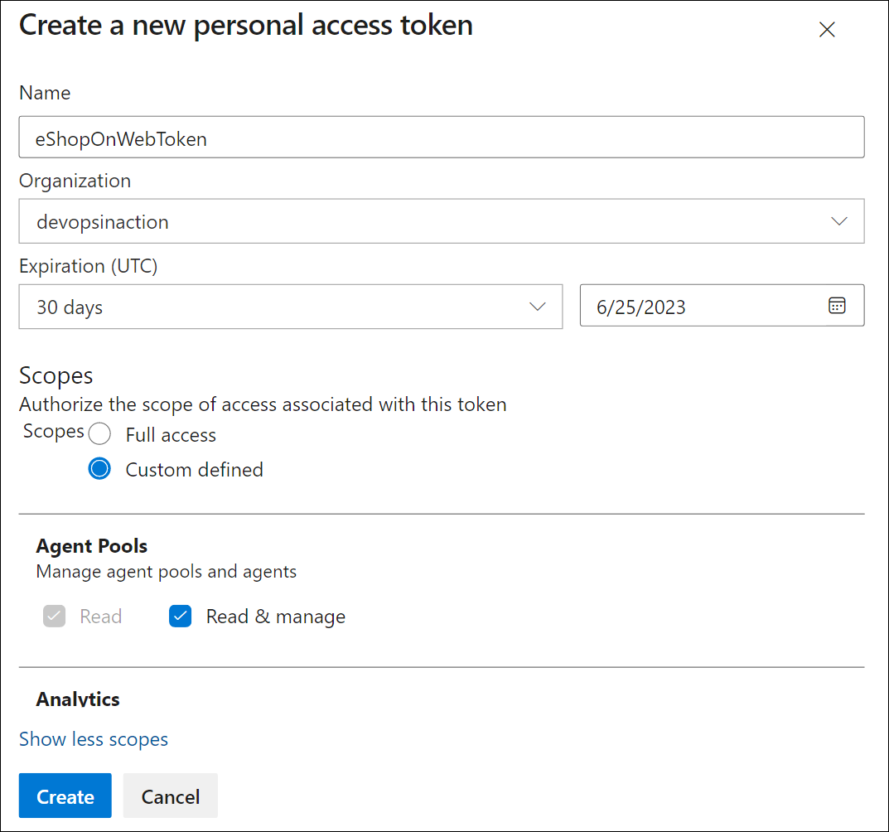

Use the least privilege option, **Agent Pools (Read & Manage)**, only for the agent configuration. Also, make sure you set the minimum expiration date for the token if that is the only purpose of the token. You can create another token with the same privileges if you need to configure the agent again.

#### Task 5: Configure the agent

1. Within the Remote Desktop session to the Azure VM, switch back to the PowerShell window. If necessary, change the current directory to the one into which you extracted the agent installation files earlier in this exercise.
2. To configure your agent to run unattended, invoke the following command:

powershellTypeCopy

.\config.cmd

**Note**: If you want to run the agent interactively, use .\run.cmd instead.

1. To configure the agent, perform the following actions when prompted:
   1. Enter the URL of the Azure DevOps organization (**server URL**) in the format [https:*//dev.azure.com/{your*](https://dev.azure.com/{your) *organization name}*.
   2. Accept the default authentication type (**PAT**).
   3. Enter the value of the PAT token you created in the previous step.
   4. Enter the agent pool name **eShopOnWebSelfPool56853955** you created earlier in this exercise.
   5. Enter the agent name **eShopOnWebSelfAgent**.
   6. Accept the default agent work folder (_work).
   7. Enter **Y** to configure the agent to run as service.
   8. Enter **Y** to enable SERVICE_SID_TYPE_UNRESTRICTED for the agent service.
   9. Enter **NT AUTHORITY\SYSTEM** to set the security context for the service.

In general, you should follow the principle of least privilege when configuring the service security context.

* 1. Accept the default option (**N**) to allow the service to start immediately after configuration is finished.

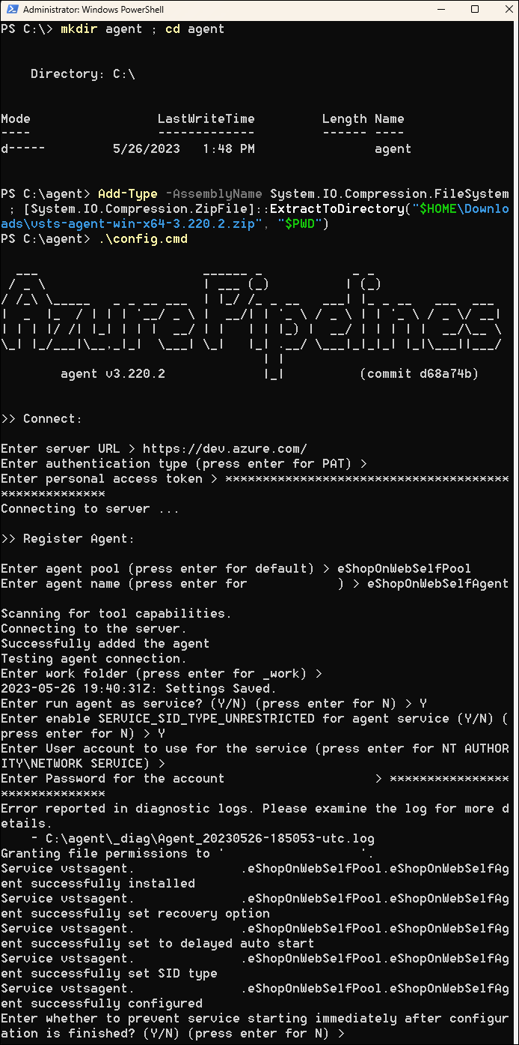

**Note**: The agent configuration process will take a few minutes to complete. Once it is done, you will see a message indicating that the agent is running as a service.

If you see an error message indicating that the agent is not running, you may need to start the service manually. To do this, open the **Services** applet in the Windows Control Panel, locate the service named **Azure DevOps Agent (eShopOnWebSelfAgent)**, and start it.

If your agent fails to start, you may need to choose a different folder for the agent work directory. To do this, re-run the agent configuration script and choose a different folder.

1. Check the agent status by switching to the web browser displaying the Azure DevOps portal, navigating to the agent pool and clicking on the **Agents** tab. You should see the new agent in the list.

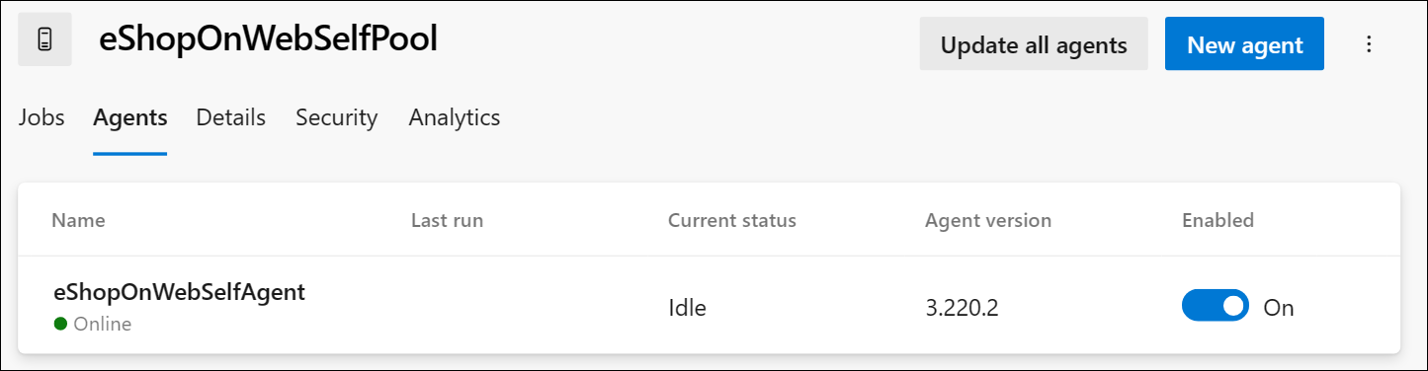

**Note**: For more details on Windows agents, see: [Self-hosted Windows agents](https://learn.microsoft.com/azure/devops/pipelines/agents/windows-agent)

In order for the agent to be able to build and deploy Azure resources from the Azure DevOps pipelines (which you will step through in the upcoming labs), you need to install Azure CLI within the operating system of the Azure VM that is hosting the agent.

1. Start a web browser and navigate to the page [https:*//learn.microsoft.com/en-us/cli/azure/install-azure-cli-windows?tabs=azure-cli&pivots=msi#install-or-update*](https://learn.microsoft.com/en-us/cli/azure/install-azure-cli-windows?tabs=azure-cli&pivots=msi#install-or-update).
2. Download and install Azure CLI.
3. (Optional) If you prefer, run the following PowerShell command to install Azure CLI:

powershellTypeCopy

$ProgressPreference = 'SilentlyContinue'; Invoke-WebRequest -Uri [https:*//aka.ms/installazurecliwindows*](https://aka.ms/installazurecliwindows) *-OutFile .\AzureCLI.msi; Start-Process msiexec.exe -Wait -ArgumentList '/I AzureCLI.msi /quiet'; Remove-Item .\AzureCLI.msi*

**Note**: If you are using a different version of the Azure CLI, you may need to adjust the above command accordingly.

1. In the web browser navigate to the page Microsoft .NET 8.0 SDK installer page at [https:*//dotnet.microsoft.com/en-us/download/dotnet/thank-you/sdk-8.0.403-windows-x64-installer*](https://dotnet.microsoft.com/en-us/download/dotnet/thank-you/sdk-8.0.403-windows-x64-installer).

You need to install the .NET 8.0 SDK (or higher) on the Azure VM that is hosting the agent. This is required to build the eShopOnWeb application in the upcoming labs. Any other tools or SDKs required for the application build should also be installed on the Azure VM.

1. Download and install Microsoft .NET 8.0 SDK.

### Exercise 2: Author YAML-based Azure Pipelines

In this exercise, you will create an application lifecycle build pipeline, using a YAML-based template.

#### Task 1: Create an Azure DevOps YAML pipeline

In this task, you will create a YAML-based pipeline for the **eShopOnWeb** project.

1. From the web browser displaying the Azure DevOps portal with the **eShopOnWeb** project open, in the vertical navigational pane on the left side, click **Pipelines**.
2. Click the **Create Pipeline** button - if you don't have any other pipelines created yet or click **New pipeline** to create an additional new one.
3. On the **Where is your code?** pane, click **Azure Repos Git**.
4. On the **Select a repository** pane, click **eShopOnWeb**.
5. On the **Configure your pipeline** pane, click **Existing Azure Pipelines YAML File**.
6. On the **Select an existing YAML file**, select **main** for the Branch, and **/.ado/eshoponweb-ci-pr.yml** for the Path.
7. Click **Continue**.
8. On the **Review your pipeline YAML** pane, review the sample pipeline. This is a rather straight-forward .NET application Build pipeline, which does the following:
   1. A single Stage: Build
   2. A single Job: Build
   3. 4 tasks within the Build Job:
   4. Dotnet Restore
   5. Dotnet Build
   6. Dotnet Test
   7. Dotnet Publish
9. On the **Review your pipeline YAML** pane, click the down-facing caret symbol next to the **Run** button, click **Save**.

**Note**: We are just creating the pipeline definition for now, without running it. You will first set up an Azure DevOps agent pool and run the pipeline in a later exercise.

#### Task 2: Update the YAML pipeline with the self-hosted agent pool

1. In the Azure DevOps portal, navigate to the **eShopOnWeb** project, and select **Pipelines** from the left-side menu.
2. Click on the **Edit** button for the pipeline you created in the previous task.
3. On the **eShopOnWeb** edit pane, in the existing YAML-based pipeline, remove line 13 which says **vmImage: ubuntu-latest** designating the target agent pool the following content, designating the newly created self-hosted agent pool:

yamlTypeCopy

pool:   
 name: eShopOnWebSelfPool56853955  
 demands: Agent.Name -equals eShopOnWebSelfAgent

**WARNING**: Be careful with copy/paste, make sure you have the same indentation shown above.

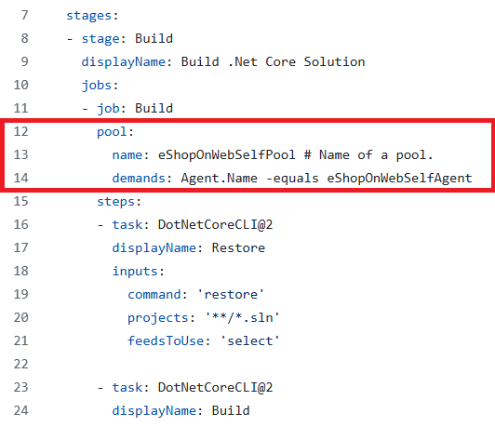

1. On the **eShopOnWeb** edit pane, in the upper right corner of the pane, click **Validate and save**. Then click **Save**.
2. On the **eShopOnWeb** edit pane, in the upper right corner of the pane, click **Run**.

**Note**: The pipeline will run on the self-hosted agent pool you created in the previous exercise.

1. Open the pipeline run and monitor the job until its successful completion.

**Note**: If you receive a permissions prompt, click **Permit** to allow the pipeline to run.

1. Once the pipeline run is complete, review the output and verify that the pipeline ran successfully.

## Review

In this lab, you learned how to implement and use self-hosted agents with YAML pipelines.

### Congratulations

You have successfully completed this lab. Click **End** to mark the lab as **Complete**.

2 Hours Remaining

# Enable Continuous Integration with Azure Pipelines

## Lab requirements

In this **Cloudslice** lab these Lab Requirements listed immediately below have already been completed for you.

* This lab requires **Microsoft Edge** or an [Azure DevOps supported browser.](https://docs.microsoft.com/azure/devops/server/compatibility)
* **Set up an Azure DevOps organization:** If you don't already have an Azure DevOps organization that you can use for this lab, create one by following the instructions available at [Create an organization or project collection](https://docs.microsoft.com/azure/devops/organizations/accounts/create-organization).

## Lab overview

In this lab, you will learn how to define build pipelines in Azure DevOps using YAML. The pipelines will be used in two scenarios:

* As part of Pull Request validation process.
* As part of the Continuous Integration implementation.

## Objectives

After you complete this lab, you will be able to:

* Include build validation as part of a Pull Request.
* Configure CI pipeline as code with YAML.

## Estimated timing: 30 minutes

## Instructions

### Exercise 0: (skip if done) Configure the lab prerequisites

In this **Cloudslice** lab, please skip **Task 1**

In this exercise, you will set up the prerequisites for the lab, which consist of a new Azure DevOps project with a repository based on the [eShopOnWeb](https://github.com/MicrosoftLearning/eShopOnWeb).

#### Task 1: (skip if done) Create and configure the team project

In this task, you will create an **eShopOnWeb** Azure DevOps project to be used by several labs.

1. On your lab computer, in a browser window open your Azure DevOps organization. Click on **New Project**. Give your project the name **eShopOnWeb** and leave the other fields with defaults. Click on **Create**.

#### Task 2: (skip if done) Import eShopOnWeb Git Repository

In this task you will import the eShopOnWeb Git repository that will be used by several labs.

1. On your lab computer, in a browser window open your Azure DevOps organization and the previously created **eShopOnWeb** project. Click on **Repos > Files** , **Import a Repository**. Select **Import**. On the **Import a Git Repository** window, paste the following URL [https:*//github.com/MicrosoftLearning/eShopOnWeb.git*](https://github.com/MicrosoftLearning/eShopOnWeb.git) and click **Import**:
2. The repository is organized the following way:
   1. **.ado** folder contains Azure DevOps YAML pipelines.
   2. **.devcontainer** folder container setup to develop using containers (either locally in VS Code or GitHub Codespaces).
   3. **infra** folder contains Bicep & ARM infrastructure as code templates used in some lab scenarios.
   4. **.github** folder contains YAML GitHub workflow definitions.
   5. **src** folder contains the .NET website used in the lab scenarios.

#### Task 3: (skip if done) Set main branch as default branch

1. Go to **Repos > Branches**.
2. Hover on the **main** branch then click the ellipsis on the right of the column.
3. Click on **Set as default branch**.

### Exercise 1: Include build validation as part of a Pull Request

In this exercise, you will include build validation to validate a Pull Request.

#### Task 1: Import the YAML build definition

In this task, you will import the YAML build definition that will be used as a Branch Policy to validate the pull requests.

Let's start by importing the build pipeline named [eshoponweb-ci-pr.yml](https://github.com/MicrosoftLearning/eShopOnWeb/blob/main/.ado/eshoponweb-ci-pr.yml).

1. Go to **Pipelines > Pipelines**
2. Click on **Create Pipeline** or **New Pipeline** button
3. Select **Azure Repos Git (YAML)**
4. Select the **eShopOnWeb56854080** repository
5. Select **Existing Azure Pipelines YAML File**
6. Select the **main** branch and the **/.ado/eshoponweb-ci-pr.yml** file, then click on **Continue**

The build definition consists of the following tasks:

* 1. **DotNet Restore**: With NuGet Package Restore you can install all your project's dependency without having to store them in source control.
  2. **DotNet Build**: Builds a project and all of its dependencies.
  3. **DotNet Test**: .Net test driver used to execute unit tests.
  4. **DotNet Publish**: Publishes the application and its dependencies to a folder for deployment to a hosting system. In this case, it's **Build.ArtifactStagingDirectory**.

1. On the **Review your pipeline YAML** pane, click the down-facing caret symbol next to the **Run** button, click **Save**.
2. Your pipeline will take a name based on the project name. Let's **rename** it for identifying the pipeline better. Go to **Pipelines > Pipelines** and click on the recently created pipeline. Click on the ellipsis and **Rename/Move** option. Name it **eshoponweb-ci-pr** and click on **Save**.

#### Task 2: Branch Policies

In this task, you will add policies to the main branch and only allow changes using Pull Requests that comply with the defined policies. You want to ensure that changes in a branch are reviewed before they are merged.

1. Go to **Repos > Branches** section.
2. On the **Mine** tab of the **Branches** pane, hover the mouse pointer over the **main** branch entry to reveal the ellipsis symbol on the right side.
3. Click the ellipsis and, in the pop-up menu, select **Branch Policies**.
4. On the **main** tab of the repository settings, enable the option for **Require minimum number of reviewers**. Add **1** reviewer and check the box **Allow requestors to approve their own changes**(as you are the only user in your project for the lab)
5. On the **main** tab of the repository settings, in the **Build Validation** section, click **+** (Add a new build policy) and in the **Build pipeline** list, select **eshoponweb-ci-pr** then click **Save**.

#### Task 3: Working with Pull Requests

In this task, you will use the Azure DevOps portal to create a Pull Request, using a new branch to merge a change into the protected **main** branch.

1. Navigate to the **Repos** section in the eShopOnWeb navigation and click **Branches**.
2. Create a new branch named **Feature01** based on the **main** branch.
3. Click **Feature01** and navigate to the **/eShopOnWeb/src/Web/Program.cs** file as part of the **Feature01** branch
4. Click the **Edit** button in the top-right
5. Make the following change on the first line:

csharpTypeCopy

*// Testing my PR*

1. Click on **Commit > Commit** (leave default commit message).
2. A message will pop-up, proposing to create a Pull Request (as your **Feature01** branch is now ahead in changes, compared to **main**). Click on **Create a Pull Request**.
3. In the **New pull request** tab, leave defaults and click on **Create**.
4. The Pull Request will show some pending requirements, based on the policies applied to the target **main** branch.
   1. At least 1 user should review and approve the changes.
   2. Build validation, you will see that the build **eshoponweb-ci-pr** was triggered automatically
5. After all validations are successful, on the top-right click on **Approve**. Now from the **Set auto-complete** dropdown you can click on **Complete**.
6. On the **Complete Pull Request** tab, click on **Complete Merge**

### Exercise 2: Configure CI Pipeline as Code with YAML

In this exercise, you will configure CI Pipeline as code with YAML.

#### Task 1: Import the YAML build definition for CI

In this task, you will add the YAML build definition that will be used to implement the Continuous Integration.

Let's start by importing the CI pipeline named [eshoponweb-ci.yml](https://github.com/MicrosoftLearning/eShopOnWeb/blob/main/.ado/eshoponweb-ci.yml).

1. Go to **Pipelines > Pipelines**.
2. Click on **New Pipeline** button.
3. Select **Azure Repos Git (YAML)**.
4. Select the **eShopOnWeb56854080** repository.
5. Select **Existing Azure Pipelines YAML File**.
6. Select the **main** branch and the **/.ado/eshoponweb-ci.yml** file, then click on **Continue**.

The CI definition consists of the following tasks:

* 1. **DotNet Restore**: With NuGet Package Restore you can install all your project's dependency without having to store them in source control.
  2. **DotNet Build**: Builds a project and all of its dependencies.
  3. **DotNet Test**: .Net test driver used to execute unit tests.
  4. **DotNet Publish**: Publishes the application and its dependencies to a folder for deployment to a hosting system. In this case, it's **Build.ArtifactStagingDirectory**.
  5. **Publish Artifact - Website**: Publish the app artifact (created in the previous step) and make it available as a pipeline artifact.
  6. **Publish Artifact - Bicep**: Publish the infrastructure artifact (Bicep file) and make it available as a pipeline artifact.

1. Click on **Run** and wait for the pipeline to execute successfully.

#### Task 2: Enable Continuous Integration

The default build pipeline definition doesn't enable Continuous Integration.

1. Click on the **Edit pipeline** option under the ellipsis menu near **Run new** button in the top-right
2. Now, you need to replace the **# trigger:** and **# - main** lines with the following code:

YAMLTypeCopy

trigger:  
 branches:  
 include:  
 - main  
 paths:  
 include:  
 - src/web*/\**

This will automatically trigger the build pipeline if any change is made to the main branch and the web application code (the src/web folder).

Since you enabled Branch Policies, you need to pass by a Pull Request in order to update your code.

1. Click the **Validate and save** button to validate and save the pipeline definition.
2. Select **Create a new branch for this commit**.
3. Keep the default branch name and **Start a pull request** checked.
4. Click on **Save**.
5. Your pipeline will take a name based on the project name. Let's **rename** it for identifying the pipeline better. Go to **Pipelines > Pipelines** and click on the recently created pipeline. Click on the ellipsis and **Rename/Move** option. Name it **eshoponweb-ci** and click on **Save**.
6. Go to **Repos > Pull Requests**.
7. Click on the **"Update eshoponweb-ci.yml for Azure Pipelines"** pull request.
8. After all validations are successful, on the top-right click on **Approve**. Now you can click on **Complete**.
9. On the **Complete Pull Request** tab, Click on **Complete Merge**

#### Task 3: Test the CI pipeline

In this task, you will create a Pull Request, using a new branch to merge a change into the protected **main** branch and automatically trigger the CI pipeline.

1. Navigate to the **Repos** section, and click on **Branches**.
2. Create a new branch named **Feature02** based on the **main** branch.
3. Click the new **Feature02** branch.
4. Navigate to the **/eShopOnWeb/src/Web/Program.cs** file and click **Edit** in the top-right.
5. Remove the first line:

csharpTypeCopy

*// Testing my PR*

1. Click on **Commit > Commit** (leave default commit message).
2. A message will pop-up, proposing to create a Pull Request (as your **Feature02** branch is now ahead in changes, compared to **main**).
3. Click on **Create a Pull Request**.
4. In the **New pull request** tab, leave defaults and click on **Create**.
5. The Pull Request will show some pending requirements, based on the policies applied to the target **main** branch.
6. After all validations are successful, on the top-right click on **Approve**. Now from the **Set auto-complete** dropdown you can click on **Complete**.
7. On the **Complete Pull Request** tab, Click on **Complete Merge**
8. Go back to **Pipelines > Pipelines**, you will notice that the build **eshoponweb-ci** was triggered automatically after the code was merged.
9. Click on the **eshoponweb-ci** build then select the last run.
10. After its successful execution, click on **Related > Published** to check the published artifacts:
    1. Bicep: the infrastructure artifact.
    2. Website: the app artifact.

## Review

In this lab, you enabled pull request validation using a build definition and configured CI pipeline as code with YAML in Azure DevOps.

### Congratulations

You have successfully completed this lab. Click **End** to mark the lab as **Complete**.

2 Hours Remaining

# Implement GitHub Actions for CI/CD

## Lab requirements

In this **Cloudslice** lab these Lab Requirements listed immediately below except for creating a GitHub account have already been completed for you.

* This lab requires **Microsoft Edge** or an [Azure DevOps supported browser.](https://docs.microsoft.com/azure/devops/server/compatibility)
* Identify an existing Azure subscription or create a new one.
* Verify that you have a Microsoft account or a Microsoft Entra account with the Contributor or the Owner role in the Azure subscription. For details, refer to [List Azure role assignments using the Azure portal](https://docs.microsoft.com/azure/role-based-access-control/role-assignments-list-portal) and [View and assign administrator roles in Azure Active Directory](https://docs.microsoft.com/azure/active-directory/roles/manage-roles-portal).
* **If you don't already have a GitHub account** that you can use for this lab, follow instructions available at [Signing up for a new GitHub account](https://github.com/join) to create one.

## Lab overview

In this lab, you'll learn how to implement a GitHub Action workflow that deploys an Azure web app.

## Objectives

After you complete this lab, you will be able to:

* Implement a GitHub Action workflow for CI/CD.
* Explain the basic characteristics of GitHub Action workflows.

## Estimated timing: 40 minutes

## Instructions

### Exercise 1: Import eShopOnWeb to your GitHub Repository

In this exercise, you will import the existing [eShopOnWeb](https://github.com/MicrosoftLearning/eShopOnWeb) repository code to your own GitHub private repo.

The repository is organized the following way:

* **.ado** folder contains Azure DevOps YAML pipelines.
* **.devcontainer** folder container setup to develop using containers (either locally in VS Code or GitHub Codespaces).
* **infra** folder contains Bicep&ARM infrastructure as code templates used in some lab scenarios.
* **.github** folder container YAML GitHub workflow definitions.
* **src** folder contains the .NET 8 website used on the lab scenarios.

#### Task 1: Create a public repository in GitHub and import eShopOnWeb

In this task, you will create an empty public GitHub repository and import the existing [eShopOnWeb](https://github.com/MicrosoftLearning/eShopOnWeb) repository.

1. From the lab computer, start a web browser, navigate to the **GitHub website** [https:*//github.com/*](https://github.com/), sign in using your account and click on **New** to create new repository.

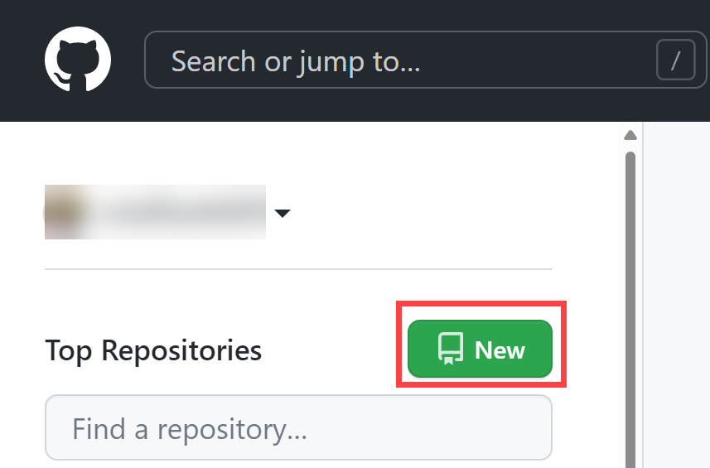

1. On the **Create a new repository** page, click on **Import a repository** link (below the page title).

**Note**: you can also open the import website directly at [https:*//github.com/new/import*](https://github.com/new/import)

1. On the **Import your project to GitHub** page:

|  |  |
| --- | --- |
| **Field** | **Value** |
| The URL for your source reapository | [https:*//github.com/MicrosoftLearning/eShopOnWeb*](https://github.com/MicrosoftLearning/eShopOnWeb) |
| Owner | Your account alias |
| Repository Name | eShopOnWeb |
| Privacy | **Public** |

1. Click on **Begin Import** and wait for your repository to be ready.
2. On the repository page, go to **Settings**, click on **Actions > General** and choose the option **Allow all actions and reusable workflows**. Click on **Save**.

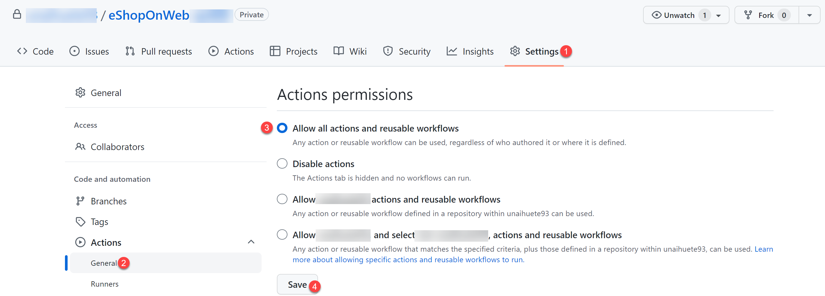

### Exercise 2: Setup your GitHub Repository and Azure access

In this exercise, you will create an Azure Service Principal to authorize GitHub accessing your Azure subscription from GitHub Actions. You will also setup the GitHub workflow that will build, test and deploy your website to Azure.

#### Task 1: Create an Azure Service Principal and save it as GitHub secret

Please skip **Steps 2-4**, in this **Cloudslice** lab, a **Resource Group** has already been created for you called rg-eshoponweb

In this task, you will create the Azure Service Principal used by GitHub to deploy the desired resources. As an alternative, you could also use [OpenID connect in Azure](https://docs.github.com/actions/deployment/security-hardening-your-deployments/configuring-openid-connect-in-azure), as a secretless authentication mechanism.

1. On your lab computer, in a browser window, open the Azure Portal ([https:*//portal.azure.com/*](https://portal.azure.com/)).
2. In the portal, look for **Resource Groups** and click on it.
3. Click on **+ Create** to create a new Resource Group for the exercise.
4. On the **Create a resource group** tab, give the following name to your Resource Group: **rg-eshoponweb-NAME** (replace NAME for some unique alias). Click on **Review + Create > Create**.
5. In the Azure Portal, open the **Cloud Shell** (next to the search bar).

**Note**: if the Azure portal asks you to create a storage, you can choose **No storage account required** options, select your subscription and click on **Apply** button

1. Make sure the terminal is running in **Bash** mode and execute the following command, replacing **SUBSCRIPTION-ID** and **RESOURCE-GROUP** with your own identifiers (both can be found on the **Overview** page of the Resource Group):

az ad sp create-for-rbac --name GH-Action-eshoponweb56854267 --role contributor --scopes /subscriptions/SUBSCRIPTION-ID/resourceGroups/RESOURCE-GROUP --sdk-auth

**Note**: Make sure this is typed or pasted as a single line!

**Note**: this command will create a Service Principal with Contributor access to the Resource Group created before. This way we make sure GitHub Actions will only have the permissions needed to interact only with this Resource Group (not the rest of the subscription)

1. The command will output a JSON object, you will later use it as a GitHub secret for the workflow. Copy the JSON. The JSON contains the identifiers used to authenticate against Azure in the name of a Microsoft Entra identity (service principal).

JSONTypeCopy

{  
 "clientId": "<GUID>",  
 "clientSecret": "<GUID>",  
 "subscriptionId": "<GUID>",  
 "tenantId": "<GUID>",  
 (...)  
 }

1. (Skip if already registered) You also need to run the following command to register the resource provider for the **Azure App Service** you will deploy later:

bashTypeCopy

az provider register --namespace Microsoft.Web

1. In a browser window, go back to your **eShopOnWeb** GitHub repository.
2. On the repository page, go to **Settings**, click on **Secrets and variables > Actions**. Click on **New repository secret**
   1. Name : **AZURE_CREDENTIALS**
   2. Secret: **paste the previously copied JSON object** (GitHub is able to keep multiple secrets under same name, used by [azure/login](https://github.com/Azure/login) action )
3. Click on **Add secret**. Now GitHub Actions will be able to reference the service principal, using the repository secret.

#### Task 2: Modify and execute the GitHub workflow

In this task, you will modify the given GitHub workflow and execute it to deploy the solution in your own subscription.

1. In a browser window, go back to your **eShopOnWeb** GitHub repository.
2. On the repository page, go to **Code** and open the following file: **eShopOnWeb/.github/workflows/eshoponweb-cicd.yml**. This workflow defines the CI/CD process for the given .NET 8 website code.
3. Uncomment the **on** section (delete "#"). The workflow triggers with every push to the main branch and also offers manual triggering ("workflow_dispatch").
4. In the **env** section, make the following changes:
   1. Replace **NAME** in **RESOURCE-GROUP** variable. It should be the resource group rg-eshoponweb
   2. For **LOCATION** use northcentralus
   3. Replace **YOUR-SUBS-ID** in **SUBSCRIPTION-ID** with 96d17210-0338-46b1-b254-f32be0737531.
   4. Replace **NAME** in **WEBAPP-NAME** with eshoponweb-webapp56854267. It will be used to create a globally unique website using Azure App Service.
5. Read the workflow carefully, comments are provided to help understand.
6. Click on **Commit changes…** on top right and **Commit changes** leaving defaults (changing the main branch). The workflow will get automatically executed.

#### Task 3: Review GitHub Workflow execution

In this task, you will review the GitHub workflow execution:

1. In a browser window, go back to your **eShopOnWeb** GitHub repository.
2. On the repository page, go to **Actions**, you will see the workflow setup before executing. Click on it.

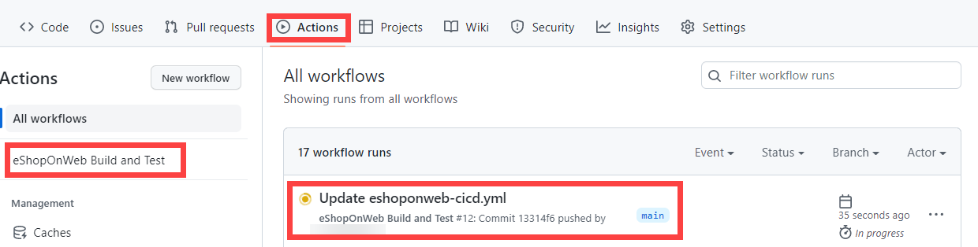

1. Wait for the workflow to finish. From the **Summary** you can see the two workflow jobs, the status and Artifacts retained from the execution. You can click in each job to review logs.

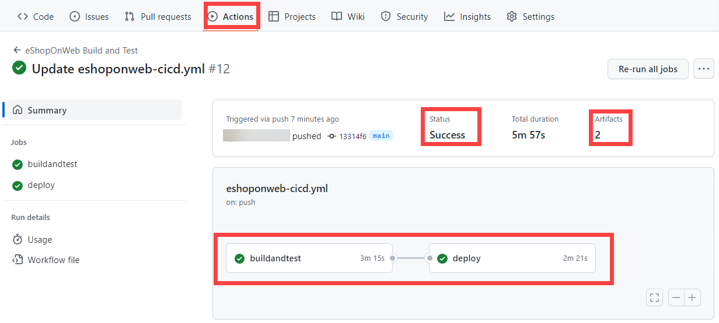

1. In a browser window, go back to the Azure Portal ([https:*//portal.azure.com/*](https://portal.azure.com/)). Open the resource group created before. You will see that the GitHub Action, using a bicep template, has created an Azure App Service Plan + App Service. You can see the published website opening the App Service and clicking **Browse**.

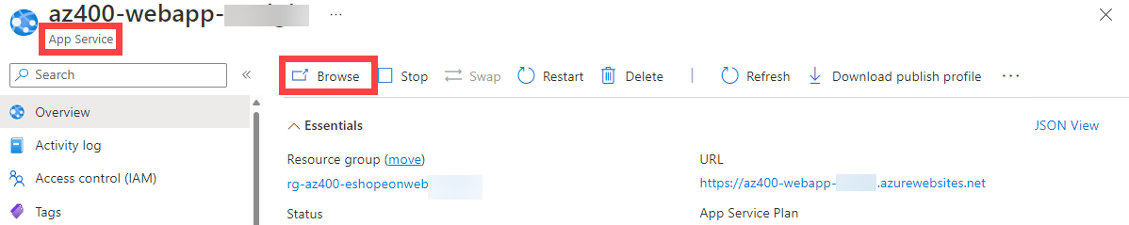

#### (OPTIONAL) Task 4: Add manual approval pre-deploy using GitHub Environments

In this task, you will use GitHub environments to ask for manual approval before executing the actions defined on the deploy job of your workflow.

1. On the repository page, go to **Code** and open the following file: **eShopOnWeb/.github/workflows/eshoponweb-cicd.yml**.
2. In the **deploy** job section, you can find a reference to an **environment** called **Development**. GitHub used [environments](https://docs.github.com/en/actions/deployment/targeting-different-environments/using-environments-for-deployment) add protection rules (and secrets) for your targets.
3. On the repository page, go to **Settings**, open **Environments** and click **New environment**.
4. Give it **Development** name and click on **Configure Environment**.

**Note**: If an environment called **Development** already exists in the **Environments** list, open its configuration by clicking on the environment name.

1. In the **Configure Development** tab, check the option **Required Reviewers** and your GitHub account as a reviewer. Click on **Save protection rules**.
2. Now lets test the protection rule. On the repository page, go to **Actions**, click on **eShopOnWeb Build and Test** workflow and click on **Run workflow > Run workflow** to execute manually.

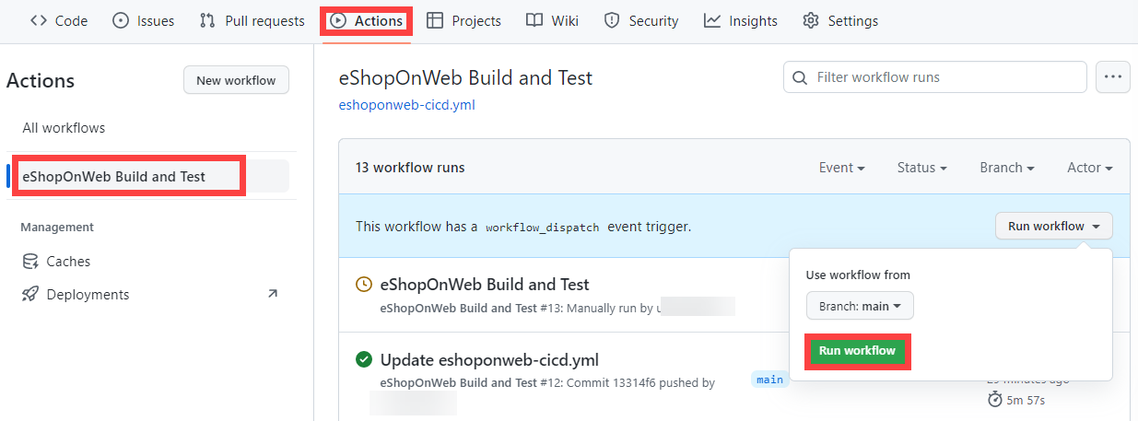

1. Click on the started execution of the workflow and wait for **buildandtest** job to finish. You will see a review request when **deploy** job is reached.
2. Click on **Review deployments**, check **Development** and click on **Approve and deploy**.

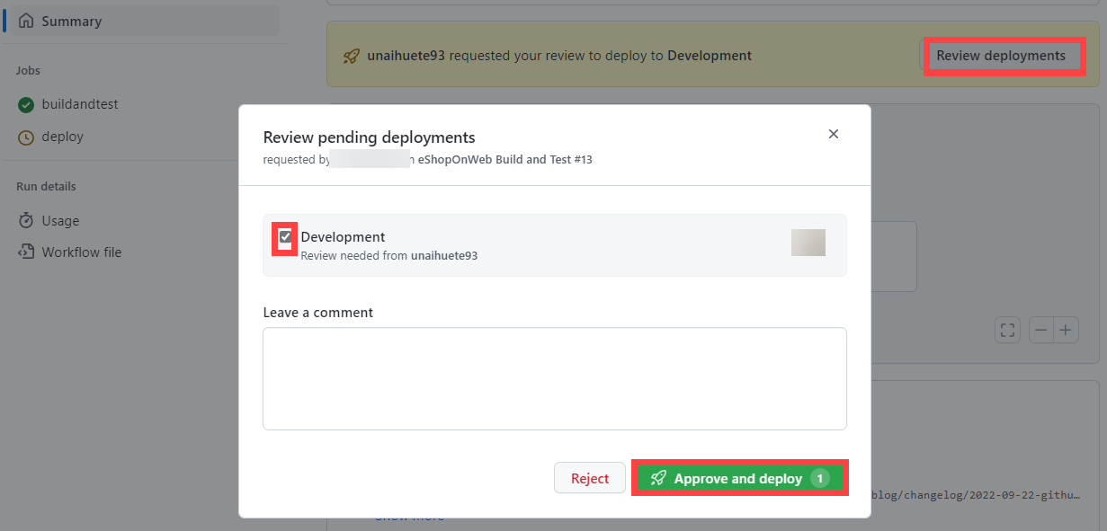

1. Workflow will follow the **deploy** job execution and finish.

Remember to delete the resources created in the Azure portal to avoid unnecessary charges.

## Review

In this lab, you implemented a GitHub Action workflow that deploys an Azure Web App.

### Congratulations

You have successfully completed this lab. Click **End** to mark the lab as **Complete**.

2 Hours Remaining

# Deploy Docker containers to Azure App Service web apps

## Lab requirements

In this **Cloudslice** lab these Lab Requirements listed immediately below have already been completed for you.

* This lab requires **Microsoft Edge** or an [Azure DevOps supported browser.](https://learn.microsoft.com/azure/devops/server/compatibility)
* **Set up an Azure DevOps organization:** If you don't already have an Azure DevOps organization that you can use for this lab, create one by following the instructions available at [Create an organization or project collection](https://learn.microsoft.com/azure/devops/organizations/accounts/create-organization).
* Identify an existing Azure subscription or create a new one.
* Verify that you have a Microsoft account or a Microsoft Entra account with the Contributor or the Owner role in the Azure subscription. For details, refer to [List Azure role assignments using the Azure portal](https://learn.microsoft.com/azure/role-based-access-control/role-assignments-list-portal) and [View and assign administrator roles in Azure Active Directory](https://learn.microsoft.com/azure/active-directory/roles/manage-roles-portal).

## Lab overview

In this lab, you will learn how to use an Azure DevOps CI/CD pipeline to build a custom Docker image, push it to Azure Container Registry, and deploy it as a container to Azure App Service.

## Objectives

After you complete this lab, you will be able to:

* Build a custom Docker image by using a Microsoft hosted Linux agent.
* Push an image to Azure Container Registry.
* Deploy a Docker image as a container to Azure App Service by using Azure DevOps.

## Estimated timing: 20 minutes

## Instructions

### Exercise 0: (skip if done) Configure the lab prerequisites

In this **Cloudslice** lab, please skip **Exercise 0**

In this exercise, you will set up the prerequisites for the lab, which consist of a new Azure DevOps project with a repository based on the [eShopOnWeb](https://github.com/MicrosoftLearning/eShopOnWeb).

#### Task 1: (skip if done) Create and configure the team project

In this task, you will create an **eShopOnWeb** Azure DevOps project to be used by several labs.

1. On your lab computer, in a browser window open your Azure DevOps organization. Click on **New Project**. Give your project the name **eShopOnWeb** and choose **Scrum** on the **Work Item process** dropdown. Click on **Create**.

#### Task 2: (skip if done) Import eShopOnWeb Git Repository

In this task you will import the eShopOnWeb Git repository that will be used by several labs.

1. On your lab computer, in a browser window open your Azure DevOps organization and the previously created **eShopOnWeb** project. Click on **Repos > Files** , **Import**. On the **Import a Git Repository** window, paste the following URL <https://github.com/MicrosoftLearning/eShopOnWeb.git> and click on **Import**:
2. The repository is organized the following way:
   1. **.ado** folder contains Azure DevOps YAML pipelines.
   2. **.devcontainer** folder container setup to develop using containers (either locally in VS Code or GitHub Codespaces).
   3. **infra** folder contains Bicep&ARM infrastructure as code templates used in some lab scenarios.
   4. **.github** folder container YAML GitHub workflow definitions.
   5. **src** folder contains the .NET 8 website used on the lab scenarios.

#### Task 3: (skip if done) Set main branch as default branch

1. Go to **Repos > Branches**.
2. Hover on the **main** branch then click the ellipsis on the right of the column.
3. Click on **Set as default branch**.

### Exercise 1: Import and run the CI pipeline

In this exercise, you will configure the service connection with your Azure Subscription then import and run the CI pipeline.

#### Task 1: Import and run the CI pipeline

1. Go to **Pipelines > Pipelines**
2. Click on **New pipeline** button (or **Create Pipeline** if you don't have other pipelines previously created)
3. Select **Azure Repos Git (YAML)**
4. Select the **eShopOnWeb** repository
5. Select **Existing Azure Pipelines YAML file**
6. Select the **main** branch and the **/.ado/eshoponweb-ci-docker.yml** file, then click on **Continue**
7. In the YAML pipeline definition, customize:
   1. **YOUR-SUBSCRIPTION-ID** with your Azure subscription ID 50fbe7f6-0710-49a8-b1d3-5dae96e7fd93.
   2. Replace the **resourceGroup** with the resource group name used during the service connection creation, for example, **AZ400-RG156854585**.
   3. Replace **location** with northcentralus.
8. Review the pipeline definition. The CI definition consists of the following tasks:
   1. **Resources**: It downloads the repository files that will be used in the following tasks.
   2. **AzureResourceManagerTemplateDeployment**: Deploys the Azure Container Registry using bicep template.
   3. **PowerShell**: Retrieve the **ACR Login Server** value from the previous task's output and create a new parameter **acrLoginServer**
   4. [**Docker**](https://learn.microsoft.com/azure/devops/pipelines/tasks/reference/docker-v0?view=azure-pipelines) **- Build**: Build the Docker image and create two tags (Latest and current BuildID)
   5. **Docker - Push**: Push the images to Azure Container Registry
9. Click on **Save and Run**.
10. Open the pipeline execution. If you see a warning message "This pipeline needs permission to access a resource before this run can continue to Build", click on **View** and then **Permit** and **Permit** again. This will allow the pipeline to access the Azure subscription.

**Note**: The deployment may take a few minutes to complete.

1. Your pipeline will take a name based on the project name. Let's **rename** it for identifying the pipeline better. Go to **Pipelines > Pipelines** and click on the recently created pipeline. Click on the ellipsis and **Rename/move** option. Name it **eshoponweb-ci-docker** and click on **Save**.
2. Navigate to the **Azure Portal** [https:*//portal.azure.com*](https://portal.azure.com), search for the Azure Container Registry in the recently created Resource Group (it should be named **AZ400-RG156854585**). On the left-hand side click **Repositories** under **Services** and make sure that the repository **eshoponweb/web** was created. When you click the repository link, you should see two tags (one of them is **latest**), these are the pushed images. If you don't see this, check the status of your pipeline.

### Exercise 2: Import and run the CD pipeline

In this exercise, you will configure the service connection with your Azure Subscription then import and run the CD pipeline.

#### Task 1: Import and run the CD pipeline

In this task, you will import and run the CD pipeline.

1. Go to **Pipelines > Pipelines**
2. Click on **New pipeline** button
3. Select **Azure Repos Git (YAML)**
4. Select the **eShopOnWeb** repository
5. Select **Existing Azure Pipelines YAML File**
6. Select the **main** branch and the **/.ado/eshoponweb-cd-webapp-docker.yml** file, then click on **Continue**
7. In the YAML pipeline definition, customize:
   1. **YOUR-SUBSCRIPTION-ID** with your Azure subscription ID 50fbe7f6-0710-49a8-b1d3-5dae96e7fd93.
   2. Replace the **resourceGroup** with the resource group name used during the service connection creation, for example, **AZ400-RG156854585**.
   3. Replace **location** with northcentralus.
8. Review the pipeline definition. The CD definition consists of the following tasks:
   1. **Resources**: It downloads the repository files that will be used in the following tasks.
   2. **AzureResourceManagerTemplateDeployment**: Deploys the Azure App Service using bicep template.
   3. **AzureResourceManagerTemplateDeployment**: Add role assignment using Bicep
9. Click on **Save and Run**.
10. Open the pipeline execution. If you see a warning message "This pipeline needs permission to access a resource before this run can continue to Deploy", click on **View** and then **Permit** and **Permit** again. This will allow the pipeline to access the Azure subscription.

**Important**: If you do not authorize the pipeline when configuring, you will encounter permission errors during execution. Common error messages include "This pipeline needs permission to access a resource" or "Pipeline run failed due to insufficient permissions". To resolve this, navigate to the pipeline run, click **View** next to the permission request, then click **Permit** to grant the necessary access to your Azure subscription and resources.

**Note**: The deployment may take a few minutes to complete.

If you receive the error message "TF402455: Pushes to this branch are not permitted; you must use a pull request to update this branch.", you need to uncheck the "Require a minimum number of reviewers" Branch protection rule enabled in the previous labs.

1. Your pipeline will take a name based on the project name. Let's **rename** it for identifying the pipeline better. Go to **Pipelines > Pipelines** and hover on the recently created pipeline. Click on the ellipsis and **Rename/move** option. Name it **eshoponweb-cd-webapp-docker** and click on **Save**.

**Note 1**: The use of the **/infra/webapp-docker.bicep** template creates an app service plan, a web app with system assigned managed identity enabled, and references the Docker image pushed previously: **${acr.properties.loginServer}/eshoponweb/web:latest**.

**Note 2**: The use of the **/infra/webapp-to-acr-roleassignment.bicep** template creates a new role assignment for the web app with AcrPull role to be able to retrieve the Docker image. This could be done in the first template, but since the role assignment can take some time to propagate, it's a good idea to do both tasks separately.

#### Task 2: Test the solution

1. In the Azure Portal, navigate to the recently created Resource Group, you should now see three resources (App Service, App Service Plan and Container Registry).
2. Navigate to the App Service, then click **Browse**, this will take you to the website.
3. Verify that the eShopOnWeb application is running successfully. Once confirmed, you have completed the lab successfully.

Remember to delete the resources created in the Azure portal to avoid unnecessary charges.

## Review

In this lab, you have learned how to use an Azure DevOps CI/CD pipeline to build a custom Docker image, push it to Azure Container Registry, and deploy it as a container to Azure App Service.

### Congratulations

You have successfully completed this lab. Click **End** to mark the lab as **Complete**.

2 Hours Remaining

# Configure Pipelines as Code with YAML

## Lab requirements

In this **Cloudslice** lab these Lab Requirements listed immediately below have already been completed for you.

* This lab requires **Microsoft Edge** or an [Azure DevOps supported browser.](https://docs.microsoft.com/azure/devops/server/compatibility)
* **Set up an Azure DevOps organization:** If you don't already have an Azure DevOps organization that you can use for this lab, create one by following the instructions available at [Create an organization or project collection](https://docs.microsoft.com/azure/devops/organizations/accounts/create-organization).
* Identify an existing Azure subscription or create a new one.
* Verify that you have a Microsoft account or a Microsoft Entra account with the Owner role in the Azure subscription and the Global Administrator role in the Microsoft Entra tenant associated with the Azure subscription. For details, refer to [List Azure role assignments using the Azure portal](https://docs.microsoft.com/azure/role-based-access-control/role-assignments-list-portal) and [View and assign administrator roles in Azure Active Directory](https://docs.microsoft.com/azure/active-directory/roles/manage-roles-portal).

## Lab overview

Many teams prefer to define their build and release pipelines using YAML. This allows them to access the same pipeline features as those using the visual designer but with a markup file that can be managed like any other source file. YAML build definitions can be added to a project by simply adding the corresponding files to the repository's root. Azure DevOps also provides default templates for popular project types and a YAML designer to simplify the process of defining build and release tasks.

## Objectives

After you complete this lab, you will be able to:

* Configure CI/CD pipelines as code with YAML in Azure DevOps.

## Estimated timing: 45 minutes

## Instructions

### Exercise 0: Configure the lab prerequisites

In this **Cloudslice** lab, please skip **Task 1**

In this exercise, you will set up the prerequisites for the lab.

#### Task 1: (skip if done) Create and configure the team project

In this task, you will create an **eShopOnWeb-56854773** Azure DevOps project to be used by several labs.

1. On your lab computer, in a browser window open your Azure DevOps organization. Click on **New Project**. Give your project the name **eShopOnWeb-56854773** and leave the other fields with defaults. Click on **Create**.



#### Task 2: Import eShopOnWeb Git Repository

In this task you will import the eShopOnWeb Git repository that will be used by several labs.

1. On your lab computer, in a browser window open your Azure DevOps organization and the previously created **eShopOnWeb-56854773** project. Click on **Repos > Files** , **Import a Repository**. Select **Import**. On the **Import a Git Repository** window, paste the following URL [https:*//github.com/MicrosoftLearning/eShopOnWeb.git*](https://github.com/MicrosoftLearning/eShopOnWeb.git) and click **Import**:



1. The repository is organized the following way:
   1. **.ado** folder contains Azure DevOps YAML pipelines.
   2. **.devcontainer** folder container setup to develop using containers (either locally in VS Code or GitHub Codespaces).
   3. **infra** folder contains Bicep&ARM infrastructure as code templates used in some lab scenarios.
   4. **.github** folder container YAML GitHub workflow definitions.
   5. **src** folder contains the .NET 8 website used on the lab scenarios.
2. Go to **Repos > Branches**.
3. Hover on the **main** branch then click the ellipsis on the right of the column.
4. Click on **Set as default branch**.

**Note**: if the main branch is already the default branch, the **Set as default branch** option is grayed out. In this case, continue with the instructions

#### Task 3: Create Azure resources

In this task, you will create an Azure web app by using the Azure portal.

1. From the lab computer, start a web browser, navigate to the **Azure Portal** [https:*//portal.azure.com*](https://portal.azure.com), and sign in with the user account that has the Owner role in the Azure subscription you will be using in this lab and has the role of the Global Administrator in the Microsoft Entra tenant associated with this subscription.
2. In the Azure portal, in the toolbar, click the **Cloud Shell** icon located directly to the right of the search text box.
3. If prompted to select either **Bash** or **PowerShell**, select **Bash**.

**Note**: If this is the first time you are starting **Cloud Shell** and you are presented with the **Getting started** pop-up, select **No storage account required** and the subscription you are using in this lab, and click on **Apply**.

1. From the **Bash** prompt, in the **Cloud Shell** pane, run the following command to create a resource group.

bashTypeCopy

LOCATION='northcentralus'

bashTypeCopy

RESOURCEGROUPNAME='az400m03l07-RG'  
az group create --name $RESOURCEGROUPNAME --location $LOCATION

1. To create a Windows App service plan by running the following command:

bashTypeCopy

SERVICEPLANNAME='az400m03l07-sp1'  
az appservice plan create --resource-group $RESOURCEGROUPNAME --name $SERVICEPLANNAME --sku B3

**Note**: If you get an error like "The subscription is not registered to use namespace 'Microsoft.Web'" when you run the previous command, run the following az provider register --namespace Microsoft.Web and then run the command that generated the error again.

1. Create a web app with a unique name.

bashTypeCopy

WEBAPPNAME=eshoponWebYAML56854773  
az webapp create --resource-group $RESOURCEGROUPNAME --plan $SERVICEPLANNAME --name $WEBAPPNAME

**Note**: Record the name of the web app. You will need it later in this lab.

1. Close the Azure Cloud Shell, but leave the Azure Portal open in the browser.

### Exercise 1: Configure CI/CD Pipelines as Code with YAML in Azure DevOps

In this exercise, you will configure CI/CD Pipelines as code with YAML in Azure DevOps.

#### Task 1: Add a YAML build definition

In this task, you will add a YAML build definition to the existing project.

1. Navigate back to the **Pipelines** pane in of the **Pipelines** hub.
2. In the **Create your first Pipeline** window, click **Create pipeline**.

**Note**: We will use the wizard to create a new YAML Pipeline definition based on our project.

1. On the **Where is your code?** pane, click **Azure Repos Git (YAML)** option.
2. On the **Select a repository** pane, click **eShopOnWeb-56854773**.
3. On the **Configure your pipeline** pane, scroll down and select **Existing Azure Pipelines YAML File**.
4. In the **Selecting an existing YAML File** blade, specify the following parameters:
   1. Branch: **main**
   2. Path: **.ado/eshoponweb-ci.yml**
5. Click **Continue** to save these settings.
6. From the **Review your Pipeline YAML** screen, click **Run** to start the Build Pipeline process.
7. Wait for the Build Pipeline to complete successfully. Ignore any warnings regarding the source code itself, as they are not relevant for this lab exercise.

**Note**: Each task from the YAML file is available for review, including any warnings and errors.

#### Task 2: Add continuous delivery to the YAML definition

In this task, you will add continuous delivery to the YAML-based definition of the pipeline you created in the previous task.

**Note**: Now that the build and test processes are successful, we can now add delivery to the YAML definition.

1. On the pipeline run pane, click the ellipsis symbol in the upper right corner and, in the dropdown menu, click **Edit pipeline**.
2. On the pane displaying the content of the **eShopOnWeb-56854773/.ado/eshoponweb-ci.yml** file, navigate to the end of the file (line 56), and hit **Enter/Return** to add a new empty line.
3. Being on line **57**, add the following content to define the **Release** stage in the YAML pipeline.

**Note**: You can define whatever stages you need to better organize and track pipeline progress.

yamlTypeCopy

- stage: Deploy  
 displayName: Deploy to an Azure Web App  
 jobs:  
 - job: Deploy  
 pool:  
 vmImage: "windows-latest"  
 steps:

1. Set the cursor on a new line at the end of the YAML definition.

**Note**: This will be the location where new tasks are added.

1. In the list of tasks on the right side of the code pane, search for and select the **Azure App Service Deploy** task.
2. In the **Azure App Service deploy** pane, specify the following settings and click **Add**:
   1. in the **Azure subscription** drop-down list, select the Azure subscription into which you deployed the Azure resources earlier in the lab, click **Authorize**, and, when prompted, authenticate by using the same user account you used during the Azure resource deployment.
   2. in the **App Service name** dropdown list, select the name of the web app you deployed earlier in the lab.
   3. in the **Package or folder** text box, **update** the Default Value to $(Build.ArtifactStagingDirectory)*/**/*Web.zip.
   4. Open the **Application and Configuration Settings** section and, in the **App settings** textbox, add -UseOnlyInMemoryDatabase true -ASPNETCORE_ENVIRONMENT Development
3. Confirm the settings from the Assistant pane by clicking the **Add** button.

**Note**: This will automatically add the deployment task to the YAML pipeline definition.

1. The snippet of code added to the editor should look similar to below, reflecting your name for the azureSubscription and WebappName parameters:

yamlTypeCopy

- task: AzureRmWebAppDeployment@4  
 inputs:  
 ConnectionType: "AzureRM"  
 azureSubscription: "AZURE SUBSCRIPTION HERE (b999999abc-1234-987a-a1e0-27fb2ea7f9f4)"  
 appType: "webApp"  
 WebAppName: "eshoponWebYAML369825031"  
 packageForLinux: "$(Build.ArtifactStagingDirectory)/**/Web.zip"  
 AppSettings: "-UseOnlyInMemoryDatabase true -ASPNETCORE_ENVIRONMENT Development"

1. Validate the task is listed as a child of the **steps** task. If not, select all lines from the added task, press the **Tab** key twice to indent it four spaces, so that it listed as a child of the **steps** task.

**Note**: The **packageForLinux** parameter is misleading in the context of this lab, but it is valid for Windows or Linux.

**Note**: By default, these two stages run independently. As a result, the build output from the first stage might not be available to the second stage without additional changes. To implement these changes, we will add a new task to download the deployment artifact in the beginning of the deploy stage.

1. Place the cursor on the first line under the **steps** node of the **deploy** stage, and hit Enter/Return to add a new empty line (Line 64).
2. On the **Tasks** pane, search for and select the **Download build artifacts** task.
3. Specify the following parameters for this task:
   1. Download Artifacts produced by: **Current Build**
   2. Download Type: **Specific Artifact**
   3. Artifact Name: **select "Website" from the list** (or **type "Website"** directly if it doesn't appear automatically in the list)
   4. Destination Directory: **$(Build.ArtifactStagingDirectory)**
4. Click **Add**.
5. The snippet of added code should look similar to below:

yamlTypeCopy

- task: DownloadBuildArtifacts@1  
 inputs:  
 buildType: "current"  
 downloadType: "single"  
 artifactName: "Website"  
 downloadPath: "$(Build.ArtifactStagingDirectory)"

1. If the YAML indentation is off, with the added task still selected in the editor, press the **Tab** key twice to indent it four spaces.

**Note**: Here as well you may also want to add an empty line before and after to make it easier to read.

1. Click **Validate and save**, and on the **Validate and save** pane, click **Save** again to commit the change directly into the main branch.

**Note**: Since our original CI-YAML was not configured to automatically trigger a new build, we have to initiate this one manually.

1. From the Azure DevOps left menu, navigate to **Pipelines** and select **Pipelines** again.
2. Open the **eShopOnWeb-56854773** Pipeline and click **Run pipeline**.
3. Confirm the **Run** from the appearing pane.
4. Notice the 2 different Stages, **Build .Net Core Solution** and **Deploy to Azure Web App** appearing.
5. Wait for the pipeline to kick off and wait until it completes the Build Stage successfully.
6. Once the Deploy Stage wants to start, you are prompted with **Permissions Needed**, as well as an orange bar saying:

textTypeCopy

This pipeline needs permission to access a resource before this run can continue to Deploy to an Azure Web App

1. Click on **View**
2. From the **Waiting for Review** pane, click **Permit**.
3. Validate the message in the **Permit access?** window, and confirm by clicking **Permit**.
4. This sets off the Deploy Stage. Wait for this to complete successfully.

**Note**: If the deployment should fail, because of an issue with the YAML Pipeline syntax, use this as a reference:

yamlTypeCopy

*#NAME THE PIPELINE SAME AS FILE (WITHOUT ".yml")*  
 *# trigger:*  
 *# - main*  
  
 resources:  
 repositories:  
 - repository: self  
 trigger: none  
  
 stages:  
 - stage: Build  
 displayName: Build .Net Core Solution  
 jobs:  
 - job: Build  
 pool:  
 vmImage: ubuntu-latest  
 steps:  
 - task: DotNetCoreCLI@2  
 displayName: Restore  
 inputs:  
 command: 'restore'  
 projects: '**/*.sln'  
 feedsToUse: 'select'  
  
 - task: DotNetCoreCLI@2  
 displayName: Build  
 inputs:  
 command: 'build'  
 projects: '**/*.sln'  
  
 - task: DotNetCoreCLI@2  
 displayName: Test  
 inputs:  
 command: 'test'  
 projects: 'tests/UnitTests/*.csproj'  
  
 - task: DotNetCoreCLI@2  
 displayName: Publish  
 inputs:  
 command: 'publish'  
 publishWebProjects: true  
 arguments: '-o $(Build.ArtifactStagingDirectory)'  
  
 - task: PublishBuildArtifacts@1  
 displayName: Publish Artifacts ADO - Website  
 inputs:  
 pathToPublish: '$(Build.ArtifactStagingDirectory)'  
 artifactName: Website  
  
 - task: PublishBuildArtifacts@1  
 displayName: Publish Artifacts ADO - Bicep  
 inputs:  
 PathtoPublish: '$(Build.SourcesDirectory)/infra/webapp.bicep'  
 ArtifactName: 'Bicep'  
 publishLocation: 'Container'  
  
 - stage: Deploy  
 displayName: Deploy to an Azure Web App  
 jobs:  
 - job: Deploy  
 pool:  
 vmImage: 'windows-latest'  
 steps:  
 - task: DownloadBuildArtifacts@1  
 inputs:  
 buildType: 'current'  
 downloadType: 'single'  
 artifactName: 'Website'  
 downloadPath: '$(Build.ArtifactStagingDirectory)'  
 - task: AzureRmWebAppDeployment@4  
 inputs:  
 ConnectionType: 'AzureRM'  
 azureSubscription: 'AZURE SUBSCRIPTION HERE (b999999abc-1234-987a-a1e0-27fb2ea7f9f4)'  
 appType: 'webApp'  
 WebAppName: 'eshoponWebYAML369825031'  
 packageForLinux: '$(Build.ArtifactStagingDirectory)/**/Web.zip'  
 AppSettings: '-UseOnlyInMemoryDatabase true -ASPNETCORE_ENVIRONMENT Development'

#### Task 3: Review the deployed site

1. Switch back to web browser window displaying the Azure portal and navigate to the blade displaying the properties of the Azure web app.
2. On the Azure web app blade, click **Overview** and, on the overview blade, click **Browse** to open your site in a new web browser tab.
3. Verify that the deployed site loads as expected in the new browser tab, showing the eShopOnWeb E-commerce website.

### Exercise 2: Configure Environment settings for CI/CD Pipelines as Code with YAML in Azure DevOps

In this exercise, you will add approvals to a YAML-based Pipeline in Azure DevOps.

#### Task 1: Set up Pipeline Environments

YAML Pipelines as Code don't have Release/Quality Gates as we have with Azure DevOps Classic Release Pipelines. However, some similarities can be configured for YAML Pipelines-as-Code using **Environments**. In this task, you will use this mechanism to configure approvals for the Build Stage.

1. From the Azure DevOps Project **eShopOnWeb-56854773**, navigate to **Pipelines**.
2. Under the Pipelines Menu to the left, select **Environments**.
3. Click **Create Environment**.
4. In the **New Environment** pane, add a Name for the Environment, called **approvals**.
5. Under **Resources**, select **None**.
6. Confirm the settings by pressing the **Create** button.
7. Once the environment is created, select **Approvals and Checks** tab from the new **approvals** environment.
8. From the **Add your first check**, select **Approvals**.
9. Add your Azure DevOps User Account Name to the **approvers** field.

**Note:** In a real-life scenario, this would reflect the name of your DevOps team working on this project.

1. Confirm the approval settings defined, by pressing the **Create** button.
2. Last, we need to add the necessary "environment: approvals" settings to the YAML pipeline code for the Deploy Stage. To do this, navigate to **Repos**, browse to the **.ado** folder, and select the **eshoponweb-ci.yml** Pipeline-as-Code file.
3. From the Contents view, click the **Edit** button to switch to Editing mode.
4. Navigate to the start of the **Deploy job** (-job: Deploy on Line 60)
5. Add a new empty line right below, and add the following snippet:

yamlTypeCopy

environment: approvals

The resulting snippet of code should look like this:

yamlTypeCopy

jobs:  
 - job: Deploy  
 environment: approvals  
 pool:  
 vmImage: "windows-latest"

1. As the environment is a specific setting of a deployment stage, it cannot be used by "jobs". Therefore, we have to make some additional changes to the current job definition.
2. On Line **60**, rename "- job: Deploy" to **- deployment: Deploy**
3. Next, under Line **63** (vmImage: windows-latest), add a new empty line.
4. Paste in the following Yaml Snippet:

yamlTypeCopy

strategy:  
 runOnce:  
 deploy:

1. Select the remaining snippet (Line **67** all the way to the end), and use the **Tab** key to fix the YAML indentation.

The resulting YAML snippet should look like this now, reflecting the **Deploy Stage**:

yamlTypeCopy

- stage: Deploy  
 displayName: Deploy to an Azure Web App  
 jobs:  
 - deployment: Deploy  
 environment: approvals  
 pool:  
 vmImage: "windows-latest"  
 strategy:  
 runOnce:  
 deploy:  
 steps:  
 - task: DownloadBuildArtifacts@1  
 inputs:  
 buildType: "current"  
 downloadType: "single"  
 artifactName: "Website"  
 downloadPath: "$(Build.ArtifactStagingDirectory)"  
 - task: AzureRmWebAppDeployment@4  
 inputs:  
 ConnectionType: "AzureRM"  
 azureSubscription: "AZURE SUBSCRIPTION HERE (b999999abc-1234-987a-a1e0-27fb2ea7f9f4)"  
 appType: "webApp"  
 WebAppName: "eshoponWebYAML369825031"  
 packageForLinux: "$(Build.ArtifactStagingDirectory)/**/Web.zip"  
 AppSettings: "-UseOnlyInMemoryDatabase true -ASPNETCORE_ENVIRONMENT Development"

1. Confirm the changes to the code YAML file by clicking **Commit** and clicking **Commit** again in the appearing Commit pane.
2. Navigate to the Azure DevOps Project menu to the left, select **Pipelines**, select **Pipelines** and notice the **eShopOnWeb-56854773** Pipeline used earlier.
3. Open the Pipeline.
4. Click **Run Pipeline** to trigger a new Pipeline run; confirm by clicking **Run**.
5. Just like before, the Build Stage kicks off as expected. Wait for it to complete successfully.
6. Next, since we have the *environment:approvals* configured for the Deploy Stage, it will ask for an approval confirmation before it kicks off.
7. This is visible from the Pipeline view, where it says **Waiting (1 check in progress)**. A notification message is also displayed saying **1 approval needs review before this run can continue to Deploy to an Azure Web App**.
8. Click the **Review** button next to this message.
9. From the appearing pane **Waiting for review**, click the **Approve** button.
10. This allows the Deploy Stage to kick off and successfully deploying the Azure Web App source code.

**Note:** While this example only used the approvals, know the other checks such as Azure Monitor, REST API, etc… can be used in a similar way

[!IMPORTANT] Remember to delete the resources created in the Azure portal to avoid unnecessary charges.

## Review

In this lab, you configured CI/CD pipelines as code with YAML in Azure DevOps.

### Congratulations

You have successfully completed this lab. Click **End** to mark the lab as **Complete**.

2 Hours Remaining

# Integrate Azure Key Vault with Azure DevOps

## Lab requirements

In this **Cloudslice** lab these Lab Requirements listed immediately below have already been completed for you.

* This lab requires **Microsoft Edge** or an [Azure DevOps supported browser.](https://learn.microsoft.com/azure/devops/server/compatibility)
* **Complete the lab environment validation:** Before starting this lab, ensure you have completed the [Validate lab environment](https://raw.githubusercontent.com/MicrosoftLearning/AZ400-DesigningandImplementingMicrosoftDevOpsSolutions/master/Instructions/Labs/AZ400_M00_Validate_lab_environment.md) which sets up the Azure DevOps organization, project, and service connection required for this lab.
* **Set up an Azure DevOps organization:** If you don't already have an Azure DevOps organization that you can use for this lab, create one by following the instructions available at [Create an organization or project collection](https://learn.microsoft.com/azure/devops/organizations/accounts/create-organization).
* Identify an existing Azure subscription or create a new one.

## Lab overview

Azure Key Vault provides secure storage and management of sensitive data, such as keys, passwords, and certificates. Azure Key Vault includes supports for hardware security modules, as well as a range of encryption algorithms and key lengths. By using Azure Key Vault, you can minimize the possibility of disclosing sensitive data through source code, which is a common mistake made by developers. Access to Azure Key Vault requires proper authentication and authorization, supporting fine grained permissions to its content.

In this lab, you will see how you can integrate Azure Key Vault with an Azure Pipelines by using the following steps:

* Create an Azure Key Vault to store a ACR password as a secret.
* Provide access to secrets in the Azure Key Vault.
* Configure permissions to read the secret.
* Configure pipeline to retrieve the password from the Azure Key Vault and pass it on to subsequent tasks.

## Objectives

After you complete this lab, you will be able to:

* Create an Azure Key Vault.
* Retrieve a secret from Azure Key Vault in an Azure DevOps pipeline.
* Use the secret in a subsequent task in the pipeline.
* Deploy a container image to Azure Container Instance (ACI) using the secret.

## Estimated timing: 40 minutes

## Instructions

### Exercise 0: (skip if done) Configure the lab prerequisites

In this **Cloudslice** lab, please skip **Exercise 0**

In this exercise, you will set up the prerequisites for the lab, which consist of a new Azure DevOps project with a repository based on the [eShopOnWeb](https://github.com/MicrosoftLearning/eShopOnWeb).

#### Task 1: (skip if done) Create and configure the team project

In this task, you will create an **eShopOnWeb** Azure DevOps project to be used by several labs.

1. On your lab computer, in a browser window open your Azure DevOps organization. Click on **New Project**. Give your project the name **eShopOnWeb** and leave the other fields with defaults. Click on **Create**.



#### Task 2: (skip if done) Import eShopOnWeb Git Repository

In this task you will import the eShopOnWeb Git repository that will be used by several labs.

1. On your lab computer, in a browser window open your Azure DevOps organization and the previously created **eShopOnWeb** project. Click on **Repos > Files** , **Import**. On the **Import a Git Repository** window, paste the following URL <https://github.com/MicrosoftLearning/eShopOnWeb.git> and click on **Import**:



1. The repository is organized the following way:
   1. **.ado** folder contains Azure DevOps YAML pipelines.
   2. **.devcontainer** folder container setup to develop using containers (either locally in VS Code or GitHub Codespaces).
   3. **infra** folder contains Bicep&ARM infrastructure as code templates used in some lab scenarios.
   4. **.github** folder container YAML GitHub workflow definitions.
   5. **src** folder contains the .NET 8 website used on the lab scenarios.

#### Task 3: (skip if done) Set main branch as default branch

1. Go to **Repos > Branches**.
2. Hover on the **main** branch then click the ellipsis on the right of the column.
3. Click on **Set as default branch**.

### Exercise 1: Setup CI pipeline to build eShopOnWeb container

In this exercise, you will create a CI pipeline that builds and pushes the eShopOnWeb container images to an Azure Container Registry (ACR). The pipeline will use Docker Compose to build the images and push them to the ACR.

#### Task 1: Setup and Run CI pipeline

In this task, you will import an existing CI YAML pipeline definition, modify and run it. It will create a new Azure Container Registry (ACR) and build/publish the eShopOnWeb container images.

1. From the lab computer, start a web browser, navigate to the Azure DevOps **eShopOnWeb** project. Go to **Pipelines > Pipelines** and click on **Create Pipeline** (or **New pipeline**).
2. On the **Where is your code?** window, select **Azure Repos Git (YAML)** and select the **eShopOnWeb** repository.
3. On the **Configure** section, choose **Existing Azure Pipelines YAML file**. Select branch: **main**, provide the following path **/.ado/eshoponweb-ci-dockercompose.yml** and click on **Continue**.

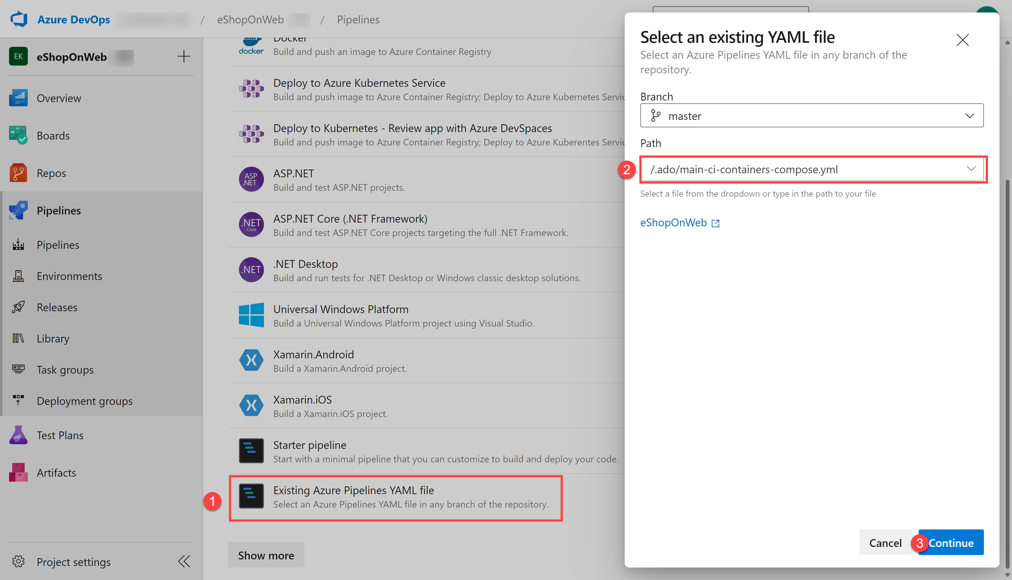

1. In the YAML pipeline definition, update **resource-group** from **AZ400-EWebShop-NAME** to AZ400-EWebShop, update **location:** to eastus2, and replace **YOUR-SUBSCRIPTION-ID** with subscriptionId 75a9c491-529d-4609-88e7-65896da0f685.
2. Click on **Save and Run** and wait for the pipeline to execute successfully. You may need to click **Save and Run** a second time to complete the pipeline creation and run process.

**Important**: If you see the message "This pipeline needs permission to access resources before this run can continue to Docker Compose to ACI", click on View, Permit and Permit again. This is needed to allow the pipeline to create the resource. You must click the build job in order to see the Permission message.

**Note**: The build may take a few minutes to complete. The build definition consists of the following tasks:

* + **AzureResourceManagerTemplateDeployment** uses **bicep** to deploy an Azure Container Registry.
  + **PowerShell** task take the bicep output (acr login server) and creates pipeline variable.
  + **DockerCompose** task builds and pushes the container images for eShopOnWeb to the Azure Container Registry .

1. Your pipeline will take a name based on the project name. Lets **rename** it for identifying the pipeline better. Go to **Pipelines > Pipelines** and click on the recently created pipeline. Click on the ellipsis and **Rename/Remove** option. Name it **eshoponweb-ci-dockercompose** and click on **Save**.
2. Once the execution is finished, on the Azure Portal, open previously defined Resource Group, and you should find an Azure Container Registry (ACR) with the created container images **eshoppublicapi** and **eshopwebmvc**. You will only use **eshopwebmvc** on the deploy phase.

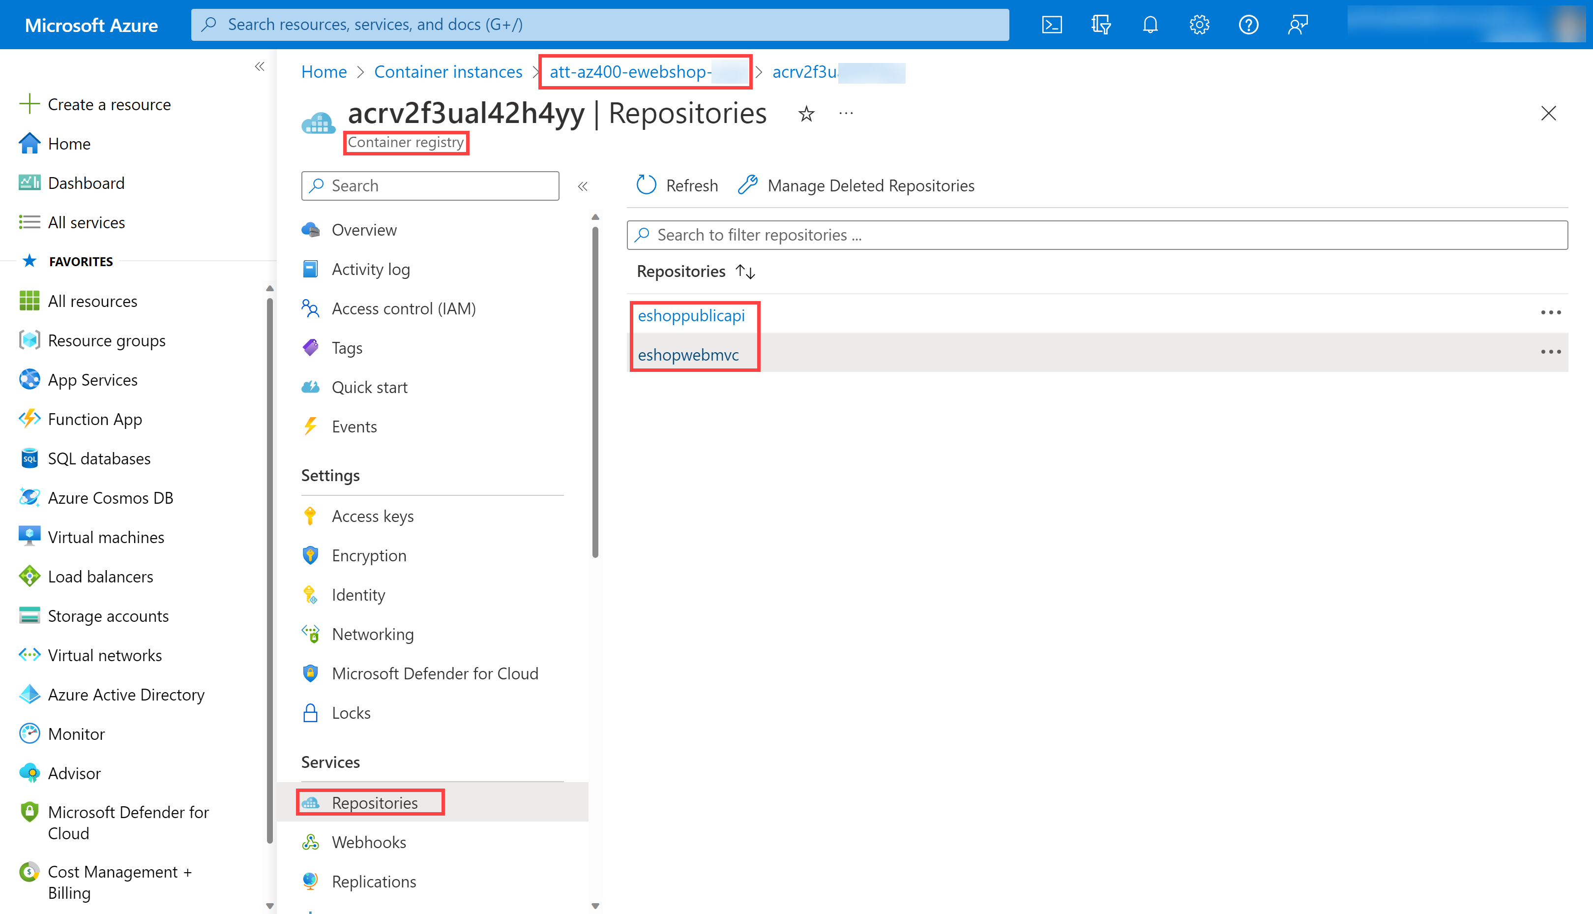

1. Click on **Access Keys**, enable the **Admin user** if not done already, and copy the **password** value. It will be used in the following task, as we will keep it as secret in Azure Key Vault.

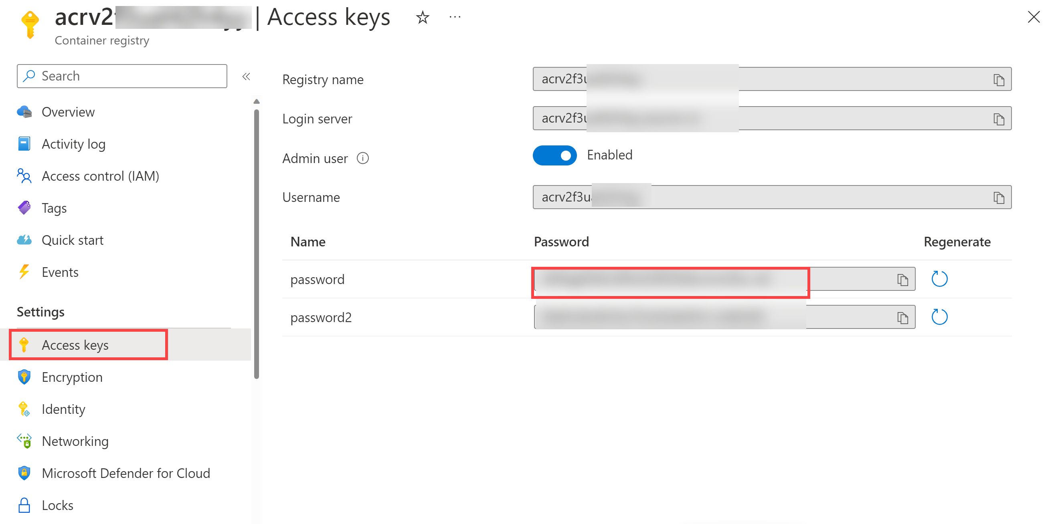

#### Task 2: Create an Azure Key Vault

In this task, you will create an Azure Key Vault by using the Azure portal.

For this lab scenario, we will have a Azure Container Instance (ACI) that pulls and runs a container image stored in Azure Container Registry (ACR). We intend to store the password for the ACR as a secret in the key vault.

1. In the Azure portal, in the **Search resources, services, and docs** text box, type **Key vault** and press the **Enter** key.
2. Select **Key vault** blade, click on **Create > Key Vault**.
3. On the **Basics** tab of the **Create a key vault** blade, specify the following settings and click on **Next**:

|  |  |
| --- | --- |
| **Setting** | **Value** |
| Subscription | the name of the Azure subscription you are using in this lab |
| Resource group | **AZ400-EWebShop** |
| Key vault name | **ewebshop-kv-56849731** |
| Region | **eastus2** |
| Pricing tier | **Standard** |
| Days to retain deleted vaults | **7** |
| Purge protection | **Disable purge protection** |

1. On the **Access configuration** tab of the **Create a key vault** blade, select **Vault access policy** and then in the **Access policies** section, click on **+ Create** to setup a new policy.

**Note**: You need to secure access to your key vaults by allowing only authorized applications and users. To access the data from the vault, you will need to provide read (Get/List) permissions to the service connection that you created during the lab environment validation for authentication in the pipeline.

* 1. On the **Permission** blade, below **Secret permissions**, check **Get** and **List** permissions. Click on **Next**.
  2. On the **Principal** blade, search for your **Azure subscription service connection** (the one created during lab environment validation, typically named "azure subs"), and select it from the list. You can find the service principal name in Azure DevOps under Project Settings > Service connections > azure subs > Manage service principal. If you encounter a permissions error when selecting the Azure subscription, click the **Authorize** button which will automatically create the access policy for you in the key vault. Click on **Next**, **Next**, **Create** (access policy).
  3. On the **Review + create** blade, click on **Create**

1. Back on the **Create a key vault** blade, click on **Review + Create > Create**

**Note**: Wait for the Azure Key Vault to be provisioned. This should take less than 1 minute.

1. On the **Your deployment is complete** blade, click on **Go to resource**.
2. On the Azure Key Vault (ewebshop-kv-NAME) blade, in the vertical menu on the left side of the blade, in the **Objects** section, click on **Secrets**.
3. On the **Secrets** blade, click on **Generate/Import**.
4. On the **Create a secret** blade, specify the following settings and click on **Create** (leave others with their default values):

|  |  |
| --- | --- |
| **Setting** | **Value** |
| Upload options | **Manual** |
| Name | **acr-secret** |
| Secret value | ACR access password copied in previous task |

#### Task 3: Create a Variable Group connected to Azure Key Vault

In this task, you will create a Variable Group in Azure DevOps that will retrieve the ACR password secret from Key Vault using the Service Connection created previously.

1. On your lab computer, start a web browser and navigate to the Azure DevOps project **eShopOnWeb**.
2. In the vertical navigational pane of the of the Azure DevOps portal, select **Pipelines > Library**. Click on **+ Variable Group**.
3. On the **New variable group** blade, specify the following settings:

|  |  |
| --- | --- |
| **Setting** | **Value** |
| Variable Group Name | **eshopweb-vg** |
| Link secrets from an Azure Key Vault | **enable** |
| Azure subscription | **Available Azure service connection > Azure subs** |
| Key vault name | Your key vault name |

1. Under **Variables**, click on **+ Add** and select the **acr-secret** secret. Click on **OK**.
2. Click on **Save**.

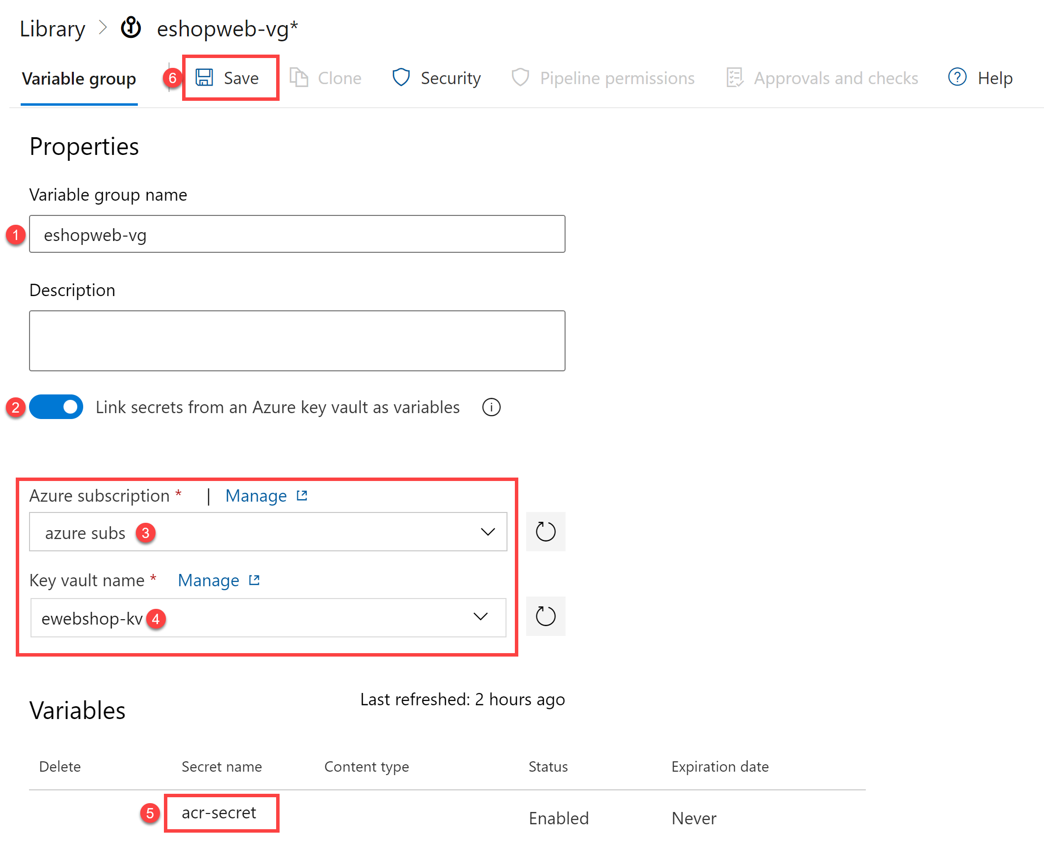

#### Task 4: Setup CD Pipeline to deploy container in Azure Container Instance (ACI)

In this task, you will import a CD pipeline, customize it, and run it for deploying the container image created before in a Azure Container Instance.

1. From the lab computer, start a web browser, navigate to the Azure DevOps **eShopOnWeb** project. Go to **Pipelines > Pipelines** and click on **New Pipeline**.
2. On the **Where is your code?** window, select **Azure Repos Git (YAML)** and select the **eShopOnWeb** repository.
3. On the **Configure** section, choose **Existing Azure Pipelines YAML file**. Select branch: **main**, provide the following path **/.ado/eshoponweb-cd-aci.yml** and click on **Continue**.
4. In the YAML pipeline definition, customize:
   1. **YOUR-SUBSCRIPTION-ID** with your Azure subscription id of 75a9c491-529d-4609-88e7-65896da0f685.
   2. **WEBAPPNAME:** az400eshop56849731
   3. **YOUR-ACR.azurecr.io** and **ACR-USERNAME** with your ACR login server (both need the ACR name, can be reviewed on the ACR > Access Keys).
   4. **AZ400-EWebShop-NAME** with the resource group name AZ400-EWebShop
   5. Update **location:** with **eastus2**
5. Click on **Save and Run**. You may need to click **Save and Run** a second time to complete the pipeline creation and run process. You must click the build job in order to see any Permission messages.
6. Open the pipeline and wait for it to execute successfully.

**Important**: If you see the message "This pipeline needs permission to access resources before this run can continue to Docker Compose to ACI", click on View, Permit and Permit again. This is needed to allow the pipeline to create the resource.

**Note**: The deployment may take a few minutes to complete. The CD definition consists of the following tasks:

* + **Resources** : it is prepared to automatically trigger based on CI pipeline completion. It also download the repository for the bicep file.
  + **Variables (for Deploy stage)** connects to the variable group to consume the Azure Key Vault secret **acr-secret**
  + **AzureResourceManagerTemplateDeployment** deploys the Azure Container Instance (ACI) using bicep template and provides the ACR login parameters to allow ACI to download the previously created container image from Azure Container Registry (ACR).

1. To verify the results of the pipeline deployment, in the Azure portal, search for and select the **AZ400-EWebShop-NAME** resource group. In the list of resources, verify that the **az400eshop** container instance was created by the pipeline.
2. Your pipeline will take a name based on the project name. Lets **rename** it for identifying the pipeline better. Go to **Pipelines > Pipelines** and click on the recently created pipeline. Click on the ellipsis and **Rename/Remove** option. Name it **eshoponweb-cd-aci** and click on **Save**.

Remember to delete the resources created in the Azure portal to avoid unnecessary charges.

## Review

In this lab, you integrated Azure Key Vault with an Azure DevOps pipeline by using the following steps:

* Created an Azure Key Vault to store an ACR password as a secret.
* Provided access to secrets in the Azure Key Vault.
* Configured permissions to read the secret.
* Configured a pipeline to retrieve the password from the Azure Key Vault and pass it on to subsequent tasks.
* Deployed a container image to Azure Container Instance (ACI) using the secret.
* Created a Variable Group connected to Azure Key Vault.

### Congratulations

You have successfully completed this lab. Click **End** to mark the lab as **Complete**.

1 Hr 54 Min Remaining

# Control Deployments using Release Gates

## Lab requirements

In this **Cloudslice** lab these Lab Requirements listed immediately below have already been completed for you.

* This lab requires **Microsoft Edge** or an [Azure DevOps supported browser.](https://docs.microsoft.com/azure/devops/server/compatibility)
* **Set up an Azure DevOps organization:** If you don't already have an Azure DevOps organization that you can use for this lab, create one by following the instructions available at [Create an organization or project collection](https://docs.microsoft.com/azure/devops/organizations/accounts/create-organization).
* Identify an existing Azure subscription or create a new one.
* Verify that you have a Microsoft account or a Microsoft Entra account with the Owner role in the Azure subscription and the Global Administrator role in the Microsoft Entra tenant associated with the Azure subscription. For details, refer to [List Azure role assignments using the Azure portal](https://docs.microsoft.com/azure/role-based-access-control/role-assignments-list-portal) and [View and assign administrator roles in Azure Active Directory](https://docs.microsoft.com/azure/active-directory/roles/manage-roles-portal).

## Lab overview

This lab covers the configuration of the deployment gates and details how to use them to control the execution of Azure Pipelines. To illustrate their implementation, you'll configure a release definition with two environments for an Azure Web App. You'll deploy to the DevTest environment only when there are no blocking bugs for the app and mark the DevTest environment complete only when there are no active alerts in Application Insights of Azure Monitor.

A release pipeline specifies the end-to-end release process for an application to be deployed across various environments. Deployments to each environment are fully automated by using jobs and tasks. Ideally, you don't want new updates to the applications to be simultaneously exposed to all the users. It's a best practice to expose updates in a phased manner, that is, expose them to a subset of users, monitor their usage, and expose them to other users based on the experience of the initial set of users.

Approvals and gates enable you to take control over the start and completion of the deployments in a release. You can wait for users to approve or reject deployments with approvals manually. Using release gates, you can specify application health criteria to be met before the release is promoted to the following environment. Before or after any environment deployment, all the specified gates are automatically evaluated until they pass or reach your defined timeout period and fail.

Gates can be added to an environment in the release definition from the pre-deployment conditions or the post-deployment conditions panel. Multiple gates can be added to the environment conditions to ensure all the inputs are successful for the release.

As an example:

* Pre-deployment gates ensure no active issues in the work item or problem management system before deploying a build to an environment.
* Post-deployment gates ensure no incidents from the app's monitoring or incident management system after being deployed before promoting the release to the following environment.

There are 4 types of gates included by default in every account.

* Invoke Azure Function: Trigger the execution of an Azure Function and ensures a successful completion.
* Query Azure Monitor alerts: Observe the configured Azure Monitor alert rules for active alerts.
* Invoke REST API: Make a call to a REST API and continues if it returns a successful response.
* Query work items: Ensure the number of matching work items returned from a query is within a threshold.

## Objectives

After you complete this lab, you will be able to:

* Configure release pipelines.
* Configure release gates.
* Test release gates.

## Estimated timing: 75 minutes

## Instructions

### Exercise 0: Configure the lab prerequisites

In this **Cloudslice** lab, please skip **Tasks 1 and 2**

In this exercise, you will set up the prerequisites for the lab.

#### Task 1: (skip if done) Create and configure the team project

In this task, you will create an **eShopOnWeb** Azure DevOps project to be used by several labs.

1. On your lab computer, in a browser window open your Azure DevOps organization. Click on **New Project**. Give your project the name **eShopOnWeb** and leave the other fields with defaults. Click on **Create**.



#### Task 2: (skip if done) Import eShopOnWeb Git Repository

In this task you will import the eShopOnWeb Git repository that will be used by several labs.

1. On your lab computer, in a browser window open your Azure DevOps organization and the previously created **eShopOnWeb** project. Click on **Repos > Files** , **Import a Repository**. Select **Import**. On the **Import a Git Repository** window, paste the following URL <https://github.com/MicrosoftLearning/eShopOnWeb.git> and click **Import**:



1. The repository is organized the following way:
   1. **.ado** folder contains Azure DevOps YAML pipelines.
   2. **.devcontainer** folder container setup to develop using containers (either locally in VS Code or GitHub Codespaces).
   3. **infra** folder contains Bicep&ARM infrastructure as code templates used in some lab scenarios.
   4. **.github** folder container YAML GitHub workflow definitions.
   5. **src** folder contains the .NET 8 website used on the lab scenarios.
2. Go to **Repos > Branches**.
3. Hover on the **main** branch then click the ellipsis on the right of the column.
4. Click on **Set as default branch**.

#### Task 3: Configure CI Pipeline as Code with YAML in Azure DevOps

In this task, you will add a YAML build definition to the existing project.

1. Navigate back to the **Pipelines** pane in of the **Pipelines** hub.
2. In the **Create your first Pipeline** window, click **Create pipeline**.

**Note**: We will use the wizard to create a new YAML Pipeline definition based on our project.

1. On the **Where is your code?** pane, click **Azure Repos Git (YAML)** option.
2. On the **Select a repository** pane, click **eShopOnWeb**.
3. On the **Configure your pipeline** pane, scroll down and select **Existing Azure Pipelines YAML File**.
4. In the **Selecting an existing YAML File** blade, specify the following parameters:
   1. Branch: **main**
   2. Path: **.ado/eshoponweb-ci.yml**
5. Click **Continue** to save these settings.
6. From the **Review your Pipeline YAML** screen, click **Run** to start the Build Pipeline process.
7. Wait for the Build Pipeline to complete successfully. Ignore any warnings regarding the source code itself, as they are not relevant for this lab exercise.

**Note**: Each task from the YAML file is available for review, including any warnings and errors.

1. Your pipeline will take a name based on the project name. Let's **rename** it for identifying the pipeline better. Go to **Pipelines > Pipelines** and click on the recently created pipeline. Click on the ellipsis and **Rename/move** option. Name it **eshoponweb-ci** and click on **Save**.

### Exercise 1: Creating the necessary Azure Resources for the Release Pipeline

#### Task 1: Create two Azure web apps

In this task, you will create two Azure web apps representing the **DevTest** and **Production** environments, into which you'll deploy the application via Azure Pipelines.

1. From the lab computer, start a web browser, navigate to the **Azure Portal** [https:*//portal.azure.com*](https://portal.azure.com), and sign in with the user account that has the Owner role in the Azure subscription you will be using in this lab and has the role of the Global Administrator in the Microsoft Entra tenant associated with this subscription.
2. In the Azure portal, click the **Cloud Shell** icon, located directly to the right of the search textbox at the top of the page.
3. If prompted to select either **Bash** or **PowerShell**, select **Bash**.

**Note**: If this is the first time you are starting **Cloud Shell** and you are presented with the **You have no storage mounted** message, select the subscription you are using in this lab, and click **Apply**.

1. From the **Bash** prompt, in the **Cloud Shell** pane, run the following command to create a resource group

bashTypeCopy

REGION='northcentralus'  
RESOURCEGROUPNAME='az400m03l08-RG'  
az group create -n $RESOURCEGROUPNAME -l $REGION

1. To create an App service plan

bashTypeCopy

SERVICEPLANNAME='az400m03l08-sp1'  
az appservice plan create -g $RESOURCEGROUPNAME -n $SERVICEPLANNAME --sku S1

1. Create two web apps with unique app names.

bashTypeCopy

SUFFIX=56850139  
az webapp create -g $RESOURCEGROUPNAME -p $SERVICEPLANNAME -n RGATES$SUFFIX-DevTest  
az webapp create -g $RESOURCEGROUPNAME -p $SERVICEPLANNAME -n RGATES$SUFFIX-Prod

**Note**: Record the name of the DevTest web app. You will need it later in this lab.

**Note**: If you encounter an error "The subscription is not registered to use namespace 'Microsoft.Web'", run the following command to register the Microsoft.Web resource provider: az provider register --namespace Microsoft.Web and wait for the registration to complete before creating the web apps.

1. Wait for the Web App Services Resources provisioning process to complete and close the **Cloud Shell** pane.

#### Task 2: Configure an Application Insights resource

1. In the Azure portal, use the **Search resources, services, and docs** text box at the top of the page to search for **Application Insights** and, in the list of results, select **Application Insights**.
2. On the **Application Insights** blade, select **+ Create**.
3. On the **Application Insights** blade, on the **Basics** tab, specify the following settings (leave others with their default values):

|  |  |
| --- | --- |
| **Setting** | **Value** |
| Resource group | **az400m03l08-RG** |
| Name | the name of the DevTest web app you recorded in the previous task |
| Region | the same Azure region to which you deployed the web apps earlier in the previous task |

1. Click **Review + create** and then click **Create**.
2. Wait for the provisioning process to complete.
3. In the Azure portal, navigate to the resource group **az400m03l08-RG** you created in the previous task.
4. In the list of resources, click the **DevTest** web app.
5. On the **DevTest** web app page, in the vertical menu on the left, in the **Monitoring** section, click **Application Insights**.
6. On the **Application Insights** blade, click **Turn on Application Insights**.
7. In the **Change your resource** section, click the **Select existing resource** option, in the list of existing resources, select the newly created Application Insight resource, click **Apply** and, when prompted for confirmation, click **Yes**.
8. Wait until the change takes effect.

**Note**: You will create monitor alerts here, which you will use in later part of this lab.

1. From the same **Settings** / **Application Insights** menu option within the Web App, select **View Application Insights Data**. This redirects you to the Application Insights blade in the Azure Portal.
2. On the Application Insights resource blade, in the **Monitoring** section, click **Alerts** and then click **Create > Alert rule**.
3. On the **Create an Alert Rule** blade, in the **Condition** section, click the **See all signals** link, type **Requests**. From the list of results, select **Failed Requests**.
4. On the **Create an Alert Rule** blade, in the **Condition** section, leave the **Threshold** set to **Static**, validate the other default settings as follows:
   1. Aggregation Type: Count
   2. Operator: Greater Than
   3. Unit: Count
5. In the **Threshold value** textbox, type **0**, and click on **Next:Actions**. Don't make any changes in the **Actions** settings blade, and define the following parameters under the **Details** section:

|  |  |
| --- | --- |
| **Setting** | **Value** |
| Severity | **2- Warning** |
| Alert rule name | **RGATESDevTest_FailedRequests** |
| Advanced Options: Automatically resolve alerts | **cleared** |

**Note**: Metric alert rules might take up to 10 minutes to activate.

**Note**: You can create multiple alert rules on different metrics such as availability < 99 percent, server response time > 5 Seconds, or server exceptions > 0

1. Confirm the creation of the Alert rule by clicking **Review+Create**, and confirm once more by clicking **Create**. Wait for the alert rule to get created successfully.

### Exercise 2: Configure the release pipeline

In this exercise, you will configure a release pipeline.

#### Task 1: Set Up Release Tasks

In this task, you will set up the release tasks as part of the Release Pipeline.

1. From the **eShopOnWeb** project in the Azure DevOps portal, in the vertical navigational pane, select **Pipelines** and then, within the **Pipelines** section, click **Releases**. > **Note**: If the **Releases** section is not visible, it is likely because the **Disable creation of classic release pipelines** toggle is set to **On** under the **Project Settings** > **Pipelines** > **Settings** > **General** section.
2. Click **New Pipeline**.
3. From the **Select a template** window, **choose** **Azure App Service Deployment** (Deploy your application to Azure App Service. Choose from Web App on Windows, Linux, containers, Function Apps, or WebJobs) under the **Featured** list of templates.
4. Click **Apply**.
5. From the **Stage** window appearing, update the default "Stage 1" Stage Name to **DevTest**. Close the popup window by using the **X** button. You are now in the graphical editor of the Release Pipeline, showing the DevTest Stage.
6. On the top of the page, rename the current pipeline from **New release pipeline** to **eshoponweb-cd**.
7. Hover the mouse over the DevTest Stage, and click the **Clone** button, to copy the DevTest Stage to an additional Stage. Name this Stage **Production**.

**Note**: The pipeline now contains two stages named **DevTest** and **Production**.

1. On the **Pipeline** tab, select the **Add an Artifact** rectangle, and select the **eshoponweb-ci** in the **Source (build pipeline)** field. Click **Add** to confirm the selection of the artifact.
2. From the **Artifacts** rectangle, notice the **Continuous deployment trigger** (lightning bolt). Click it to open the **Continuous deployment trigger** settings. Click **Disabled** to toggle the switch and enable it. Leave all other settings at default and close the **Continuous deployment trigger** pane, by clicking the **x** mark in its upper right corner.
3. Within the **DevTest Environments** stage, click the **1 job, 1 task** label and review the tasks within this stage.

**Note**: The DevTest environment has 1 task which, respectively, publishes the artifact package to Azure Web App.

1. On the **All pipelines > eshoponweb-cd** pane, ensure that the **DevTest** stage is selected. In the **Azure subscription** dropdown list, select your Azure subscription and click **Authorize**. If prompted, authenticate by using the user account with the Owner role in the Azure subscription.
2. Confirm the App Type is set to "Web App on Windows". Next, in the **App Service name** dropdown list, select the name of the **DevTest** web app.
3. Select the Task **Deploy Azure App Service**. In the **Package or Folder** field, update the default value of **$(System.DefaultWorkingDirectory)/**/*.zip** to $(System.DefaultWorkingDirectory)*/**/*Web.zip

**Note**: Notice an exclamation mark next to the Tasks tab. This is expected, as we need to configure the settings for the Production Stage.

1. Open the **Application and Configuration Settings** pane and enter -UseOnlyInMemoryDatabase true -ASPNETCORE_ENVIRONMENT Development in the **App settings** box.
2. On the **All pipelines > eshoponweb-cd** pane, navigate to the **Pipeline** tab, and this time, within the **Production** Stage, click the **1 job, 1 task** label. Similar to the DevTest stage earlier, complete the pipeline settings. Under the Tasks tab / Production Deployment process, in the **Azure subscription** dropdown list, select the Azure subscription you used for the **DevTest Environment** stage, shown under **Available Azure Service connections**, as we already created the service connection before when authorizing the subscription use.
3. In the **App Service name** dropdown list, select the name of the **Prod** web app.
4. Select the Task **Deploy Azure App Service**. In the **Package or Folder** field, update the default value of **$(System.DefaultWorkingDirectory)/**/*.zip** to $(System.DefaultWorkingDirectory)*/**/*Web.zip
5. Open the **Application and Configuration Settings** pane and enter -UseOnlyInMemoryDatabase true -ASPNETCORE_ENVIRONMENT Development in the **App settings** box.
6. On the **All pipelines > eshoponweb-cd** pane, click **Save** and, in the **Save** dialog box, click **OK**.

You have now successfully configured the Release Pipeline.

1. In the browser window displaying the **eShopOnWeb** project, in the vertical navigational pane, in the **Pipelines** section, click **Pipelines**.
2. On the **Pipelines** pane, click the entry representing **eshoponweb-ci** build pipeline and then click on **Run Pipeline**.
3. On the **Run pipeline** pane, accept the default settings and click **Run** to trigger the pipeline. **Wait for the build pipeline to finish**.

**Note**: After the build succeeds, the release will be triggered automatically and the application will be deployed to both the environments. Validate the release actions, once the build pipeline completed successfully.

1. In the vertical navigational pane, in the **Pipelines** section, click **Releases** and, on the **eshoponweb-cd** pane, click the entry representing the most recent release.
2. On the **eshoponweb-cd > Release-1** blade, track the progress of the release and verify that the deployment to both web apps completed successfully.
3. Switch to the Azure portal interface, navigate to the resource group **az400m03l08-RG**, in the list of resources, click the **DevTest** web app, on the web app blade, click **Browse**, and verify that the web page (E-commerce website) loads successfully in a new web browser tab.
4. Switch back to the Azure portal interface, this time navigating to the resource group **az400m03l08-RG**, in the list of resources, click the **Production** web app, on the web app blade, click **Browse**, and verify that the web page loads successfully in a new web browser tab.
5. Close the web browser tab displaying the **EShopOnWeb** web site.

**Note**: Now you have the application with CI/CD configured. In the next exercise we will set up Quality Gates as part of a more advanced Release pipeline.

### Exercise 3: Configure release gates

In this exercise, you will set up Quality Gates in the release pipeline.

#### Task 1: Configure pre-deployment gates for approvals

In this task, you will configure pre-deployment gates.

1. Switch to the web browser window displaying the Azure DevOps portal, and open the **eShopOnWeb** project. In the vertical navigational pane, in the **Pipelines** section, click **Releases** and, on the **eshoponweb-cd** pane, click **Edit**.
2. On the **All pipelines > eshoponweb-cd** pane, on the left edge of the rectangle representing the **DevTest Environment** stage, click the oval shape representing the **Pre-deployment conditions**.
3. On **Pre-deployment conditions** pane, set the **Pre-deployment approvals** slider to **Enabled** and, in the **Approvers** text box, type and select your Azure DevOps account name.

**Note**: In a real-life scenario, this should be a DevOps Team name alias instead of your own name.

1. **Save** the pre-approval settings and close the popup window.
2. Click **Create Release** and confirm by pressing the **Create** button from the popup window.
3. Notice the green confirmation message, saying "Release-2" has been created. Click the link of "Release-2" to navigate to its details.
4. Notice the **DevTest** Stage is in a **Pending Approval** state. Click the **Approve** button. This sets off the DevTest Stage again.

#### Task 2: Configure post-deployment gates for Azure Monitor

In this task, you will enable the post-deployment gate for the DevTest Environment.

1. Back on the **All pipelines > eshoponweb-cd** pane, on the right edge of the rectangle representing the **DevTest Environment** stage, click the oval shape representing the **Post-deployment conditions**.
2. On **Post-deployment conditions** pane, set the **Gates** slider to **Enabled**, click **+ Add**, and, in the pop-up menu, click **Query Azure Monitor Alerts**.
3. On **Post-deployment conditions** pane, in the **Query Azure Monitor Alerts** section, in the **Azure subscription** dropdown list, select the **service connection** entry representing the connection to your Azure subscription, and, in the **Resource group** dropdown list, select the **az400m03l08-RG** entry.
4. On the **Post-deployment conditions** pane, expand the **Advanced** section and configure the following options:
   1. Filter type: **None**
   2. Severity: **Sev0, Sev1, Sev2, Sev3, Sev4**
   3. Time Range: **Past Hour**
   4. Alert State: **Acknowledged, New**
   5. Monitor Condition: **Fired**
5. On **Post-deployment conditions** pane, expand the **Evaluation options** and configure the following options:
   1. Set the value of **Time between re-evaluation of gates** to **5 Minutes**.
   2. Set the value of **Timeout after which gates fail** to **8 Minutes**.
   3. Select the **On successful gates, ask for approvals** option.

**Note**: The sampling interval and timeout work together so that the gates will call their functions at suitable intervals and reject the deployment if they don't succeed during the same sampling interval within the timeout period.

1. Close the **Post-deployment conditions** pane, by clicking the **x** mark in its upper right corner.
2. Back on the **eshoponweb-cd** pane, click **Save**, and in the **Save** dialog box, click **OK**.

### Exercise 4: Test release gates

In this exercise, you will test the release gates by updating the application, which will trigger a deployment.

#### Task 1: Update and deploy application after adding release gates

In this task, you will first generate some alerts for the DevTest Web App, followed by tracking the release process with the release gates enabled.

1. From the Azure Portal, browse to the **DevTest Web App** Resource deployed earlier.
2. From the Overview pane, notice the **URL** field showing the Hyperlink of the web application. Click this link, which redirects you to the eShopOnWeb web application in the browser.
3. To simulate a **Failed Request**, add **/discount** to the URL, which will result in an error message, since that page does not exist. Refresh this page several times to generate multiple events.
4. From the Azure Portal, in the "Search resources, services and docs" field, enter **Application Insights** and select the **DevTest-AppInsights** Resource created in the previous exercise. Next, navigate to **Alerts**.
5. There should be at least **1** new alert in the list of results, having a **Severity 2** enter **Alerts** to open the Alerts Service of Azure Monitor.
6. Notice there should be at least **1** Failed_Alert with **Severity 2 - Warning** showing up in the list. This got trigger when you validated the non-existing website URL address in the previous exercise.

**Note:** If no Alert shows up yet, wait another few minutes.

1. Return back to the Azure DevOps Portal, open the **eShopOnWeb** Project. Navigate to **Pipelines**, select **Releases** and select the **eshoponweb-cd**.
2. Click the **Create Release** button.
3. Wait for the Release pipeline to kick off, and **approve** the DevTest Stage release action.
4. Wait for the DevTest release Stage to complete successfully. Notice how the **Post-deployment Gates** is switching to an **Evaluation Gates** status. Click the **Evaluation Gates** icon.
5. For the **Query Azure Monitor Alerts**, notice an initial failed state.
6. Let the Release pipeline in a pending state for the next 5 minutes. After the 5 minutes did pass, notice the 2nd evaluation failing again.
7. This is expected behavior, since there is an Application Insights Alerts triggered for the DevTest Web App.

**Note**: Since there is an alert triggered by the exception, **Query Azure Monitor** gate will fail. This, in turn, will prevent deployment to the **Production** environment.

1. Wait a couple of minutes and validate the status of the Release Gates again. Within a few minutes after the initial Release Gates got checked, and since the initial Application Insight Alert got triggered with the action "Fired", it should result in a successful Release Gate, allowing the deployment of the Production Release Stage.

**Note:** If your gate fails, close the alert.

[!IMPORTANT] Remember to delete the resources created in the Azure portal to avoid unnecessary charges.

## Review

In this lab, you configured release pipelines and then configured and tested release gates.

### Congratulations

You have successfully completed this lab. Click **End** to mark the lab as **Complete**.

1 Hr 57 Min Remaining

Set up and run functional tests

[End](https://labclient.labondemand.com/Instructions/9dbed3fc-ae56-4235-b153-9c09d4d6d265#)

InstructionsResources

# Set up and run functional tests

## Lab requirements

In this **Cloudslice** lab these Lab Requirements listed immediately below have already been completed for you.

* This lab requires **Microsoft Edge** or an [Azure DevOps supported browser.](https://docs.microsoft.com/azure/devops/server/compatibility)
* **Set up an Azure DevOps organization:** If you don't already have an Azure DevOps organization that you can use for this lab, create one by following the instructions available at [Create an organization or project collection](https://learn.microsoft.com/dotnet/architecture/modern-web-apps-azure/test-asp-net-core-mvc-apps).

## Lab overview

Software of any complexity can fail in unexpected ways in response to changes. Thus, testing after making changes is required for all but the most trivial (or least critical) applications. Manual testing is the slowest, least reliable, most expensive way to test software.

There are many kinds of automated tests for software applications. The simplest, lowest level test is the unit test. At a slightly higher level, there are integration tests and functional tests. Other kinds of tests, such as UI tests, load tests, stress tests, and smoke tests, are beyond the scope of this lab.

*If you want to know more about the different types of testing, we recommend you reading this article:* [*Test ASP.NET Core MVC apps*](https://learn.microsoft.com/dotnet/architecture/modern-web-apps-azure/test-asp-net-core-mvc-apps)*.*

## Objectives

After you complete this lab, you will be able to configure a CI pipeline for a .Net application that includes:

* Unit Tests
* Integration Tests
* Functional Tests

## Estimated timing: 20 minutes

## Instructions

### Exercise 0: (skip if done) Configure the lab prerequisites

In this **Cloudslice** lab, please skip **Exercise 0 Task 1** you may continue with **Exercise 0, Task 2**

In this exercise, you will set up the prerequisites for the lab, which consist of a new Azure DevOps project with a repository based on the [eShopOnWeb](https://github.com/MicrosoftLearning/eShopOnWeb).

#### Task 1: (skip if done) Create and configure the team project

In this task, you will create an **eShopOnWeb** Azure DevOps project to be used by several labs.

1. On your lab computer, in a browser window open your Azure DevOps organization. Click on **New Project**. Give your project the name **eShopOnWeb** and leave the other fields with defaults. Click on **Create**.

#### Task 2: (skip if done) Import the eShopOnWeb Git Repository

In this task you will import the eShopOnWeb Git repository that will be used by several labs.

1. On your lab computer, in a browser window open your Azure DevOps organization and the previously created **eShopOnWeb** project. Click on **Repos > Files** , **Import a Repository**. Select **Import**. On the **Import a Git Repository** window, paste the following URL [https:*//github.com/MicrosoftLearning/eShopOnWeb.git*](https://github.com/MicrosoftLearning/eShopOnWeb.git) and click **Import**:
2. The repository is organized the following way:
   1. **.ado** folder contains Azure DevOps YAML pipelines.
   2. **.devcontainer** folder container setup to develop using containers (either locally in VS Code or GitHub Codespaces).
   3. **infra** folder contains Bicep & ARM infrastructure as code templates used in some lab scenarios.
   4. **.github** folder contains YAML GitHub workflow definitions.
   5. **src** folder contains the .NET website used in the lab scenarios.

#### Task 3: (skip if done) Set main branch as default branch

1. Go to **Repos > Branches**.
2. Hover on the **main** branch then click the ellipsis on the right of the column.
3. Click on **Set as default branch**.

To correct for a known issue, please implement the following steps before proceeding:

* Go to **Repos > Files** and select **Directory.Packages.props** and then select the **Edit** button
* Change Microsoft.EntityFrameworkCore.Tools from version 9.0.4 to 8.0.8
* Change System.Text.Json from version 9.0.4 (or 9.0.2) to 8.0.1
* Select the **Commit** button, and then select **Commit** again.

### Exercise 1: Setup Tests in CI pipeline

In this exercise, you will setup tests in CI pipeline.

#### Task 1: (Skip if done) Import the YAML build definition for CI

In this task, you will add the YAML build definition that will be used to implement the Continuous Integration.

Let's start by importing the CI pipeline named [eshoponweb-ci.yml](https://github.com/MicrosoftLearning/eShopOnWeb/blob/main/.ado/eshoponweb-ci.yml).

1. Go to **Pipelines > Pipelines**.
2. Click on **New Pipeline** button (or **Create Pipeline** if you haven't any pipeline).
3. Select **Azure Repos Git (YAML)**.
4. Select the **eShopOnWeb-56850504** repository.
5. Select **Existing Azure Pipelines YAML File**.
6. Select the **main** branch and the **/.ado/eshoponweb-ci.yml** file, then click on **Continue**.

The CI definition consists of the following tasks:

* 1. **DotNet Restore**: With NuGet Package Restore you can install all your project's dependency without having to store them in source control.
  2. **DotNet Build**: Builds a project and all of its dependencies.
  3. **DotNet Test**: .Net test driver used to execute unit tests.
  4. **DotNet Publish**: Publishes the application and its dependencies to a folder for deployment to a hosting system. In this case, it's **Build.ArtifactStagingDirectory**.
  5. **Publish Artifact - Website**: Publish the app artifact (created in the previous step) and make it available as a pipeline artifact.
  6. **Publish Artifact - Bicep**: Publish the infrastructure artifact (Bicep file) and make it available as a pipeline artifact.

1. Click the **Save** button (not **Save and run**) on the top-right part of the page to save the pipeline definition. You can find the **Save** button by clicking on the arrow to the right of the **Save and Run** (or **Run**) button.

#### Task 2: Add tests to the CI pipeline

In this task, you will add the integration and functional tests to the CI Pipeline.

You can notice that the Unit Tests task is already part of the pipeline.

* **Unit Tests** test a single part of your application's logic. One can further describe it by listing some of the things that it isn't. A unit test doesn't test how your code works with dependencies or infrastructure – that's what integration tests are for.

1. Edit the pipeline you created in the previous task pressing the **Edit** button.
2. Now you need to add the Integration Tests task after the Unit Tests task:

YAMLTypeCopy

- task: DotNetCoreCLI@2  
 displayName: Integration Tests  
 inputs:  
 command: 'test'  
 projects: 'tests/IntegrationTests/*.csproj'

**Integration Tests** test how your code works with dependencies or infrastructure. Although it's a good idea to encapsulate your code that interacts with infrastructure like databases and file systems, you will still have some of that code, and you will probably want to test it. Additionally, you should verify that your code's layers interact as you expect when your application's dependencies are fully resolved. This functionality is the responsibility of integration tests.

1. Then you need to add the Functional tests task after the Integration Tests task:

YAMLTypeCopy

- task: DotNetCoreCLI@2  
 displayName: Functional Tests  
 inputs:  
 command: 'test'  
 projects: 'tests/FunctionalTests/*.csproj'

**Functional Tests** are written from the perspective of the user, and verify the correctness of the system based on its requirements. Unlike integration tests that are written from the perspective of the developer, to verify that some components of the system work correctly together.

1. Click **Validate and Save** button, and if validation is successful, click **Save** again to commit the changes directly into the main branch.

#### Task 3: Check the tests summary

1. Click on the **Run**, then from the **Run pipeline** tab, click on **Run** again.
2. Wait for the pipeline to start and until it completes the Build Stage successfully.
3. Once completed, the **Test** tab will show as part of the pipeline run. Click on it to check the summary. It looks like shown below:

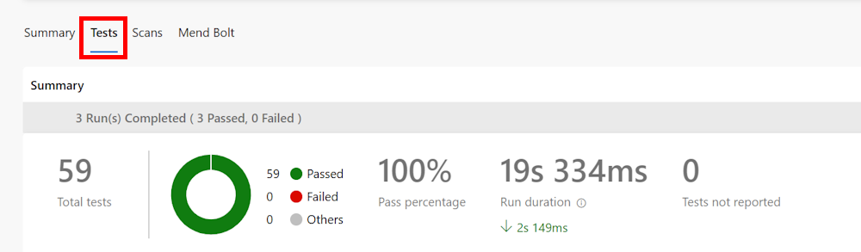

1. For more details, at the bottom of the page, the table shows a list of the different run tests.

**Note**: If the table is empty, you need to reset the filters to have all the details about the tests run.

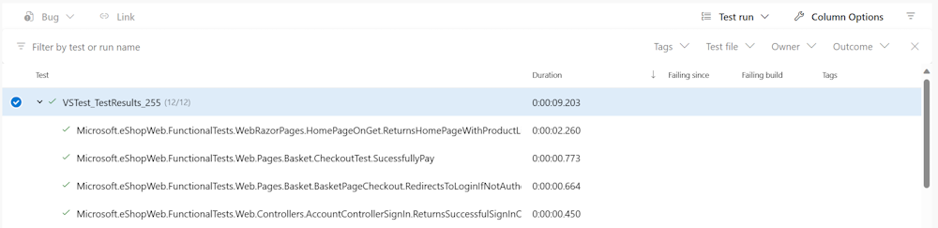

## Review

In this lab, you learned how to setup and run different tests types using Azure Pipelines and .NET.

### Congratulations

You have successfully completed this lab. Click **End** to mark the lab as **Complete**.

2 Hours Remaining

# Enable Dynamic Configuration and Feature Flags

## Lab requirements

In this **Cloudslice** lab these Lab Requirements listed immediately below have already been completed for you.

* This lab requires **Microsoft Edge** or an [Azure DevOps supported browser.](https://learn.microsoft.com/azure/devops/server/compatibility)
* **Set up an Azure DevOps organization:** If you don't already have an Azure DevOps organization that you can use for this lab, create one by following the instructions available at [Create an organization or project collection](https://learn.microsoft.com/azure/devops/organizations/accounts/create-organization?view=azure-devops).
* Identify an existing Azure subscription or create a new one.
* Verify that you have a Microsoft account or a Microsoft Entra account with the Contributor or the Owner role in the Azure subscription. For details, refer to [List Azure role assignments using the Azure portal](https://learn.microsoft.com/azure/role-based-access-control/role-assignments-list-portal) and [View and assign administrator roles in Azure Active Directory](https://learn.microsoft.com/azure/active-directory/roles/manage-roles-portal).

## Lab overview

[Azure App Configuration](https://learn.microsoft.com/azure/azure-app-configuration/overview) provides a service to manage application settings and feature flags centrally. Modern programs, especially those running in a cloud, generally have many distributed components. Spreading configuration settings across these components can lead to hard-to-troubleshoot errors during application deployment. Use App Configuration to store all the settings for your application and secure their accesses in one place.

## Objectives

After you complete this lab, you will be able to:

* Enable dynamic configuration.
* Manage feature flags.

## Estimated timing: 45 minutes

## Instructions

### Exercise 0: (skip if done) Configure the lab prerequisites

In this **Cloudslice** lab, please skip **Exercise 0**

In this exercise, you will set up the prerequisites for the lab, which consist of a new Azure DevOps project with a repository based on the [eShopOnWeb](https://github.com/MicrosoftLearning/eShopOnWeb).

#### Task 1: (skip if done) Create and configure the team project

In this task, you will create an **eShopOnWeb** Azure DevOps project to be used by several labs.

1. On your lab computer, in a browser window open your Azure DevOps organization. Click on **New Project**. Give your project the name **eShopOnWeb** and choose **Scrum** on the **Work Item process** dropdown. Click on **Create**.

#### Task 2: (skip if done) Import eShopOnWeb Git Repository

In this task you will import the eShopOnWeb Git repository that will be used by several labs.

1. On your lab computer, in a browser window open your Azure DevOps organization and the previously created **eShopOnWeb** project. Click on **Repos > Files** , **Import**. On the **Import a Git Repository** window, paste the following URL <https://github.com/MicrosoftLearning/eShopOnWeb.git> and click on **Import**:
2. The repository is organized the following way:
   1. **.ado** folder contains Azure DevOps YAML pipelines.
   2. **.devcontainer** folder container setup to develop using containers (either locally in VS Code or GitHub Codespaces).
   3. **infra** folder contains Bicep&ARM infrastructure as code templates used in some lab scenarios.
   4. **.github** folder container YAML GitHub workflow definitions.
   5. **src** folder contains the .NET 8 website used on the lab scenarios.

#### Task 3: (skip if done) Set main branch as default branch

1. Go to **Repos > Branches**.
2. Hover on the **main** branch then click the ellipsis on the right of the column.
3. Click on **Set as default branch**.

### Exercise 1: (skip if done) Import and run CI/CD Pipelines

In this exercise, you will import CI/CD pipelines to build and deploy the eShopOnWeb application. The CI pipeline is already prepared to build the application and run tests. The CD pipeline will deploy the application to an Azure Web App.

#### Task 1: Import and run the CI pipeline

Let's start by importing the CI pipeline named [eshoponweb-ci.yml](https://github.com/MicrosoftLearning/eShopOnWeb/blob/main/.ado/eshoponweb-ci.yml).

1. Go to **Pipelines > Pipelines**.
2. Click on **Create Pipeline** button (if there are no pipelines) or **New pipeline** button (if there are already created pipelines).
3. Select **Azure Repos Git (Yaml)**.
4. Select the **eShopOnWeb** repository.
5. Select **Existing Azure Pipelines YAML File**.
6. Select the **main** branch and the **/.ado/eshoponweb-ci.yml** file, then click on **Continue**.
7. Click the **Run** button to run the pipeline.
8. Your pipeline will take a name based on the project name. Let's **rename** it for identifying the pipeline better. Go to **Pipelines > Pipelines** and click on the recently created pipeline. Click on the ellipsis and **Rename/Remove** option. Name it **eshoponweb-ci** and click on **Save**.

#### Task 2: Import and run the CD pipeline

Let's import the CD pipeline named [eshoponweb-cd-webapp-code.yml](https://github.com/MicrosoftLearning/eShopOnWeb/blob/main/.ado/eshoponweb-cd-webapp-code.yml).

1. Go to **Pipelines > Pipelines**.
2. Click on **New pipeline** button.
3. Select **Azure Repos Git (Yaml)**.
4. Select the **eShopOnWeb** repository.
5. Select **Existing Azure Pipelines YAML File**.
6. Select the **main** branch and the **/.ado/eshoponweb-cd-webapp-code.yml** file, then click on **Continue**.
7. In the YAML pipeline definition, customize:
   1. **resource-group:** AZ400-RG1
   2. **location:** northcentralus
   3. **subscriptionid:** e1a52230-15f3-41ee-9af1-da93fc128b91
   4. **webappname:** az400-webapp-56850751

In the YAML file also add '/**' to the following 2 lines of code.

* + csmFile: '$(Pipeline.Workspace)/**/Bicep/$(templateFile)'
  + packageForLinux: '$(Pipeline.Workspace)/**/Website/Web.zip'

1. Click on **Save and Run** and wait for the pipeline to execute successfully.

**Note**: You must click **Save and Run** twice. If the Jobs window displays a permission needed message, select **Deploy** from the Jobs window, select **View**, and then **Permit** twice to complete the pipeline run.

**Note**: The deployment may take a few minutes to complete.

The CD definition consists of the following tasks:

* + **Resources**: it is prepared to automatically trigger based on CI pipeline completion. It also downloads the repository for the bicep file.
  + **AzureResourceManagerTemplateDeployment**: Deploys the Azure Web App using bicep template.

1. Your pipeline will take a name based on the project name. Let's **rename** it for identifying the pipeline better. Go to **Pipelines > Pipelines** and click on the recently created pipeline. Click on the ellipsis and **Rename/Remove** option. Name it **eshoponweb-cd-webapp-code** and click on **Save**.

### Exercise 2: Manage Azure App Configuration

In this exercise, you will create the App Configuration resource in Azure, enable the managed identity and then test the full solution.

**Note**: This exercise doesn't require any coding skills. The website's code implements already Azure App Configuration functionalities.

If you want to know how to implement this in your application, please take a look at these tutorials: [Use dynamic configuration in an ASP.NET Core app](https://learn.microsoft.com/azure/azure-app-configuration/enable-dynamic-configuration-aspnet-core) and [Manage feature flags in Azure App Configuration](https://learn.microsoft.com/azure/azure-app-configuration/manage-feature-flags).

#### Task 1: Create the App Configuration resource

1. In the Azure Portal, search for the **App Configuration** service
2. Click **Create app configuration** then select:
   1. Your Azure Subscription.
   2. The Resource Group **AZ400-RG1**
   3. Location: northcentralus
   4. A unique name: **appcs-56850751**
   5. Select the **Free** pricing tier.
3. Click on **Review + create** then **Create**.
4. After creating the App Configuration service, go to **Overview** and copy/save the value of the **Endpoint**.

#### Task 2: Enable Managed Identity

1. Go to the Web App deployed using the pipeline (it should be named **az400-webapp-NAME**).
2. In the **Settings** section, click on **Identity** then switch status to **On** in the **System Assigned** section, click **save > yes** and wait a few seconds for the operation to finish.
3. Go back to the App Configuration service and click on **Access control** then **Add role assignment**.
4. In the **Role** section, select **App Configuration Data Reader**.
5. In the **Members** section, check **Manage Identity**, then click **+ Select members**. In the **Managed Identity** field, select **App Service (1)**, select your app service, then click **Select**.
6. Click on **Review and assign** twice to complete the role assignment.

#### Task 3: Configure the Web App

In order to make sure that your website is accessing App Configuration, you need to update its configuration.

1. Go back to your Web App.
2. In the **Settings** section, click on **Environment Variables**.
3. Add two new application settings:
   1. First app setting
      1. **Name:** UseAppConfig
      2. **Value:** true
   2. Second app setting
      1. **Name:** AppConfigEndpoint
      2. **Value:** *the value you saved/copied previously from App Configuration Endpoint. It should look like* [*https://appcs-NAME-REGION.azconfig.io*](https://appcs-name-region.azconfig.io/)
4. Click **Apply** then **Confirm** and wait for the settings to be updated.
5. Go to **Overview** and click on **Browse**
6. At this step, you will see no changes in the website since the App Configuration doesn't contain any data. This is what you will do in the next tasks.

#### Task 4: Test the Configuration Management

1. In your website, select **Visual Studio** in the **Brand** drop-down list and click on the arrow button (**>**).
2. You will see a message saying *"THERE ARE NO RESULTS THAT MATCH YOUR SEARCH"*. The goal of this Lab is to be able to update that value without updating the website's code or redeploying it.
3. In order to try this, go back to App Configuration.
4. In the **Operations** section, select **Configuration Explorer**.
5. Click on **Create > Key-value** then add:
   1. **Key:** eShopWeb:Settings:NoResultsMessage
   2. **Value:** *type your custom message*
6. Click **Apply** then go back to your website and refresh the page.
7. You should see your new message instead of the old default value.

#### Task 5: Test the Feature Flag

Let's continue to test the Feature manager.

1. In order to try this, go back to App Configuration.
2. In the **Operations** section, select **Feature manager**.
3. Click on **Create** then add:
   1. **Enable feature flag:** Checked
   2. **Feature flag name:** SalesWeekend
4. Click **Apply** then go back to your website and refresh the page.
5. You should see an image with text "ALL T-SHIRTS ON SALE THIS WEEKEND".
6. You can disable this feature in App Configuration and then you would see that the image disappears.

[!IMPORTANT] Remember to delete the resources created in the Azure portal to avoid unnecessary charges. Be sure to disable the **eshoponweb-cd-webapp-code** pipeline or it will re-create a deleted resource group and associated resources after the next run of **eshoponweb-ci**.

## Review

In this lab, you learned how to dynamically enable configuration and manage feature flags.

### Congratulations

You have successfully completed this lab. Click **End** to mark the lab as **Complete**.

1 Hr 58 Min Remaining

# Deployments using Azure Bicep templates

## Lab requirements

In this **Cloudslice** lab these Lab Requirements listed immediately below have already been completed for you.

* This lab requires **Microsoft Edge** or an [Azure DevOps supported browser.](https://docs.microsoft.com/azure/devops/server/compatibility)
* **Set up an Azure DevOps organization:** If you don't already have an Azure DevOps organization that you can use for this lab, create one by following the instructions available at [Create an organization or project collection](https://docs.microsoft.com/azure/devops/organizations/accounts/create-organization).
* Identify an existing Azure subscription or create a new one.
* Verify that you have a Microsoft account or a Microsoft Entra account with the Owner role in the Azure subscription and the Global Administrator role in the Microsoft Entra tenant associated with the Azure subscription. For details, refer to [List Azure role assignments using the Azure portal](https://docs.microsoft.com/azure/role-based-access-control/role-assignments-list-portal) and [View and assign administrator roles in Azure Active Directory](https://docs.microsoft.com/azure/active-directory/roles/manage-roles-portal).

## Lab overview

In this lab, you'll create an Azure Bicep template and modularize it using the Azure Bicep Modules concept. You'll then modify the main deployment template to use the module and finally deploy all the resources to Azure.

## Objectives

After you complete this lab, you will be able to:

* Understand an Azure Bicep template's structure.
* Create a reusable Bicep module.
* Modify the main template to use the module
* Deploy all the resources to Azure using Azure YAML pipelines.

## Estimated timing: 45 minutes

## Instructions

### Exercise 0: (skip if done) Configure the lab prerequisites

In this **Cloudslice** lab, please skip **Task 1**

In this exercise, you will set up the prerequisites for the lab, which consist of a new Azure DevOps project with a repository based on the [eShopOnWeb](https://github.com/MicrosoftLearning/eShopOnWeb).

#### Task 1: (skip if done) Create and configure the team project

In this task, you will create an **eShopOnWeb** Azure DevOps project to be used by several labs.

1. On your lab computer, in a browser window open your Azure DevOps organization. Click on **New Project**. Give your project the name **eShopOnWeb** and leave the other fields with defaults. Click on **Create**.



#### Task 2: (skip if done) Import eShopOnWeb Git Repository

In this task you will import the eShopOnWeb Git repository that will be used by several labs.

1. On your lab computer, in a browser window open your Azure DevOps organization and the previously created **eShopOnWeb** project. Click on **Repos > Files** , **Import a Repository**. Select **Import**. On the **Import a Git Repository** window, paste the following URL <https://github.com/MicrosoftLearning/eShopOnWeb.git> and click **Import**:



1. The repository is organized the following way:
   1. **.ado** folder contains Azure DevOps YAML pipelines.
   2. **.devcontainer** folder container setup to develop using containers (either locally in VS Code or GitHub Codespaces).
   3. **infra** folder contains Bicep&ARM infrastructure as code templates used in some lab scenarios.
   4. **.github** folder container YAML GitHub workflow definitions.
   5. **src** folder contains the .NET 8 website used on the lab scenarios.

#### Task 3: (skip if done) Set main branch as default branch

1. Go to **Repos > Branches**.
2. Hover on the **main** branch then click the ellipsis on the right of the column.
3. Click on **Set as default branch**.

### Exercise 1: Understand an Azure Bicep template and simplify it using a reusable module

In this lab, you will review an Azure Bicep template and simplify it using a reusable module.

#### Task 1: Create Azure Bicep template

In this task, you will use Visual Studio Code to create an Azure Bicep template

1. In the browser tab you have your Azure DevOps project open, navigate to **Repos** and **Files**. Open the infra folder and find the simple-windows-vm.bicep file.

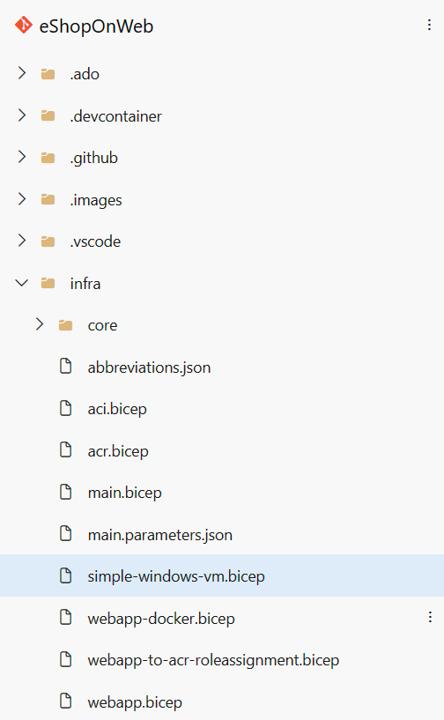

1. Review the template to get a better understanding of its structure. There are some parameters with types, default values and validation, some variables, and quite a few resources with these types:
   1. Microsoft.Storage/storageAccounts
   2. Microsoft.Network/publicIPAddresses
   3. Microsoft.Network/virtualNetworks
   4. Microsoft.Network/networkInterfaces
   5. Microsoft.Compute/virtualMachines
2. Pay attention to how simple the resource definitions are and the ability to implicitly reference symbolic names instead of explicit dependsOn throughout the template.

#### Task 2: Create a bicep module for storage resources

In this task, you will create a storage template module **storage.bicep** which will create a storage account only and will be imported by the main template. The storage template module needs to pass a value back to the main template, **main.bicep**, and this value will be defined in the outputs element of the storage template module.

1. First we need to remove the storage resource from our main template. From the top right corner of your browser window click the **Edit** button:

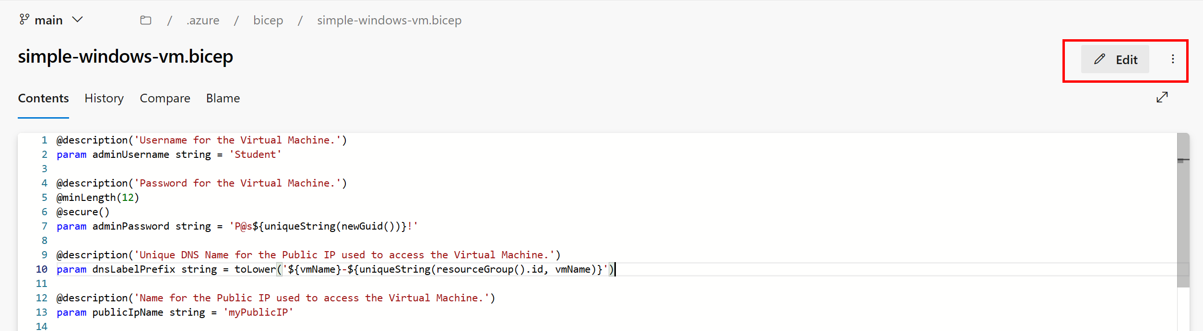

1. Now delete the storage resource:

bicepTypeCopy

resource storageAccount 'Microsoft.Storage/storageAccounts@2022-05-01' = {  
 name: storageAccountName  
 location: location  
 sku: {  
 name: 'Standard_LRS'  
 }  
 kind: 'Storage'  
}

1. Change the default value of the publicIPAllocationMethod parameter from Dynamic to Static at line 20
2. Change the default value of the publicIpSku parameter from Basic to Standard at line 27
3. Commit the file, however, we're not done with it yet.

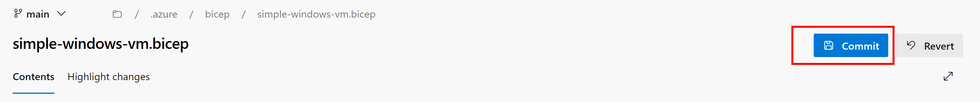

1. Next, hover your mouse over the Infra folder and click the ellipsis icon, then select **New**, and **File**. Enter **storage.bicep** for the name and click **Create**.

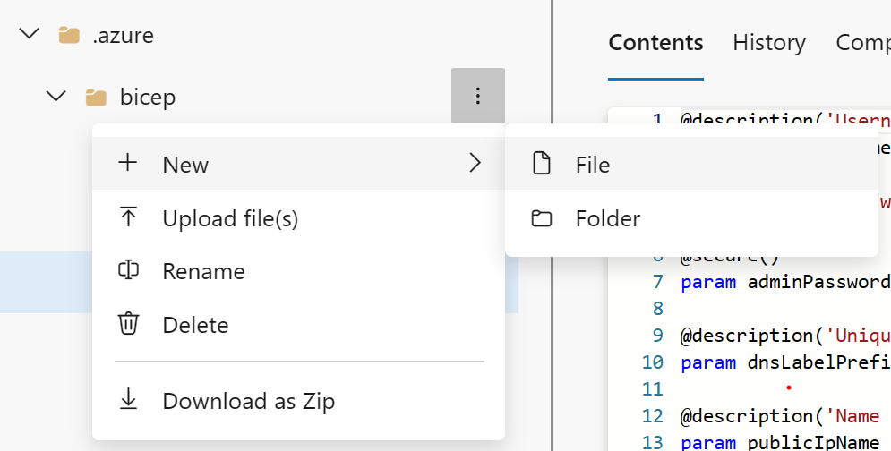

1. Now copy the following code snippet into the file and commit your changes:

bicepTypeCopy

@description('Location for all resources.')  
param location string = resourceGroup().location  
  
@description('Name for the storage account.')  
param storageAccountName string  
  
resource storageAccount 'Microsoft.Storage/storageAccounts@2022-05-01' = {  
 name: storageAccountName  
 location: location  
 sku: {  
 name: 'Standard_LRS'  
 }  
 kind: 'Storage'  
}  
  
output storageURI string = storageAccount.properties.primaryEndpoints.blob

#### Task 3: Modify the simple-windows-vm template to use the template module

In this task, you will modify the simple-windows-vm.bicep template to reference the template module you created in the previous task.

1. Navigate back to the simple-windows-vm.bicep file and click on the **Edit** button once again.
2. Next, add the following code after the variables:

bicepTypeCopy

module storageModule './storage.bicep' = {  
 name: 'linkedTemplate'  
 params: {  
 location: location  
 storageAccountName: storageAccountName  
 }  
}

1. We also need to modify the reference to the storage account blob URI in our virtual machine resource to use the output of the module instead. Find the virtual machine resource and replace the diagnosticsProfile section with the following:

bicepTypeCopy

diagnosticsProfile: {  
 bootDiagnostics: {  
 enabled: true  
 storageUri: storageModule.outputs.storageURI  
 }  
}

1. Review the following details in the main template:
   1. A module in the main template is used to link to another template.
   2. The module has a symbolic name called storageModule. This name is used for configuring any dependencies.
   3. You can only use **Incremental** deployment mode when using template modules.
   4. A relative path is used for your template module.
   5. Use parameters to pass values from the main template to the template modules.
2. Commit the template.

### Exercise 2: Deploying the templates to Azure using YAML pipelines

In this lab, you will use an Azure DevOps YAML pipeline to deploy your template to your Azure environment.

#### Task 1: Deploy resources to Azure by YAML pipelines

1. Navigate back to the **Pipelines** pane in of the **Pipelines** hub.
2. In the **Create your first Pipeline** window, click **Create pipeline**.

**Note**: We will use the wizard to create a new YAML Pipeline definition based on our project.

1. On the **Where is your code?** pane, click **Azure Repos Git (YAML)** option.
2. On the **Select a repository** pane, click **eShopOnWeb56850945**.
3. On the **Configure your pipeline** pane, scroll down and select **Existing Azure Pipelines YAML File**.
4. In the **Selecting an existing YAML File** blade, specify the following parameters:
   1. Branch: **main**
   2. Path: **.ado/eshoponweb-cd-windows-cm.yml**
5. Click **Continue** to save these settings.
6. In the variables section, update the following: **resource-group:** AZ400-RG1 and **location:** eastus2
7. Click the **Save and run** button from the top right corder and when the commit dialog appeared, click **Save and run** again.

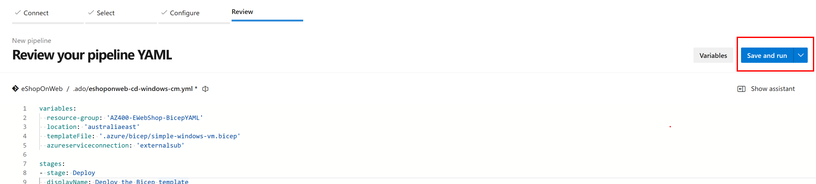

1. Wait for the deployment to finish and review the results. 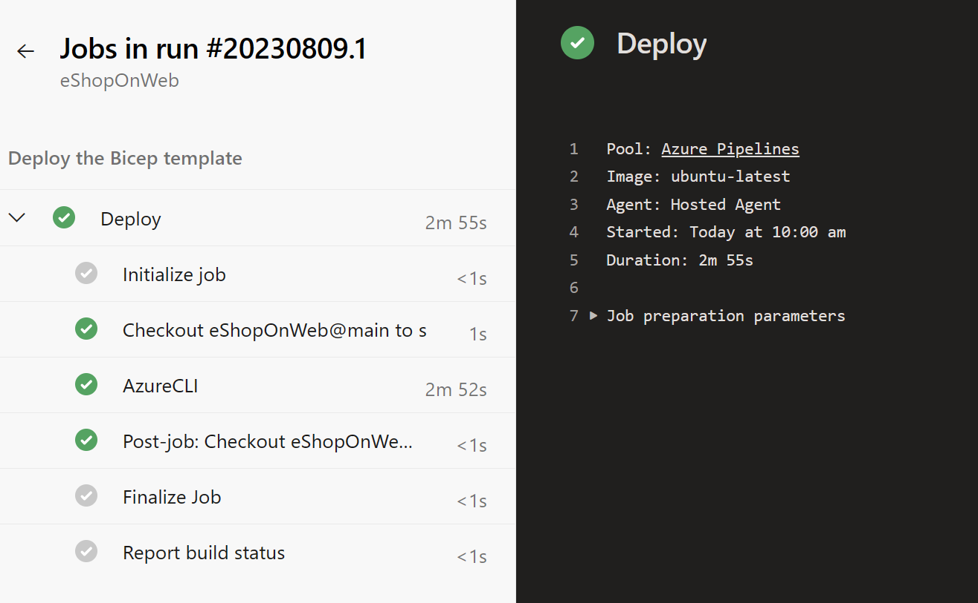

**Note**: Remember to give the pipeline permission to use the previously created Service Connection.

Remember to delete the resources created in the Azure portal to avoid unnecessary charges.

## Review

In this lab, you learned how to create an Azure Bicep template, modularize it by using a template module, modify the main deployment template to use the module and updated dependencies, and finally deploy the templates to Azure using YAML pipelines.

### Congratulations

You have successfully completed this lab. Click **End** to mark the lab as **Complete**.

2 Hours Remaining

# Package Management with Azure Artifacts

## Lab requirements

In this **Cloudslice** lab these Lab Requirements listed immediately below have already been completed for you.

* This lab requires **Microsoft Edge** or an [Azure DevOps supported browser.](https://docs.microsoft.com/azure/devops/server/compatibility)
* **Set up an Azure DevOps organization:** If you don't already have an Azure DevOps organization that you can use for this lab, create one by following the instructions available at [AZ-400 Lab Prerequisites](https://microsoftlearning.github.io/AZ400-DesigningandImplementingMicrosoftDevOpsSolutions/Instructions/Labs/AZ400_M00_Validate_lab_environment.html).
* **Set up the sample eShopOnWeb Project:** If you don't already have the sample eShopOnWeb Project that you can use for this lab, create one by following the instructions available at [AZ-400 Lab Prerequisites](https://microsoftlearning.github.io/AZ400-DesigningandImplementingMicrosoftDevOpsSolutions/Instructions/Labs/AZ400_M00_Validate_lab_environment.html).
* Visual Studio 2022 Community Edition available from [Visual Studio Downloads page](https://visualstudio.microsoft.com/downloads/). Visual Studio 2022 installation should include **ASP.NET and web development**, **Azure development**, and **.NET Core cross-platform development** workloads.
* **.NET Core SDK:** [Download and install the .NET Core SDK (2.1.400+)](https://go.microsoft.com/fwlink/?linkid=2103972)
* **Azure Artifacts credential provider:** [Download and install the credential provider](https://go.microsoft.com/fwlink/?linkid=2099625).

## Lab overview

Azure Artifacts facilitate discovery, installation, and publishing NuGet, npm, and Maven packages in Azure DevOps. It's deeply integrated with other Azure DevOps features such as Build, making package management a seamless part of your existing workflows.

## Objectives

After you complete this lab, you will be able to:

* Create and connect to a feed.
* Create and publish a NuGet package.
* Import a NuGet package.
* Update a NuGet package.

## Estimated timing: 35 minutes

## Instructions

### Exercise 0: Configure the lab prerequisites

In this **Cloudslice** lab, please skip **Tasks 1 and 3**

In this exercise, you will set up the prerequisites for the lab.

#### Task 1: (skip if done) Create and configure the team project

In this task, you will create an **eShopOnWeb** Azure DevOps project to be used by several labs.

1. On your lab computer, in a browser window open your Azure DevOps organization. Click on **New Project**. Give your project the name **eShopOnWeb** and leave the other fields with defaults. Click on **Create**.



#### Task 2: (skip if done) Import eShopOnWeb Git Repository

In this task you will import the eShopOnWeb Git repository that will be used by several labs.

1. On your lab computer, in a browser window open your Azure DevOps organization and the previously created **eShopOnWeb** project. Click on **Repos > Files** , **Import a Repository**. Select **Import**. On the **Import a Git Repository** window, paste the following URL [https:*//github.com/MicrosoftLearning/eShopOnWeb.git*](https://github.com/MicrosoftLearning/eShopOnWeb.git) and click **Import**:



1. The repository is organized the following way:
   1. **.ado** folder contains Azure DevOps YAML pipelines.
   2. **.devcontainer** folder container setup to develop using containers (either locally in VS Code or GitHub Codespaces).
   3. **infra** folder contains Bicep&ARM infrastructure as code templates used in some lab scenarios.
   4. **.github** folder container YAML GitHub workflow definitions.
   5. **src** folder contains the .NET 8 website used on the lab scenarios.

#### Task 3: (skip if done) Set main branch as default branch

1. Go to **Repos > Branches**.
2. Hover on the **main** branch then click the ellipsis on the right of the column.
3. Click on **Set as default branch**.

#### Task 4: Configuring the eShopOnWeb solution in Visual Studio

In this task, you will configure Visual Studio to prepare for the lab.

In this **Cloudslice** lab, it is recommended to implement the following steps in place of **Steps 1-6** below.

* Open **Visual Studio**, select **Clone a repository**. In the **Browse a repository** section, select **Azure DevOps**.
* Select **Sign in**, **Work or school account**, **Continue**, and then sign in using [User1-56851028@LODSPRODMCA.onmicrosoft.com](mailto:User1-56851028@LODSPRODMCA.onmicrosoft.com) and d^5T3C8x.
* Click **Ok** and **Done**. After a moment you will be signed in and can click **Close**.
* Once signed in, in the **Connect to a Project** dialog, select the **eShopOnWeb-56851028** repo, set the **Path** as desired and select **Clone**.

1. Ensure that you are viewing the **eShopOnWeb** team project on the Azure DevOps portal.

**Note**: You can access the project page directly by navigating to the [https://dev.azure.com/<your-Azure-DevOps-account-name>/eShopOnWeb](https://dev.azure.com/%3Ccode%3E%3Cyour-Azure-DevOps-account-name%3E%3C/code%3E/eShopOnWeb) URL, where the <your-Azure-DevOps-account-name> placeholder, represents your Azure DevOps Organization name.

1. In the vertical menu on the left side of the **eShopOnWeb** pane, click **Repos**.
2. On the **Files** pane, click **Clone**, select the drop-down arrow next to **Clone in VS Code**, and, in the dropdown menu, select **Visual Studio**.
3. If prompted whether to proceed, click **Open**.
4. If prompted, sign in with the user account you used to set up your Azure DevOps organization.
5. Within the Visual Studio interface, in the **Azure DevOps** pop-up window, accept the default local path (C:\eShopOnWeb) and click **Clone**. This will automatically import the project into Visual Studio.
6. Leave Visual Studio window open for use in your lab.

### Exercise 1: Working with Azure Artifacts

In this exercise, you will learn how to work with Azure Artifacts by using the following steps:

* Create and connect to a feed.
* Create and publish a NuGet package.
* Import a NuGet package.
* Update a NuGet package.

#### Task 1: Creating and connecting to a feed

In this task, you will create and connect to a feed.

1. In the web browser window displaying your project settings in the Azure DevOps portal, in the vertical navigational pane, select **Artifacts**.
2. With the **Artifacts** hub displayed, click **+ Create feed** at the top of the pane.

**Note**: This feed will be a collection of NuGet packages available to users within the organization and will sit alongside the public NuGet feed as a peer. The scenario in this lab will focus on the workflow for using Azure Artifacts, so the actual architectural and development decisions are purely illustrative. This feed will include common functionality that can be shared across projects in this organization.

1. On the **Create new feed** pane, in the **Name** textbox, type **eShopOnWebShared56851028**. In the **Visibility** section, select **Specific people**, and in the **Scope** section, select the **Project:eShopOnWeb** option, leave other settings with their default values, and click **Create**.

**Note**: Any user who wants to connect to this NuGet feed must configure their environment.

1. Back on the **Artifacts** hub, click **Connect to feed**.
2. On the **Connect to feed** pane, in the **NuGet** section, select **Visual Studio** and, on the **Visual Studio** pane, copy the **Source** url. [https:*//pkgs.dev.azure.com/Azure-DevOps-Org-Name/_packaging/eShopOnWebShared/nuget/v3/index.json*](https://pkgs.dev.azure.com/Azure-DevOps-Org-Name/_packaging/eShopOnWebShared/nuget/v3/index.json)
3. Switch back to the **Visual Studio** window.
4. In the Visual Studio window, click **Tools** menu header, in the dropdown menu, select **NuGet Package Manager** and, in the cascading menu, select **Package Manager Settings**.
5. In the **Options** dialog box, click **Package Sources** and click the plus sign to add a new package source.
6. At the bottom of the dialog box, in the **Name** textbox, replace **Package source** with **eShopOnWebShared56851028** and, in the **Source** textbox, paste the URL you copied in the Azure DevOps portal.
7. Click **Update** and then click **OK** to finalize the addition.

**Note**: Visual Studio is now connected to the new feed.

#### Task 2: Creating and publishing an in-house developed NuGet package

In this task, you will create and publish an in-house developed custom NuGet package.

1. In the Visual Studio window you used to configure the new package source, in the main menu, click **File**, in the dropdown menu, click **New** and then, in the cascading menu, click **Project**.

**Note**: We will now create a shared assembly that will be published as a NuGet package so that other teams can integrate it and stay up to date without having to work directly with the project source.

1. In the **Create a new project** pane, use the search textbox to locate the **Class Library** template, select the template for C# that targets .NET or .NET Standard, and click **Next**.
2. On the **Class Library** page of the **Create a new project** pane, specify the following settings and click **Create**:

|  |  |
| --- | --- |
| **Setting** | **Value** |
| Project name | **eShopOnWeb.Shared56851028** |
| Location | accept the default value |
| Solution | **Create new solution** |
| Solution name | **eShopOnWeb.Shared56851028** |

Check the checkbox to **Place solution and project in the same directory**.

1. Click Next. Accept **.NET 8** as Framework option.
2. Confirm the project creation by pressing the **Create** button.
3. Within the Visual Studio interface, in the **Solution Explorer** pane, right-click **Class1.cs**, in the right-click menu, select **Delete**, and, when prompted for confirmation, click **OK**.
4. Press **Ctrl+Shift+B** or **Right-click on the EShopOnWeb.Shared Project** and select **Build** to build the project.
5. From your lab workstation, open the Start menu, and search for **Windows PowerShell**. Next, in the cascading menu, click **Open Windows PowerShell as administrator**.
6. In the **Administrator: Windows PowerShell** window, navigate to the eShopOnWeb.Shared folder, by executing the following command:

powershellTypeCopy

cd c:\Users\Admin\source\repos\eShopOnWeb.Shared56851028

**Note**: The **eShopOnWeb.Shared** folder is the location of the **eShopOnWeb.Shared.csproj** file. If you chose a different location or project name, navigate to that location instead.

1. Run the following to create a **.nupkg** file from the project (change the value of XXXXXX placeholder with a unique string).

powershellTypeCopy

dotnet pack .\eShopOnWeb.Shared56851028.csproj -p:PackageId=eShopOnWeb-XXXXXX.Shared

**Note**: The **dotnet pack** command builds the project and creates a NuGet package in the **bin\Release** folder. If you don't have a **Release** folder, you can use the **Debug** folder instead.

**Note**: Disregard any warnings displayed in the **Administrator: Windows PowerShell** window.

**Note**: dotnet pack builds a minimal package based on the information it is able to identify from the project. The argument -p:PackageId=eShopOnWeb-XXXXXX.Shared allows you to create a package with a specific name instead using the name contains in the project. For example, if you substitute the string 12345 to the XXXXXX placeholder, the name of the package will be **eShopOnWeb-12345.Shared.1.0.0.nupkg**. The version number was retrieved from the assembly.

1. In the PowerShell window, run the following command to open the **bin\Release** folder:

powershellTypeCopy

cd .\bin\Release

1. Run the following to publish the package to the **eShopOnWebShared** feed. Replace the source with the URL you copied earlier from the Visual Studio **Source** url [https:*//pkgs.dev.azure.com/Azure-DevOps-Org-Name/_packaging/eShopOnWebShared/nuget/v3/index.json*](https://pkgs.dev.azure.com/Azure-DevOps-Org-Name/_packaging/eShopOnWebShared/nuget/v3/index.json)

In this **Cloudslice** lab, you will need to run this command before **Step 12**.

powershellTypeCopy

iex "& { $(irm <https://aka.ms/install-artifacts-credprovider.ps1>) } -AddNetfx"

powershellTypeCopy

dotnet nuget push --source "<https://pkgs.dev.azure.com/Azure-DevOps-Org-Name/_packaging/eShopOnWebShared/nuget/v3/index.json>" --api-key az "eShopOnWeb-XXXXXX.Shared.1.0.0.nupkg"

**Important**: If you receive and authorization error (401 Unauthorized), you need to install the credential provider for your operating system to be able to authenticate with Azure DevOps. You can find the installation instructions at [Azure Artifacts Credential Provider](https://go.microsoft.com/fwlink/?linkid=2099625). You can install by running the following command in the PowerShell window: iex "& { $(irm <https://aka.ms/install-artifacts-credprovider.ps1>) } -AddNetfx"

**Note**: You need to provide an **API Key**, which can be any non-empty string. We're using **az** here. When prompted, sign in to your Azure DevOps organization.

**Note**: If the prompt does not appear, or you receive the warning **warn : The plugin credential provider could not acquire credentials. Authentication may require manual action. Consider re-running the command with --interactive for dotnet, /p:NuGetInteractive=true for MSBuild or removing the -NonInteractive switch for NuGet"**, you can add the **--interactive** parameter to the command.

1. Wait for the confirmation of the successful package push operation.
2. Switch to the web browser window displaying the Azure DevOps portal and, in the vertical navigational pane, select **Artifacts**.
3. On the **Artifacts** hub pane, click the dropdown list in the upper left corner and, in the list of feeds, select the **eShopOnWebShared56851028** entry.

**Note**: The **eShopOnWebShared** feed should include the newly published NuGet package.

1. Click the NuGet package to display its details.

#### Task 3: Importing an Open-Source NuGet package to the Azure DevOps Package Feed

Besides developing your own packages, why not using the Open Source NuGet ([https://www.nuget.org](https://www.nuget.org/)) DotNet Package library? With a few million packages available, there will always be something useful for your application.

In this task, we will use a generic "Newtonsoft.Json" sample package, but you can use the same approach for other packages in the library.

1. From the same PowerShell window used in the previous task to push the new package, navigate back to the **eShopOnWeb.Shared** folder (cd ../..), and run the following **dotnet** command to install the sample package:

powershellTypeCopy

dotnet add package Newtonsoft.Json

1. Check the output of the install process. It shows the different Feeds it will try to download the package:

powershellTypeCopy

Feeds used:  
 [https:*//api.nuget.org/v3/registration5-gz-semver2/newtonsoft.json/index.json*](https://api.nuget.org/v3/registration5-gz-semver2/newtonsoft.json/index.json) [https:*//pkgs.dev.azure.com/<AZURE_DEVOPS_ORGANIZATION>/eShopOnWeb/_packaging/eShopOnWebShared/nuget/v3/index.json*](https://pkgs.dev.azure.com/<AZURE_DEVOPS_ORGANIZATION>/eShopOnWeb/_packaging/eShopOnWebShared/nuget/v3/index.json)

1. Next, it will show additional output regarding the actual installation process itself.

powershellTypeCopy

Determining projects to restore...  
Writing C:\Users\AppData\Local\Temp\tmpxnq5ql.tmp  
info : X.509 certificate chain validation will use the default trust store selected by .NET for code signing.  
info : X.509 certificate chain validation will use the default trust store selected by .NET for timestamping.  
info : Adding PackageReference for package 'Newtonsoft.Json' into project 'c:\eShopOnWeb\eShopOnWeb.Shared\eShopOnWeb.Shared.csproj'.  
info : GET [https:*//api.nuget.org/v3/registration5-gz-semver2/newtonsoft.json/index.json*](https://api.nuget.org/v3/registration5-gz-semver2/newtonsoft.json/index.json)info : OK [https:*//api.nuget.org/v3/registration5-gz-semver2/newtonsoft.json/index.json*](https://api.nuget.org/v3/registration5-gz-semver2/newtonsoft.json/index.json) *124ms*  
info : Restoring packages for c:\eShopOnWeb\eShopOnWeb.Shared\eShopOnWeb.Shared.csproj...  
info : GET [https:*//api.nuget.org/v3/vulnerabilities/index.json*](https://api.nuget.org/v3/vulnerabilities/index.json)info : OK [https:*//api.nuget.org/v3/vulnerabilities/index.json*](https://api.nuget.org/v3/vulnerabilities/index.json) *84ms*  
info : GET [https:*//api.nuget.org/v3-vulnerabilities/2024.02.15.23.23.24/vulnerability.base.json*](https://api.nuget.org/v3-vulnerabilities/2024.02.15.23.23.24/vulnerability.base.json)info : GET [https:*//api.nuget.org/v3-vulnerabilities/2024.02.15.23.23.24/2024.02.17.11.23.35/vulnerability.update.json*](https://api.nuget.org/v3-vulnerabilities/2024.02.15.23.23.24/2024.02.17.11.23.35/vulnerability.update.json)info : OK [https:*//api.nuget.org/v3-vulnerabilities/2024.02.15.23.23.24/vulnerability.base.json*](https://api.nuget.org/v3-vulnerabilities/2024.02.15.23.23.24/vulnerability.base.json) *14ms*  
info : OK [https:*//api.nuget.org/v3-vulnerabilities/2024.02.15.23.23.24/2024.02.17.11.23.35/vulnerability.update.json*](https://api.nuget.org/v3-vulnerabilities/2024.02.15.23.23.24/2024.02.17.11.23.35/vulnerability.update.json) *30ms*  
info : Package 'Newtonsoft.Json' is compatible with all the specified frameworks in project 'c:\eShopOnWeb\eShopOnWeb.Shared\eShopOnWeb.Shared.csproj'.  
info : PackageReference for package 'Newtonsoft.Json' version '13.0.3' added to file 'c:\eShopOnWeb\eShopOnWeb.Shared\eShopOnWeb.Shared.csproj'.  
info : Writing assets file to disk. Path: c:\eShopOnWeb\eShopOnWeb.Shared\obj\project.assets.json  
log : Restored c:\eShopOnWeb\eShopOnWeb.Shared\eShopOnWeb.Shared.csproj (in 294 ms).

1. The Newtonsoft.Json package got installed in the Packages as **Newtonsoft.Json**. From the Visual Studio **Solution Explorer**, navigate to the **eShopOnWeb.Shared56851028** Project, expand Dependencies, and notice the **Newtonsoft.Json** under the Packages. Click on the little arrow to the left of the Packages, to open the folder and file list.

When you created the Azure DevOps Artifacts Package Feed, by design, it allows for **upstream sources**, such as nuget.org in the dotnet example that brings in the Newtonsoft.Json package from where the package is hosted. This is a common practice to avoid duplication of packages and to ensure that the latest version is always used.

1. From the Azure DevOps Portal, **refresh** the Artifacts Package Feed page. The list of packages shows both the **eShopOnWeb.Shared** custom-developed package, as well as the **Newtonsoft.Json** public sourced package.
2. From the Visual Studio **eShopOnWeb.Shared** Solution, right-click the **eShopOnWeb.Shared** Project, and select **Manage NuGet Packages** from the context menu.
3. From the NuGet Package Manager window, validate the **Package Source** is set to **eShopOnWebShared**.
4. Click **Browse**, and wait for the list of NuGet Packages to load.
5. This list will also show both the **eShopOnWeb.Shared** custom-developed package, as well as the **Newtonsoft.Json** public sourced package.

## Review

In this lab, you learned how to work with Azure Artifacts by using the following steps:

* Created and connect to a feed.
* Created and publish a NuGet package.
* Imported a custom-developed NuGet package.

### Congratulations

You have successfully completed this lab. Click **End** to mark the lab as **Complete**.

2 Hours Remaining

# Monitor Application Performance with Azure Load Testing

## Lab requirements

In this **Cloudslice** lab these Lab Requirements listed immediately below have already been completed for you.

* This lab requires **Microsoft Edge** or an [Azure DevOps supported browser.](https://docs.microsoft.com/azure/devops/server/compatibility)
* **Set up an Azure DevOps organization:** If you don't already have an Azure DevOps organization that you can use for this lab, create one by following the instructions available at [Create an organization or project collection](https://docs.microsoft.com/azure/devops/organizations/accounts/create-organization).
* Identify an existing Azure subscription or create a new one.
* Verify that you have a Microsoft account or a Microsoft Entra account with the Owner role in the Azure subscription and the Global Administrator role in the Microsoft Entra tenant associated with the Azure subscription. For details, refer to [List Azure role assignments using the Azure portal](https://docs.microsoft.com/azure/role-based-access-control/role-assignments-list-portal) and [View and assign administrator roles in Azure Active Directory](https://docs.microsoft.com/azure/active-directory/roles/manage-roles-portal#view-my-roles).

## Lab overview

**Azure Load Testing** is a fully managed load-testing service that enables you to generate high-scale load. The service simulates traffic for your applications, regardless of where they're hosted. Developers, testers, and quality assurance (QA) engineers can use it to optimize application performance, scalability, or capacity. Quickly create a load test for your web application by using a URL, and without prior knowledge of testing tools. Azure Load Testing abstracts the complexity and infrastructure to run your load test at scale. For more advanced load testing scenarios, you can create a load test by reusing an existing Apache JMeter test script, a popular open-source load and performance tool. For example, your test plan might consist of multiple application requests, you want to call non-HTTP endpoints, or you're using input data and parameters to make the test more dynamic.

In this lab, you'll learn about how you can use Azure Load Testing to simulate performance testing against a live-running web application with different load scenarios. Lastly, you'll learn how to integrate Azure Load Testing into your CI/CD pipelines.

## Objectives

After you complete this lab, you will be able to:

* Deploy Azure App Service web apps.
* Compose and Run a YAML-based CI/CD pipeline.
* Deploy Azure Load Testing.
* Investigate Azure web app performance by using Azure Load Testing.
* Integrate Azure Load Testing into your CI/CD pipelines.

## Estimated timing: 60 minutes

## Instructions

### Exercise 0: (skip if done) Configure the lab prerequisites

In this **Cloudslice** lab, please skip **Tasks 1 and 3**

In this exercise, you will set up the prerequisites for the lab.

#### Task 1: (skip if done) Create and configure the team project

In this task, you will create an **eShopOnWeb** Azure DevOps project to be used by several labs.

1. On your lab computer, in a browser window open your Azure DevOps organization. Click on **New Project**. Give your project the name **eShopOnWeb** and choose **Scrum** on the **Work Item process** dropdown. Click on **Create**.



#### Task 2: (skip if done) Import eShopOnWeb Git Repository

In this task you will import the eShopOnWeb Git repository that will be used by several labs.

1. On your lab computer, in a browser window open your Azure DevOps organization and the previously created **eShopOnWeb** project. Click on **Repos > Files** , **Import**. On the **Import a Git Repository** window, paste the following URL [https:*//github.com/MicrosoftLearning/eShopOnWeb.git*](https://github.com/MicrosoftLearning/eShopOnWeb.git) and click on **Import**:



1. The repository is organized the following way:
   1. **.ado** folder contains Azure DevOps YAML pipelines
   2. **.devcontainer** folder container setup to develop using containers (either locally in VS Code or GitHub Codespaces)
   3. **infra** folder contains Bicep&ARM infrastructure as code templates used in some lab scenarios.
   4. **.github** folder container YAML GitHub workflow definitions.
   5. **src** folder contains the .NET 8 website used on the lab scenarios.

#### Task 3: (skip if done) Set main branch as default branch

1. Go to **Repos > Branches**.
2. Hover on the **main** branch then click the ellipsis on the right of the column.
3. Click on **Set as default branch**.

#### Task 4: Create Azure resources

In this task, you will create an Azure web app by using the cloud shell in Azure portal.

1. From the lab computer, start a web browser, navigate to the **Azure Portal** [https:*//portal.azure.com*](https://portal.azure.com), and sign in.
2. In the Azure portal, in the toolbar, click the **Cloud Shell** icon located directly to the right of the search text box.
3. If prompted to select either **Bash** or **PowerShell**, select **Bash**.

**Note**: If this is the first time you are starting **Cloud Shell** and you are presented with the **You have no storage mounted** message, select the subscription you are using in this lab, and select **Create storage**.

1. From the **Bash** prompt, in the **Cloud Shell** pane, run the following command to create a resource group

bashTypeCopy

RESOURCEGROUPNAME='az400m08l14-RG'  
 LOCATION='northcentralus'  
 az group create --name $RESOURCEGROUPNAME --location $LOCATION

1. To create a Windows App service plan by running the following command:

bashTypeCopy

SERVICEPLANNAME='az400l14-sp'  
 az appservice plan create --resource-group $RESOURCEGROUPNAME \  
 --name $SERVICEPLANNAME --sku B3

1. Create a web app with a unique name.

bashTypeCopy

WEBAPPNAME=az400eshoponweb56851152  
 az webapp create --resource-group $RESOURCEGROUPNAME --plan $SERVICEPLANNAME --name $WEBAPPNAME

TypeCopy

> **Note**: Record the name of the web app. You will need it later in this lab.

### Exercise 1: Configure CI/CD Pipelines as Code with YAML in Azure DevOps

In this exercise, you will configure CI/CD Pipelines as code with YAML in Azure DevOps.

#### Task 1: Add a YAML build and deploy definition

In this task, you will add a YAML build definition to the existing project.

1. Navigate back to the **Pipelines** pane in of the **Pipelines** hub.
2. Click **New pipeline** (or Create Pipeline if this is the first one you create).

**Note**: We will use the wizard to create a new YAML Pipeline definition based on our project.

1. On the **Where is your code?** pane, click **Azure Repos Git (YAML)** option.
2. On the **Select a repository** pane, click **eShopOnWeb-56851152**.
3. On the **Configure your pipeline** pane, scroll down and select **Starter Pipeline**.
4. **Select** all lines from the Starter Pipeline, and delete them.
5. **Copy** the full template pipeline from below, knowing you will need to make parameter modifications **before saving** the changes:

ymlTypeCopy

*#Template Pipeline for CI/CD*  
 *# trigger:*  
 *# - main*  
  
 resources:  
 repositories:  
 - repository: self  
 trigger: none  
  
 stages:  
 - stage: Build  
 displayName: Build .Net Core Solution  
 jobs:  
 - job: Build  
 pool:  
 vmImage: ubuntu-latest  
 steps:  
 - task: DotNetCoreCLI@2  
 displayName: Restore  
 inputs:  
 command: "restore"  
 projects: "**/*.sln"  
 feedsToUse: "select"  
  
 - task: DotNetCoreCLI@2  
 displayName: Build  
 inputs:  
 command: "build"  
 projects: "**/*.sln"  
  
 - task: DotNetCoreCLI@2  
 displayName: Publish  
 inputs:  
 command: "publish"  
 publishWebProjects: true  
 arguments: "-o $(Build.ArtifactStagingDirectory)"  
  
 - task: PublishBuildArtifacts@1  
 displayName: Publish Artifacts ADO - Website  
 inputs:  
 pathToPublish: "$(Build.ArtifactStagingDirectory)"  
 artifactName: Website  
  
 - stage: Deploy  
 displayName: Deploy to an Azure Web App  
 jobs:  
 - job: Deploy  
 pool:  
 vmImage: "windows-2019"  
 steps:  
 - task: DownloadBuildArtifacts@1  
 inputs:  
 buildType: "current"  
 downloadType: "single"  
 artifactName: "Website"  
 downloadPath: "$(Build.ArtifactStagingDirectory)"

1. Set the cursor on a new line at the end of the YAML definition. **Make sure you position the cursor at the indentation of the previous task level**.

**Note**: This will be the location where new tasks are added.

1. Click **Show Assistant** from the right hand side of the portal. In the list of tasks, search for and select the **Azure App Service Deploy** task.
2. In the **Azure App Service deploy** pane, specify the following settings and click **Add**:
   1. in the **Azure subscription** drop-down list, select the service connection you just created.
   2. Validate **App Service Type** points to Web App on Windows.
   3. in the **App Service name** dropdown list, select the name of the web app you deployed earlier in the lab (**az400eshoponweb…).
   4. in the **Package or folder** text box, **update** the Default Value to $(Build.ArtifactStagingDirectory)*/**/*Web.zip.
   5. Expand **Application and Configuration Settings**, and in the App settings text box, add the following key-value pairs: -UseOnlyInMemoryDatabase true -ASPNETCORE_ENVIRONMENT Development.
3. Confirm the settings from the Assistant pane by clicking the **Add** button.

**Note**: This will automatically add the deployment task to the YAML pipeline definition.

1. The snippet of code added to the editor should look similar to below, reflecting your name for the azureSubscription and WebappName parameters:

ymlTypeCopy

- task: AzureRmWebAppDeployment@5  
 inputs:  
 ConnectionType: "AzureRM"  
 azureSubscription: "SERVICE CONNECTION NAME"  
 appType: "webApp"  
 WebAppName: "az400eshoponWeb369825031"  
 packageForLinux: "$(Build.ArtifactStagingDirectory)/**/Web.zip"  
 AppSettings: "-UseOnlyInMemoryDatabase true -ASPNETCORE_ENVIRONMENT Development"

TypeCopy

> **Note**: The **packageForLinux** parameter is misleading in the context of this lab, but it is valid for Windows or Linux.

1. Before saving the updates to the yml-file, give it a more clear name. On top of the yaml-editor window, it shows **EShopOnweb/azure-pipelines-#.yml**. (where # is a number, typically 1 but could be different in your setup.) Select **that filename**, and rename it to **m08l14-pipeline.yml**
2. Click **Save**, on the **Save** pane, click **Save** again to commit the change directly into the main branch.

**Note**: Since our original CI-YAML was not configured to automatically trigger a new build, we have to initiate this one manually.

1. From the Azure DevOps left menu, navigate to **Pipelines** and select **Pipelines** again. Next, select **All** to open all pipeline definitions, not just the Recent ones.

**Note**: if you kept all previous pipelines from previous lab exercises, this new pipeline might have reused a default **eShopOnWeb (#)** sequence name for the pipeline as shown in below screenshot. Select a pipeline (most probably the one with the highest sequence number, select Edit and validate it points to the m08l14-pipeline.yml code file).

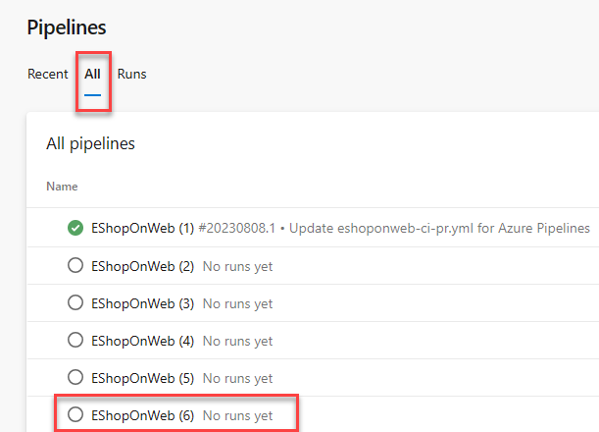

1. Confirm to run this pipeline by clicking **Run pipeline** from the appearing pane and confirm by clicking **Run** once more.
2. Notice the 2 different Stages, **Build .Net Core Solution** and **Deploy to Azure Web App** appearing.
3. Wait for the pipeline to kick off.
4. **Ignore** any Warnings showing up during the Build Stage. Wait until it completes the Build Stage successfully. (You can select the actual Build stage to see more details from the logs.)
5. Once the Deploy Stage wants to start, you are prompted with **Permissions Needed**, as well as an orange bar saying:

textTypeCopy

This pipeline needs permission to access a resource before this run can continue to Deploy to an Azure Web App

1. Click on **View**
2. From the **Waiting for Review** pane, click **Permit**.
3. Validate the message in the **Permit popup** window, and confirm by clicking **Permit**.
4. This sets off the Deploy Stage. Wait for this to complete successfully.

#### Task 2: Review the deployed site

1. Switch back to web browser window displaying the Azure portal and navigate to the blade displaying the properties of the Azure web app.
2. On the Azure web app blade, click **Overview** and, on the overview blade, click **Browse** to open your site in a new web browser tab.
3. Verify that the deployed site loads as expected in the new browser tab, showing the eShopOnWeb E-commerce website.

### Exercise 2: Deploy and Setup Azure Load Testing

In this exercise, you will deploy an Azure Load Testing Resource in Azure, and configure different Load Testing scenarios for your live-running Azure App Service.

**Important**: Azure Load Testing is a **paid service**. You will incur costs for running load tests. Make sure to clean up resources after you have completed the lab to avoid incurring additional costs. For each 'Load Testing Resource' that is active during any part of a month you will be charged the monthly fee, and have access to the included 50 VUH. See the [Azure Load Testing pricing page](https://azure.microsoft.com/pricing/details/load-testing) for more information.

#### Task 1: Deploy Azure Load Testing

In this task, you will deploy an Azure Load Testing Resource into your Azure subscription.

1. From the Azure Portal [https:*//portal.azure.com*](https://portal.azure.com), navigate to **Create Azure Resource**.
2. In the 'Search Services and marketplace' search field, enter **Azure Load Testing**.
3. Select **Azure Load Testing** (published by Microsoft), from the search results.
4. From the Azure Load Testing Page, click **Create** to start the deployment process.
5. From the 'Create a Load Testing Resource' page, provide the necessary details for the resource deployment:
   1. **Subscription**: select your Azure Subscription
   2. **Resource Group**: select the Resource Group you used for deploying the Web App Service in the earlier exercise
   3. **Name**: eShopOnWebLoadTesting-56851152
   4. **Region**: Select region **northcentralus**

**Note**: Azure Load Testing service is not available in all Azure Regions.

1. Click **Review and Create**, to have your settings validated.
2. Click **Create** to confirm, and get the Azure Load Testing resource deployed.
3. You are switched to the 'Deployment is in progress' page. Wait for a few minutes, until the deployment completes successfully.
4. Click **Go to Resource** from the deployment progress page, to navigate to the **eShopOnWebLoadTesting-56851152** Azure Load Testing resource.

**Note**: If you closed the blade or closed the Azure Portal during the deployment of the Azure Load Testing Resource, you can find it again from the Azure Portal Search field, or from the Resources / Recent list of resources.

#### Task 2: Create Azure Load Testing tests

In this task, you will create different Azure Load Testing tests, using different load configuration settings.

1. From within the **eShopOnWebLoadTesting-56851152** Azure Load Testing Resource blade, navigate to **Tests** under **Tests**. Click the **+ Create** menu option, and select **Create a URL-based test**.
2. Uncheck the **Enable advanced settings** checkbox, to display the advanced settings.
3. Complete the following parameters and settings to create a load test:
   1. **Test URL**: Enter the URL from the Azure App Service you deployed in the previous exercise (az400eshoponweb…azurewebsites.net), **including https://**
   2. **Specify Load**: Virtual Users
   3. **Number of Virtual Users**: 50
   4. **Test Duration (minutes)**: 5
   5. **Ramp-up time (minutes)**: 1
4. Confirm the configuration of the test, by clicking **Review and Create**, (Don't make any changes in the other tabs). Click **Create** once more.
5. This kicks off the Load Testing tests, which will run The test will run for 5 minutes.
6. With the test running, navigate back to the **eShopOnWebLoadTesting-56851152** Azure Load Testing Resource page, and navigate to **Tests**, select **Tests** and see a test **Get_eshoponweb…**
7. From the top menu, click **Create**, **Create a URL-based test**, to create a 2nd Load test.
8. Complete the following parameters and settings to create another load test:
   1. **Test URL**: Enter the URL from the Azure App Service you deployed in the previous exercise (eShopOnWeb…azurewebsites.net), **including https://**
   2. **Specify Load**: Requests per Second (RPS)
   3. **Requests per second (RPS)**: 100
   4. **Response time (milliseconds)**: 500
   5. **Test Duration (minutes)**: 5
   6. **Ramp-up time (minutes)**: 1
9. Confirm the configuration of the test, by clicking **Review + create**, and **Create** once more.
10. The test will run for about 5 minutes.

#### Task 3: Validate Azure Load Testing results

In this task, you will validate the outcome of an Azure Load Testing TestRun.

With both quick tests complete, let's make a few changes to them, and validate the results.

1. From **Azure Load Testing**, navigate to **Tests**. Select either of the test definitions, to open a more detailed view, by **clicking** on one of the tests. This redirects you to the more detailed test page. From here, you can validate the details of the actual runs, by selecting the **TestRun_mm/dd/yy-hh:hh** from the resulting list.
2. From the detailed **TestRun** page, identify the actual outcome of the Azure Load Testing simulation. Some of the values are:
   1. Load / Total Requests
   2. Duration
   3. Response Time (shows the outcome in seconds, reflecting the 90th percentile response time - this means that, for 90% of the requests, the response time will be within the given results)
   4. Throughput in requests per second
3. More below, several of these values are represented using dashboard graph line and chart views.
4. Take a few minutes to **compare the results** of both simulated tests with each other, and **identify the impact** of more users on the App Service performance.

### Exercise 3: Automate a Load Test with CI/CD in Azure Pipelines

Get started with automating load tests in Azure Load Testing by adding it to a CI/CD pipeline. After running a load test in the Azure portal, you export the configuration files, and configure a CI/CD pipeline in Azure Pipelines (similar capability exists for GitHub Actions).

After you complete this exercise, you have a CI/CD workflow that is configured to run a load test with Azure Load Testing.

#### Task 1: Identify Azure DevOps Service Connection details

In this task, you will grant the required permissions to the Azure DevOps Service Connection.

1. From the **Azure DevOps Portal** [https:*//aex.dev.azure.com*](https://aex.dev.azure.com), navigate to the **eShopOnWeb** Project.
2. From the down left corner, select **Project Settings**.
3. Under the **Pipelines** section, select **Service Connections**.
4. Notice the Service Connection, having the name of your Azure Subscription you used to deploy Azure Resources at the start of the lab exercise.
5. **Select the Service Connection**. From the **Overview** tab, navigate to **Details** and select **Manage service connection roles**.
6. This redirects you to the Azure Portal, from where it opens the resource group details in the access control (IAM) blade.

#### Task 2: Grant permissions to the Azure Load Testing resource

Azure Load Testing uses Azure RBAC to grant permissions for performing specific activities on your load testing resource. To run a load test from your CI/CD pipeline, you grant the **Load Test Contributor** role to the Azure DevOps service connection.

1. Select **+ Add** and **Add role assignment**.
2. In the **Role tab**, select **Load Test Contributor** in the list of job function roles.
3. In the **Members tab**, select **Select members**, and then find and select your user account and click **Select**.
4. In the **Review + assign tab**, select **Review + assign** to add the role assignment.

You can now use the service connection in your Azure Pipelines workflow definition to access your Azure load testing resource.

#### Task 3: Export load test input files and Import to Azure Repos

To run a load test with Azure Load Testing in a CI/CD workflow, you need to add the load test configuration settings and any input files in your source control repository. If you have an existing load test, you can download the configuration settings and all input files from the Azure portal.

Perform the following steps to download the input files for an existing load testing in the Azure portal:

1. In the **Azure portal**, go to your **Azure Load Testing** resource.
2. On the left pane, select **Tests** to view the list of load tests, and then select **your test**.
3. Selecting the **ellipsis (…)** next to the test run you're working with, and then select **Download input file**.
4. The browser downloads a zipped folder that contains the load test input files.
5. Use any zip tool to extract the input files. The folder contains the following files:
   1. *config.yaml*: the load test YAML configuration file. You reference this file in the CI/CD workflow definition.
   2. *quick_test.jmx*: the JMeter test script
6. Commit all extracted input files to your source control repository. To do this, navigate to the **Azure DevOps Portal** [https:*//aex.dev.azure.com*](https://aex.dev.azure.com), and navigate to the **eShopOnWeb** DevOps Project.
7. Select **Repos**. In the source code folder structure, notice the **tests** subfolder. Notice the ellipsis (…), and select **New > Folder**.
8. specify **jmeter** as folder name, and **placeholder.txt** for the file name (Note: a Folder cannot be created as empty)
9. Click **Commit** to confirm the creation of the placeholder file and jmeter folder.
10. From the **Folder structure**, navigate to the new created **jmeter** subfolder. Click the **ellipsis(…)** and select **Upload File(s)**.
11. Using the **Browse** option, navigate to the location of the extracted zip-file, and select both **config.yaml** and **quick_test.jmx**.
12. Click **Commit** to confirm the file upload into source control.
13. Within Repos, browse to the **/tests/jmeter** subfolder just created.
14. Open the Load Testing **config.yaml** file. Click **Edit** to allow editing of the file.
15. Replace the **displayName** and **testId** attributes with the value **ado_load_test**

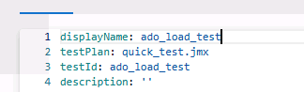

#### Task 4: Update the CI/CD workflow YAML definition file

1. From within the Azure DevOps Portal and Project, navigate to **Pipelines** and select the pipeline created at the start of this exercise. Click **Edit**.
2. In the YAML script, navigate to **line 64** and press ENTER/RETURN, to add a new empty line. (this is right before the Deploy Stage of the YAML file).
3. At line 65, select the Tasks Assistant to the right-hand side, and search for **Azure Load Testing** (make sure you position the cursor at the indentation of the previous task level).
4. Complete the graphical pane with the correct settings of your scenario:
   1. Azure Subscription: Select the subscription that starts with **Ignite-lod#######** and then click **Authorize**
   2. Load Test File: $(Build.SourcesDirectory)/tests/jmeter/config.yaml
   3. Load Test Resource Group: The Resource Group which holds your Azure Load Testing Resources
   4. Load Test Resource Name: eShopOnWebLoadTesting-56851152
   5. Load Test Run Name: ado_run
   6. Load Test Run Description: load testing from ADO
5. Confirm the injection of the parameters as a snippet of YAML by clicking **Add**
6. If the indentation of the YAML snippet is giving errors (red squiggly lines), fix them by adding 2 spaces or tab to position the snippet correctly.
7. The below sample snippet shows what the YAML code should look like

ymlTypeCopy

- task: AzureLoadTest@1  
 inputs:  
 azureSubscription: 'AZURE DEMO SUBSCRIPTION'  
 loadTestConfigFile: `$(Build.SourcesDirectory)/tests/jmeter/config.yaml`  
 resourceGroup: 'az400m08l14-RG'  
 loadTestResource: 'eShopOnWebLoadTesting-56851152'  
 loadTestRunName: 'ado_run'  
 loadTestRunDescription: 'load testing from ADO'

1. below the inserted YAML snippet, add a new empty line by pressing ENTER/RETURN.
2. below this empty line, add a snippet for the Publish task, showing the results of the Azure Load testing task during the pipeline run:

ymlTypeCopy

- publish: $(System.DefaultWorkingDirectory)/loadTest  
 artifact: loadTestResults

1. If the indentation of the YAML snippet is giving errors (red squiggly lines), fix them by adding 2 spaces or tab to position the snippet correctly.
2. With both snippets added to the CI/CD pipeline, click on **Validate and save** and, then, **Save** the changes.
3. Once saved, click **Run** to trigger the pipeline.
4. Confirm the branch (main) and click the **Run** button to start the pipeline run.
5. From the pipeline status page, click the **Deploy** stage to open the verbose logging details of the different tasks in the pipeline.
6. Wait for the pipeline to kick off the Deploy Stage, and arrive at the **AzureLoadTest** task in the flow of the pipeline.
7. While the task is running, browse to the **Azure Load Testing** in the Azure Portal, and see how the pipeline creates a new RunTest, named **ado_load_test**. You can select it to show the outcome values of the TestRun job.
8. Navigate back to the Azure DevOps CI/CD Pipeline Run view, where the **AzureLoadTest task** completed successfully. From the verbose logging output, the resulting values of the load test will be visible as well:

textTypeCopy

Task : Azure Load Testing  
 Description : Automate performance regression testing with Azure Load Testing  
 Version : 1.2.30  
 Author : Microsoft Corporation  
 Help : [https:*//docs.microsoft.com/azure/load-testing/tutorial-cicd-azure-pipelines#azure-load-testing-task*](https://docs.microsoft.com/azure/load-testing/tutorial-cicd-azure-pipelines#azure-load-testing-task)<hr class='pagebreak'/>  
 Test '0d295119-12d0-482d-94be-a7b84787c004' already exists  
 Uploaded test plan for the test  
 Creating and running a testRun for the test  
 View the load test run in progress at: [https:*//portal.azure.com/#blade/Microsoft_Azure_CloudNativeTesting/NewReport//resourceId/%2fsubscriptions%4b75-a1e0-27fb2ea7f9f4%2fresourcegroups%2faz400m08l14-RG%2fproviders%2fmicrosoft.loadtestservice%2floadtests%2feShopOnWebLoadTesting-56851152/testId/0d295119-12d0-787c004/testRunId/161046f1-d2d3-46f7-9d2b-c8a09478ce4c*](https://portal.azure.com/#blade/Microsoft_Azure_CloudNativeTesting/NewReport//resourceId/%2fsubscriptions%4b75-a1e0-27fb2ea7f9f4%2fresourcegroups%2faz400m08l14-RG%2fproviders%2fmicrosoft.loadtestservice%2floadtests%2feShopOnWebLoadTesting-56851152/testId/0d295119-12d0-787c004/testRunId/161046f1-d2d3-46f7-9d2b-c8a09478ce4c) TestRun completed  
  
 -------------------Summary ---------------  
 TestRun start time: Mon Jul 24 2023 21:46:26 GMT+0000 (Coordinated Universal Time)  
 TestRun end time: Mon Jul 24 2023 21:51:50 GMT+0000 (Coordinated Universal Time)  
 Virtual Users: 50  
 TestStatus: DONE  
  
 ------------------Client-side metrics------------  
  
 Homepage  
 response time : avg=1359ms min=59ms med=539ms max=16629ms p(90)=3127ms p(95)=5478ms p(99)=13878ms  
 requests per sec : avg=37  
 total requests : 4500  
 total errors : 0  
 total error rate : 0  
 Finishing: AzureLoadTest

1. You have now performed an automated Load Test as part of a pipeline run. In the last task, you will specify conditions for failure, meaning, we will not allow our deploy Stage to start, if the performance of the web app is below a certain threshold.

#### Task 5 : Add failure/success criteria to Load Testing Pipeline

In this task, You'll use load test fail criteria to get alerted (have a failed pipeline run as result) when the application doesn't meet your quality requirements.

1. From Azure DevOps, navigate to the eShopOnWeb Project, and open **Repos**.
2. Within Repos, browse to the **/tests/jmeter** subfolder created and used earlier.
3. Open the Load Testing *config.yaml** file. Click **Edit** to allow editing of the file.
4. Replace failureCriteria: [] if present, otherwise append the following snippet of code:

textTypeCopy

failureCriteria:  
 - avg(response_time_ms) > 300  
 - percentage(error) > 50

1. Save the changes to the config.yaml by clicking **Commit** and Commit once more.
2. Navigate back to **Pipelines** and run the **eShopOnWeb** pipeline again. After a few minutes, it will complete the run with a **failed** status for the **AzureLoadTest** task.
3. Open the verbose logging view for the pipeline, and validate the details of the **AzureLoadtest**. A similar sample output is below:

textTypeCopy

Creating and running a testRun for the test  
 View the load test run in progress at: [https:*//portal.azure.com/#blade/Microsoft_Azure_CloudNativeTesting/NewReport//resourceId/%2fsubscriptions%2fb86d9ae1-7552-47fb2ea7f9f4%2fresourcegroups%2faz400m08l14-RG%2fproviders%2fmicrosoft.loadtestservice%2floadtests%2feShopOnWebLoadTesting-56851152/testId/0d295119-12d0-a7b84787c004/testRunId/f4bec76a-8b49-44ee-a388-12af34f0d4ec*](https://portal.azure.com/#blade/Microsoft_Azure_CloudNativeTesting/NewReport//resourceId/%2fsubscriptions%2fb86d9ae1-7552-47fb2ea7f9f4%2fresourcegroups%2faz400m08l14-RG%2fproviders%2fmicrosoft.loadtestservice%2floadtests%2feShopOnWebLoadTesting-56851152/testId/0d295119-12d0-a7b84787c004/testRunId/f4bec76a-8b49-44ee-a388-12af34f0d4ec) TestRun completed  
  
 -------------------Summary ---------------  
 TestRun start time: Mon Jul 24 2023 23:00:31 GMT+0000 (Coordinated Universal Time)  
 TestRun end time: Mon Jul 24 2023 23:06:02 GMT+0000 (Coordinated Universal Time)  
 Virtual Users: 50  
 TestStatus: DONE  
  
 -------------------Test Criteria ---------------  
 Results :1 Pass 1 Fail  
  
 Criteria :Actual Value Result  
 avg(response_time_ms) > 300 1355.29 FAILED  
 percentage(error) > 50 PASSED  
  
  
 ------------------Client-side metrics------------  
  
 Homepage  
 response time : avg=1355ms min=58ms med=666ms max=16524ms p(90)=2472ms p(95)=5819ms p(99)=13657ms  
 requests per sec : avg=37  
 total requests : 4531  
 total errors : 0  
 total error rate : 0  
 *##[error]TestResult: FAILED*  
 Finishing: AzureLoadTest

1. Notice how the last line of the Load testing output says **##[error]TestResult: FAILED**; since we defined a **FailCriteria** having an avg response time of > 300, or having an error percentage of > 20, now seeing an avg response time which is more than 300, the task will be flagged as failed.

**Note**: Imagine in a real-life scenario, you would validate the performance of your App Service, and if the performance is below a certain threshold - typically meaning there is more load on the Web App, you could trigger a new deployment to an additional Azure App Service. As we can't control the response time for Azure lab environments, we decided to revert the logic to guarantee the failure.

1. The FAILED status of the pipeline task, actually reflects a SUCCESS of the Azure Load Testing requirement criteria validation.

[!IMPORTANT] Remember to delete the resources created in the Azure portal to avoid unnecessary charges.

## Review

In this exercise, you deployed a web app to Azure App Service by using Azure Pipelines, as well as deploying an Azure Load Testing Resource with TestRuns. Next, you integrated the JMeter load testing config.yaml file to Azure Repos source control, and extending your CI/CD pipeline with the Azure Load Testing. In the last exercise, you learned how to define the success criteria of the LoadTest.

### Congratulations

You have successfully completed this lab. Click **End** to mark the lab as **Complete**.

2 Hours Remaining

# Share team knowledge using Azure Project Wiki

## Lab requirements

In this **Cloudslice** lab these Lab Requirements listed immediately below have already been completed for you.

* This lab requires **Microsoft Edge** or an [Azure DevOps supported browser.](https://docs.microsoft.com/azure/devops/server/compatibility)
* **Set up an Azure DevOps organization:** If you don't already have an Azure DevOps organization that you can use for this lab, create one by following the instructions available at [AZ-400 Lab Prerequisites](https://microsoftlearning.github.io/AZ400-DesigningandImplementingMicrosoftDevOpsSolutions/Instructions/Labs/AZ400_M00_Validate_lab_environment.html).
* **Set up the sample eShopOnWeb Project:** If you don't already have the sample eShopOnWeb Project that you can use for this lab, create one by following the instructions available at [AZ-400 Lab Prerequisites](https://microsoftlearning.github.io/AZ400-DesigningandImplementingMicrosoftDevOpsSolutions/Instructions/Labs/AZ400_M00_Validate_lab_environment.html).

## Lab overview

In this lab, you'll create and configure a wiki in Azure DevOps, including managing markdown content and creating a Mermaid diagram.

## Objectives

After you complete this lab, you will be able to:

* Create a wiki in an Azure Project.
* Add and edit markdown.
* Create a Mermaid diagram.

## Estimated timing: 45 minutes

## Instructions

#### PreTask: Import eShopOnWeb Git Repository

In this task you will import the eShopOnWeb Git repository that will be used by several labs.

1. On your lab computer, in a browser window open your Azure DevOps organization and the previously created **eShopOnWeb** project. Click on **Repos > Files** , **Import**. On the **Import a Git Repository** window, paste the following URL [https:*//github.com/MicrosoftLearning/eShopOnWeb.git*](https://github.com/MicrosoftLearning/eShopOnWeb.git) and click on **Import**:



### Exercise 1: Publish code as a wiki

In this exercise, you will step through publishing an Azure DevOps repository as wiki and managing the published wiki.

**Note**: Content that you maintain in a Git repository can be published to an Azure DevOps wiki. For example, content written to support a software development kit, product documentation, or README files can be published directly to a wiki. You have the option of publishing multiple wikis within the same Azure DevOps team project.

#### Task 1: Publish a branch of an Azure DevOps repo as wiki

In this task, you will publish a branch of an Azure DevOps repo as wiki.

**Note**: If your published wiki corresponds to a product version, you can publish new branches as you release new versions of your product.

1. In the vertical menu on the left side, click **Repos**, in the upper section of the **Files** pane, make sure you have the **eShopOnWeb** repo selected (choose it from the dropdown on the top with Git icon). In the branch dropdown list (on top of "Files" with the branch icon), select **main**, and review the content of the main branch.
2. To the left of the **Files** pane, in the listing of the repo folder and file hierarchy, expand the **src** folder and browse to **Web -> wwwroot -> images** subfolder. In the **Images** subfolder, locate the **brand.png** entry, hover with the mouse pointer over its right end to reveal the vertical ellipsis (three dots) symbol representing the **More** menu, click **Download** to download the **brand.png** file to the local **Downloads** folder on your lab computer.

**Note**: You will use this image in the next exercise of this lab.

1. We will store the Wiki source files in a separate folder within the Repos current folder structure. From within **Repos**, select **Files**. Notice the **eShopOnWeb** Repo title on top of the folder structure. **Select the ellipsis (3 dots)**, Choose **New / Folder**, and provide **Documents** as title for the New Folder name. As a repo doesn't allow you to create an empty folder, provide **READ.ME** as New File name.
2. Confirm the creation of the folder and the file by pressing the **Create** button.
3. The READ.ME file will open in the built-in view mode. Since this is stored 'as code', you need to **Commit** the changes by clicking the **Commit** button. In the Commit window, confirm once more by pressing **Commit**.
4. In the Azure DevOps vertical menu on the left side, click **Overview**, in the **Overview** section, select **Wiki**, select *\*Publish code as wiki*.
5. On the **Publish code as wiki** pane, specify the following settings and click **Publish**.

|  |  |
| --- | --- |
| **Setting** | **Value** |
| Repository | **eShopOnWeb-56851284** |
| Branch | **main** |
| Folder | **/Documents** |
| Wiki name | **eShopOnWeb (Documents)** |

**Note**: This will automatically open the Wiki section, and publish **the editor**, where you can provide a Wiki page title, as well as adding the actual content. Notice you are encouraged to use MarkDown format, but make use of the ribbon to help you with some of the MarkDown layout syntax.

1. In the Wiki Page **Title** field, enter "Welcome to our Online Retail Store!"
2. In the body of the Wiki Page, paste in the following text:

textTypeCopy

*##Welcome to Our Online Retail Store!*  
At our online retail store, we offer a **wide range of products** to meet the **needs of our customers**. Our selection includes everything from *clothing and accessories to electronics, home decor, and more*.  
  
We pride ourselves on providing a seamless shopping experience for our customers. Our website offers the following benefits:  
1. user-friendly,  
1. and easy to navigate,   
1. allowing you to find what you're looking for,  
1. quickly and easily.   
  
We also offer a range of **_payment and shipping options_** to make your shopping experience as convenient as possible.  
  
### about the team  
Our team is dedicated to providing exceptional customer service. If you have any questions or concerns, our knowledgeable and friendly support team is always available to assist you. We also offer a hassle-free return policy, so if you're not completely satisfied with your purchase, you can easily return it for a refund or exchange.  
  
*### Physical Stores*  
|Location|Area|Hours|  
|--|--|--|  
| New Orleans | Home and DIY |07.30am-09.30pm |  
| Seattle | Gardening | 10.00am-08.30pm |  
| New York | Furniture Specialists | 10.00am-09.00pm |  
  
*## Our Store Qualities*  
- We're committed to providing high-quality products  
- Our products are offered at affordable prices   
- We work with reputable suppliers and manufacturers   
- We ensure that our products meet our strict standards for quality and durability.   
- Plus, we regularly offer sales and discounts to help you save even more.  
  
#Summary  
Thank you for choosing our online retail store for your shopping needs. We look forward to serving you!

1. This sample text gives you an overview of several of the common MarkDown syntax features, ranging from Title and subtitles (##), bold (*\*), italic (*), how to create tables, and more.
2. Once finished, press the **Save** button in the upper right corner.
3. **Refresh** your browser, or select any other DevOps portal option and return to the Wiki section. Notice you are now presented with the **EshopOnWeb (Documents)** Wiki, as well as having the **Welcome to our Online Retail Store** as **HomePage** of the Wiki.

#### Task 2: Manage content of a published wiki

In this task, you will manage content of the wiki you published in the previous task.

1. In the vertical menu on the left side, click **Repos**, ensure that the dropdown menu in the upper section of the **Files** pane displays the **eShopOnWeb** repo and **main** branch, in the repo folder hierarchy, select the **Documents** folder, and select the **Welcome-to-our-Online-Retail-Store!.md** file.
2. Notice how the MarkDown format is visible here as raw text format, allowing you to continue editing the file content from here as well.

**Note**: Since the Wiki source files are handled as source code, remember all practices from traditional source control (Clone, Pull Requests, Approvals and more), can now also be applied to Wiki pages.

### Exercise 2: Create and manage a project wiki

In this exercise, you will step through creating and managing a project wiki.

**Note**: You can create and manage wiki independently of the existing repos.

#### Task 1: Create a project wiki including a Mermaid diagram and an image

In this task, you will create a project wiki and add to it a Mermaid diagram and an image.

1. On your lab computer, in the Azure DevOps portal displaying the **Wiki pane** of the **EShopOnweb** project, with the content of the **eShopOnWeb (Documents)** wiki selected, at the top of the pane, click the **eShopOnWeb (Documents)** dropdown list header (the arrow down icon), and, in the drop down list, select **Create new project wiki**.
2. In the **Page title** text box, type **Project Design**.
3. Place the cursor in the body of the page, click the left-most icon in the toolbar representing the header setting and, in the dropdown list, click **Header 1**. This will automatically add the hash character (**#**) at the beginning of the line.
4. Directly after the newly added **#** character, type **Authentication and Authorization** and press the **Enter** key.
5. Click the left-most icon in the toolbar representing the header setting and, in the dropdown list, click **Header 2**. This will automatically add the hash character (**##**) at the beginning of the line.
6. Directly after the newly added **##** character, type **Azure DevOps OAuth 2.0 Authorization Flow** and press the **Enter** key.
7. **Copy and paste** the following code to insert a mermaid diagram on your wiki.

textTypeCopy

::: mermaid  
sequenceDiagram  
 participant U as User  
 participant A as Your app  
 participant D as Azure DevOps  
 U->>A: Use your app  
 A->>D: Request authorization for user  
 D-->>U: Request authorization  
 U->>D: Grant authorization  
 D-->>A: Send authorization code  
 A->>D: Get access token  
 D-->>A: Send access token  
 A->>D: Call REST API with access token  
 D-->>A: Respond to REST API  
 A-->>U: Relay REST API response  
:::

**Note**: For details regarding the Mermaid syntax, refer to [About Mermaid](https://mermaid-js.github.io/mermaid/#/)

1. To the right of the editor pane, in the preview pane, click **Load diagram** and review the outcome.

**Note**: The output should resemble the flowchart that illustrates how to [Authorize access to REST APIs with OAuth 2.0](https://docs.microsoft.com/azure/devops/integrate/get-started/authentication/oauth)

1. In the upper right corner of the editor pane, click the down-facing caret next to the **Save** button and, in the dropdown menu, click **Save with revision message**.
2. In the **Save page** dialog box, type **Authentication and authorization section with the OAuth 2.0 Mermaid diagram** and click **Save**.
3. On the **Project Design** editor pane, place the cursor at the end of the Mermaid element you added earlier in this task, press the **Enter** key to add an extra line, click the left-most icon in the toolbar representing the header setting and, in the dropdown list, click **Header 2**. This will automatically add the double hash character (**##**) at the beginning of the line.
4. Directly after the newly added **##** character, type **User Interface** and press the **Enter** key.
5. On the **Project Design** editor pane, in the toolbar, click the paper clip icon representing the **Insert a file** action, in the **Open** dialog box, navigate to the **Downloads** folder, select the **Brand.png** file you downloaded in the previous exercise, and click **Open**.
6. Back on the **Project Design** editor pane, review the preview pane and verify that the image is properly displayed.
7. In the upper right corner of the editor pane, click the down-facing caret next to the **Save** button and, in the dropdown menu, click **Save with revision message**.
8. In the **Save page** dialog box, type **User Interface section with the eShopOnWeb image** and click **Save**.
9. Back on the editor pane, in the upper right corner, click **Close**.

#### Task 2: Manage a project wiki

In this task, you will manage the newly created project wiki.

**Note**: You will start by reverting the most recent change to the wiki page.

1. On your lab computer, in the Azure DevOps portal displaying the **Wiki pane** of the **eShopOnWeb** project, with the content of the **Project Design** wiki selected, in the upper right corner, click the vertical ellipsis symbol and, in the dropdown menu, click **View revisions**.
2. On the **Revisions** pane, click the entry representing the most recent change.
3. On the resulting pane, review the comparison between the previous and the current version of the document, click **Revert**, when prompted for the confirmation, click **Revert** again, and then click **Browse Page**.
4. Back on the **Project Design** pane, verify that the change was successfully reverted.

**Note**: Now you will add another page to the project wiki and set it as the wiki home page.

1. On the **Project Design** pane, at the bottom left corner, click **+ New page**.
2. On the page editor pane, in the **Page title** text box, type **Project Design Overview**, click **Save**, and then click **Close**.
3. Back in the pane listing the pages within the **Project Design** project wiki, locate the **Project Design Overview** entry, select it with the mouse pointer, drag and drop it above the **Project Design** page entry.
4. Confirm the changes by pressing the **Move** button in the appearing window.
5. Verify that the **Project Design Overview** entry is listed as the top level page with the home icon designating it as the wiki home page.

## Review

In this lab, you created and configured Wiki in an Azure DevOps, including managing markdown content and creating a Mermaid diagram.

### Congratulations

You have successfully completed this lab. Click **End** to mark the lab as **Complete**.

1 Hr 58 Min Remaining